Notebook Check
Check all that are complete.
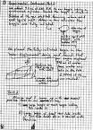
______ Front cover information: Name, class, and date started
______ Notebook policy on back page
______ Table of contents up to date
______ Signature and dates on each page
______ Black or blue ink, no pencil or fancy markers
______ Pages Numbered
______ Corrections properly done using strike outs with initials (no erasures or cross-outs)
______ No loose papers
______ Legible
______ Check proper use of graphs, labels, units, etc.
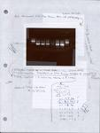
______ Pictures and other papers may be taped into notebook but make sure they are initialed and dated.
______ Each page signed by a witness
“If it is not written, it is not done.”
______ All work should be recorded in the notebook and it is required by GLP (Good Laboratory Practices)/ GMP (Good Manufacturing Practices) regulations
______ Background notes, reason for experiment
______ Procedure: Actual actions taken in lab, any changes or mistakes to original procedure should be recorded.
______ Results and data recorded
______ Conclusion: Reference earlier work here.
______ List lab partners

