Protein Structure

Name: ________________________________ Date: _________________________

Instructions: Your teacher will show you a picture of all four types of protein structures. Write down the information corresponding to each structure on your handout.

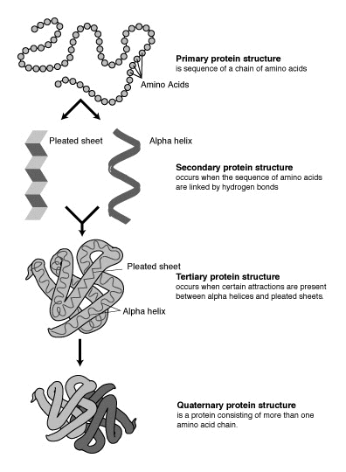
Primary Protein Structure
__________________________________
__________________________________
__________________________________

Secondary Protein Structure
______________________________________
______________________________________
______________________________________

Tertiary Protein Structure
______________________________________
______________________________________
______________________________________

Quaternary Protein Structure
___________________________________
___________________________________
___________________________________
Protein Structure
Primary Protein Structure
A sequence of a chain of amino acids

Secondary Protein Structure
Amino acid sequences are linked together by hydrogen bonds to form beta pleated sheets or alpha helixes

Tertiary Protein Structure
Alpha helixes and beta pleated sheets are attracted together

Quaternary Protein Structure
Protein consisting of more than one amino acid chain

