Circulatory System Exam

Matching: Three points each.

- ________thrombus a. narrowing of the vessels
- ________embolus b. disease in which blood doesn’t clot
- ________myocardial infarction c. clot
- ________leukemia d. travelling clot
- ________congestive heart failure e. high blood pressure
- ________hemophilia f. stroke
- ________transient ischemic attack g. heart attack
- ________hypertension h. mini-stroke, warning sign
- ________atherosclerosis i. malignant disease of bone marrow
- ________cerebrovascular accident j. heart muscles don’t beat adequately

Electrical Pathway of the Heart. Number each section of the electrical pathway in order, from 1 – 5. Two points each.

- ___________ AV node
- ___________ Bundle of HIS
- ___________ purkinje fibers
- ___________ SA node
- ___________ left and right bundle branches

Multiple Choice. Two points each.

- Erythrocytes are:

  - white blood cells
  - red blood cells
  - platelets
  - plasma

- Leukocytes are:

  - white blood cells
  - red blood cells
  - platelets
  - plasma

- Thrombocytes are:

  - white blood cells
  - red blood cells
  - platelets
  - plasma

19. The muscular wall that separates the two sides of the heart is called the:

- atria
- ventricles
- septum
- myocardium

- The smooth layer that lines the inside of the heart is called the:

  - pericardium
  - myocardium
  - endocardium
  - innercardium

- The double layered membrane that covers the heart is the:

  - pericardium
  - myocardium
  - endocardium
  - outercardium

21-32. Starting at the Inferior/Superior vena cava, follow the pathway of the blood through the heart. Begin with #1 and follow through to #12. One point each.

______right ventricle _______pulmonary veins
______left ventricle _______ pulmonary artery
______right atrium _______lungs
______left atrium _______aorta
______tricuspid valve ______pulmonary valve
______bicuspid (mitral) valve ______aortic valve

33- 45. Labeling. (Hint: use the terms from the previous section as a partial wordbank). Two points each.

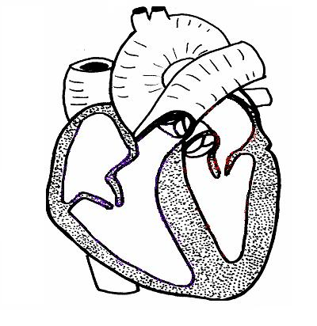
33.
34.
35.
36.
37.
38.
39.
40.
41.
42.
43.
44.
45.

33. ___________________________ 40. _________________________

34. ___________________________ 41. _________________________

35. ___________________________ 42. _________________________

36. ___________________________ 43. _________________________

37. ___________________________ 44. _________________________

38. ___________________________ 45. _________________________

39. ___________________________

