Name: ______________________________ Class Period: _____ Date: __________

Label each of the structures of the digestive system next to its corresponding line. On the back of this page, write the name of each structure and a brief description of its function(s).

Word bank: esophagus, rectum, duodenum, small intestine, salivary glands, epiglottis, large intestine, liver, stomach, appendix, gallbladder, teeth, tongue, pancreas, common bile duct

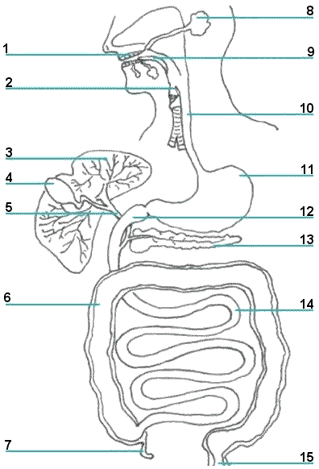

KEY

1: teeth
2: epiglottis
3: liver
4: gall bladder
5: common bile duct
6: large intestine
7: appendix
8: salivary gland
9: tongue
10: esophagus
11: stomach
12: small intestine (duodenum)
13: pancreas
14: small intestine
15: rectum

