Key to pulse site
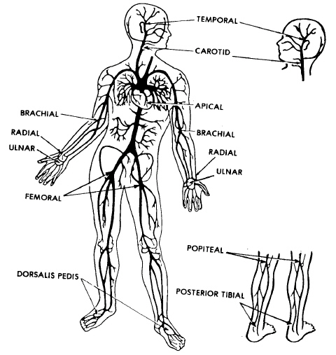
1
2
3
4
5
4
5
6
7
8
9

- ___TEMPORAL___ 6. ___FEMORAL________
- ___CAROTID_____ 7. ___POPLITEAL___
- _APEX OF HEART__ 8. ___DORSALIS pedis______
- ___BRACHIAL___ 9. ___POSTERIOR tibialis____
- ___RADIAL______

