Name ____________________ Date _________________

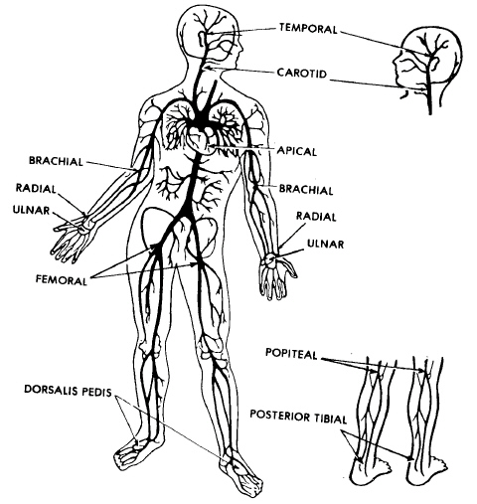
1
2
3
4
5
4
5
6
7
8
9

- ____________________ 6. ____________________
- ____________________ 7. ____________________
- ____________________ 8. ____________________
- ____________________ 9. ____________________
- ____________________

