Identify each piece of equipment and describe the purpose. Name _________________

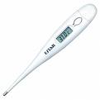
2.

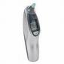
1.

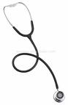
A
B
4. Identify the item and label the parts

A.
B.
C.
C

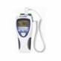
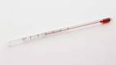
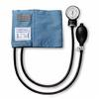
5.
6.
7.
8. Identify the part
9. Identify the part
3.
10. What piece or pieces of equipment is missing that is needed for V/S that is not pictured?

