Endocrine System Exam

Wordbank: Each question is worth three points (60 points total).
Not all terms will be used.

hypothyroidism hyperthyroidism hormones
Pituitary gland giantism dwarfism
Ovaries oxytocin lutenizing hormone
Parathyroid glands Cushing’s syndrome Addison’s Disease
goiter thymus placenta
Graves disease pancreas diabetes mellitus
Acromegaly adrenal glands testes

- The endocrine system consists of a group of ductless glands that secrete _________________ directly into the bloodstream.
- The ______________________ is often called the “master gland,” though this is technically not accurate.
- A _____________ is an enlargement of the thyroid gland.
- ____________________ is overactivity of the thyroid gland.
- ____________________ is underactivity of the thyroid gland.
- _____________________________ is a severe form of hyperthyroidism.
- ______________________ results when the pituitary gland secretes excessive amounts of somatotropin (growth hormone) before puberty.
- ______________________ results from an undersecretion of somatotropin and can be caused by a tumor, infection, genetic factors, or injury.
- In individuals with __________________, bones of the hands, feet, and face enlarge.
- The ___________________________ are four small glands located behind and attached to the thyroid gland.
- The ________________ are often called the suprarenal glands.
- ____________________________ may result in a “moon face” and obesity.
- ____________________________ results in weight loss, muscle weakness, a “bronzing” color of the skin, and hypoglycemia. President Kennedy had this disorder.
- The _______________ is a fish-shaped organ located behind the stomach.
- The _______________ is a mass of tissue located in the upper part of the chest that wastes away during puberty.
- The ________________ is a temporary endocrine gland produced during pregnancy.
- ________________________ is a chronic disease caused by decreased secretion of insulin.
- The ______________ are the sex glands of the male.
- The ______________ are the sex glands of the female.
- __________________ is the hormone released during childbirth and lactation.

Diabetes Mellitus: 2 points each (30 points total)

For questions 21-25, determine if the patient is suffering from Insulin Shock (IS) or Diabetic Coma (DC) and write the correct response in the space provided:

- Patient has eaten but not taken insulin: ____________________
- Patient took insulin but did not eat: _______________________
- Patient ate, took insulin, but exercised more than usual: _________________________
- Patient “got tired” of having diabetes and stopped taking insulin: __________________________
- Patient ate but took more insulin than usual: ___________________

For questions 26-30, determine if the patient is suffering from hypoglycemia or hyperglycemia and write the correct response in the space provided:

- red, hot skin: _____________________________
- cool, clammy skin: ________________________
- typically sudden onset: _____________________
- typically 2-3 days for onset: _________________
- irritability and shaking: _____________________

For questions 31-35, circle the correct response:

- A patient with hypoglycemia needs (insulin / sugar).
- A patient with hyperglycemia needs (insulin / sugar).
- Type I diabetics will (always/sometimes) require daily insulin.
- Type II diabetics will (always/sometimes) require daily insulin.
- (Type I / Type II / Gestational) diabetes will usually resolve after pregnancy.

36 - 40: 2 points each (10 points total). Label the pancreas, pituitary gland, adrenal glands, ovaries, and thyroid on the attached image of endocrine system.

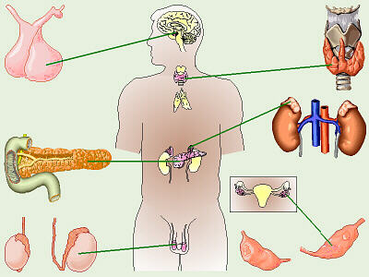
36.
37.
38.
39.
40.

36. ______________________________________

37. ______________________________________

38. ______________________________________

39. ______________________________________

40. ______________________________________

