There are three goals for all rescue operations:

- To maintain rescuer safety.

- To triage in lightly and moderately damaged buildings.

- To evacuate victims as quickly as possible from moderately damaged buildings while minimizing additional injury.

None of these goals can be achieved without creating as safe an environment as possible before attempting rescue. There are, therefore, certain precautions that rescuers must take to minimize risk.

- Know your limitations. Many volunteers have been injured or killed during rescue operations because they did not pay attention to their own physical and mental limitations. Rescuers should take the time to eat, drink fluids, rest, and relax so that they can return with a clear mind and improved energy.

- Follow safety procedures. You should always use the proper safety equipment required for the situation and follow established procedures, including:

- Working in pairs.
- Never entering an unstable structure.
- Lifting by bending the knees, keeping the back straight, and pushing up with the legs.
- Carrying the load close to the body.
- Lifting and carrying no more than is reasonable.

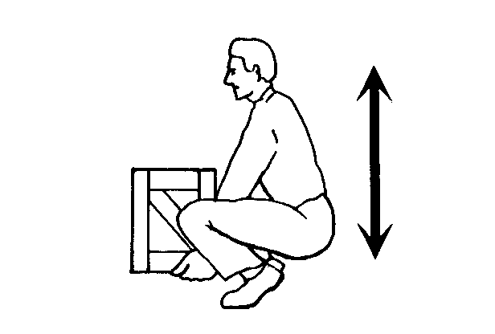
Proper Body Position for Lifting

Proper Body Position for Lifting showing the back straight and lifting with the knees.

Conducting Rescue Operations (Continued)
You may encounter situations in which debris needs to be moved to free victims. When you must remove debris to locate victims, you should set up a human chain and pass the debris from one person to the next. Set up the chain in a position that will not interfere with rescue operations. Wear leather gloves to protect your hands.

Removing Victims

There are two basic types of removal:

- Self-removal or assist.

- Lifts and drags.

It is usually best to allow an ambulatory victim to extricate himself or herself. However, sometimes ambulatory victims are not as strong and uninjured as they think that they are. When victims become free from entrapment, they may need assistance to exit the structure.

Conducting Rescue Operations (Continued)
The type of extrication method selected should depend on the:

- General stability of the immediate environment.

- Number of rescuers available.

- Strength and ability of the rescuers.

- Condition of the victim.

If safety and time permit, you should not use lifts and drags to remove victims when closed-head or spinal injury is suspected. In such cases, the spine must be stabilized using a backboard. Doors, tables, and similar materials can be used as improvised backboards. The backboard must be able to carry the person, and proper lifting techniques must be used. When moving victims, rescuers must use teamwork and communication, and keep the victim's spine in a straight line. Remember, rescuer safety and the condition of the building will dictate the approach.

There are several types of lifts and carries. For example, if the rescuer is physically able and the victim is small, he or she may use the one-person arm carry to lift and carry the victim by:

- Reaching around the victim's back and under the knees.

- Lifting the victim while keeping the rescuer's back straight and lifting with the legs.

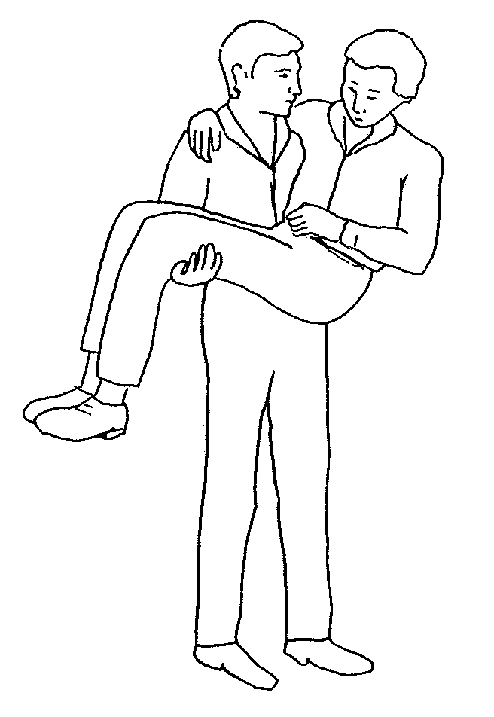
One-Person Arm Carry

One-Person Arm Carry, which shows the rescuer holding the victim around the victim’s back and under the knees.

Note: Consider the size of the victim and the distance he or she needs to be carried before using this carry.

Conducting Rescue Operations (Continued)
Another way for a single rescuer to lift a victim safely is by using the one-person pack-strap carry. Using this method, the rescuer should follow the steps outlined below:

- Step 1: Stand with his or her back to the victim.

- Step 2: Place the victim's arms over the rescuer's shoulders and grab the hands in front of the rescuer's chest.

- Step 3: Hoist the victim by bending forward slightly, until his or her feet just clear the floor.

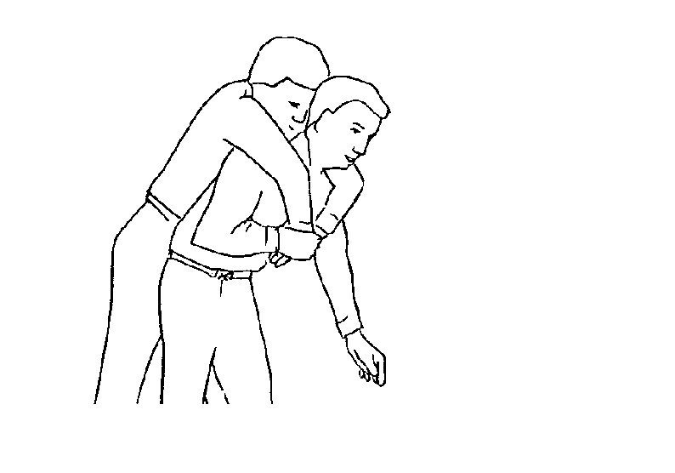
One-Person Pack-Strap Carry

One-Person Pack-Strap Carry in which the rescuer places the victim’s arms over his or her shoulder and grabs the victim’s hands over his or her chest, then hoists the victim by bending over slightly.

Victim removal is easier when multiple rescuers are available. With two rescuers, a victim may be removed using a two-person lift.

- Rescuer 1: Squat at the victim's head and grasp the victim from behind around the midsection. Reach under the arms and grasp the victim's forearms.

- Rescuer 2: Squat between the victim's knees, facing either toward or away from the victim. Grasp the outside of the victim's legs at the knees.

- Both rescuers: Rise to a standing position, keeping backs straight and lifting with the legs. Walk the victim to safety.

Conducting Rescue Operations (Continued)
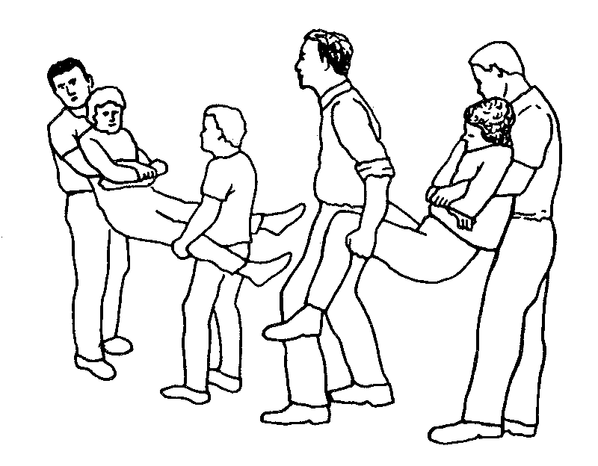
Two-Person Carry

Two-Person Carry in which rescuer 1 squats at the victim’s head and grasps the victim from behind at the midsection. Rescuer 2 squats between the victim’s knees, grasping the outside of the knees. Both rescuers rise to a standing position.
Two rescuers can also remove a victim by seating him or her on a chair:

- Rescuer 1: Facing the back of the chair, grasp the back uprights.

- Rescuer 2: Facing away from the victim, reach back and grasp the two front legs of the chair.

- Both rescuers: Tilt the chair back, lift, and walk out.

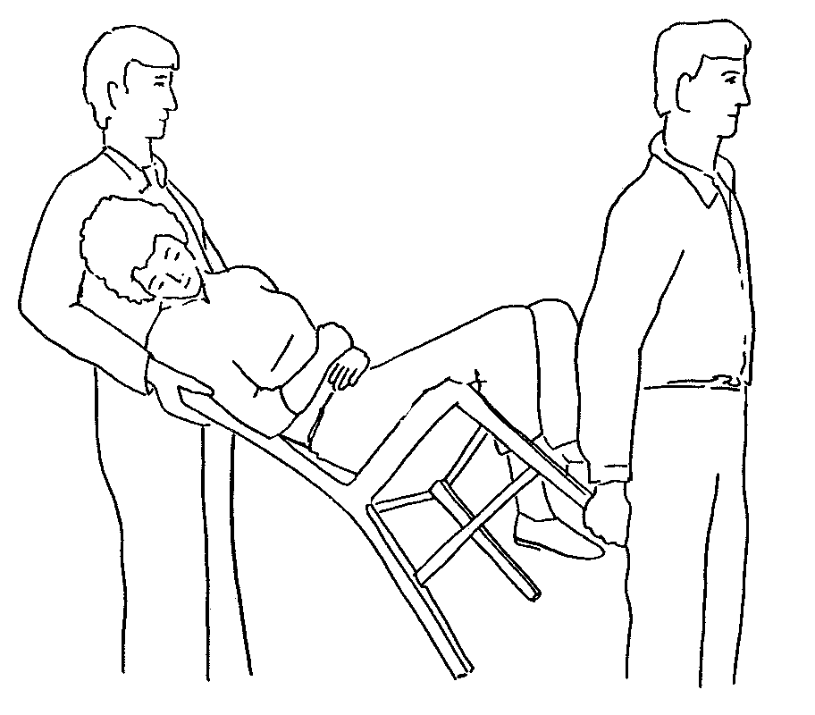
Chair Carry

Chair Carry in which the victim is placed in a chair and tilted backward as rescuers lift the victim. This carry requires two rescuers.

Conducting Rescue Operations (Continued)
You can use the blanket carry for victims who cannot be removed by other means. The blanket carry requires at least six rescuers to ensure stability for the victim, and one rescuer must be designated the lead person:

- Step 1: Lay a blanket next to the victim.

- Step 2: Tuck the blanket under the victim, and roll the victim into the center of the blanket.

- Step 3: With three rescuers squatting on each side and grasping a “handle,” the lead person checks the team for even weight distribution and correct lifting position.

- Step 4: The lead person calls out, “Ready to lift on the count of three: One, two, three, lift.”

- Step 5: The team lifts and stands in unison— keeping the victim level—and carries the victim feet first.

The team must also lower the victim together, using the following steps:

- Step 1: The lead person calls out, “Ready to lower on the count of three: One, two, three, lower.”

- Step 2: The team lowers the victim in unison, exercising caution to keep the victim level.

A variety of materials—such as blankets—can be used as improvised stretchers.

Rescuers can also drag a victim out of a confined area by grasping either under the arms or by the feet and pulling across the floor. However, unless there is no other way to remove the victim and the victim’s removal is time critical, you should not use this drag when debris may cause additional injury.

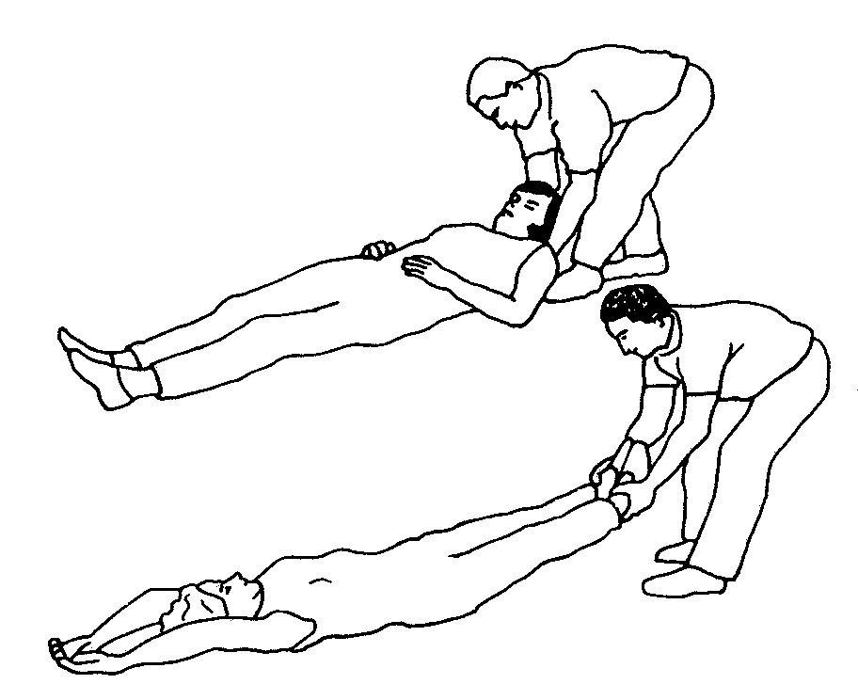
Correct Drag Techniques

Correct Drag Technique, showing the rescuer grasping the victim by either the feet or shoulders and dragging him or her clear of the hazard.

Conducting Rescue Operations (Continued)
When necessary, one rescuer can use the blanket drag by following these steps:

- Step 1: Wrap the victim in a blanket.

- Step 2: Squat down and grasp an edge of the blanket.

- Step 3: Drag the victim across the floor.

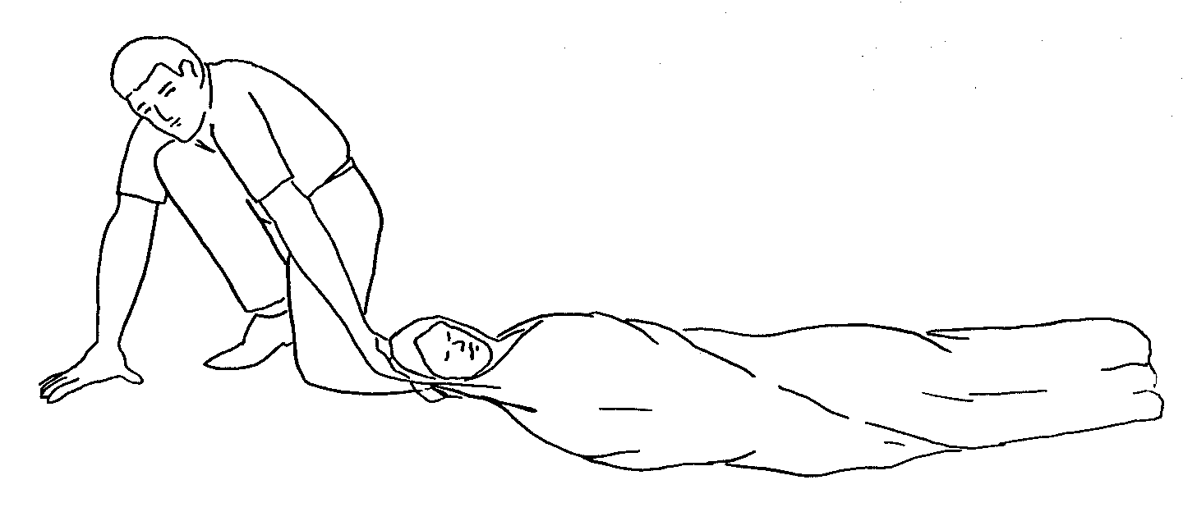
Blanket Drag

Blanket Drag, showing the victim wrapped in a blanket with the rescuer squatting at the victim’s head. The rescuer grasps the blanket behind the victim’s head and drags him or her clear of the hazard.

Exercise: Removing Victims

Purpose: This exercise will provide you with an opportunity to practice the removal of victims from a collapse situation, using leveraging/cribbing and drags and carries. You will be assigned into groups and assigned to do a room search, locate victims, and remove the victims.

Instructions: Use the following steps to complete this exercise:

- Enter your assigned "collapse site" room, do a room search, locate the victims and use leveraging and cribbing procedures to free them, and use appropriate lifts and drags to remove the victims from the room (and, if possible, from the building).

- Rotate roles so that there are two new victims. Repeat the exercise until everyone has had an opportunity to practice being a rescuer.

