Identify Laboratory Glassware

Directions: Match the name with the appropriate glassware.

- Beaker -
- Bottle & Stopper -
- Erlenmeyer Flask -
- Funnel -
- Graduated Cylinder -
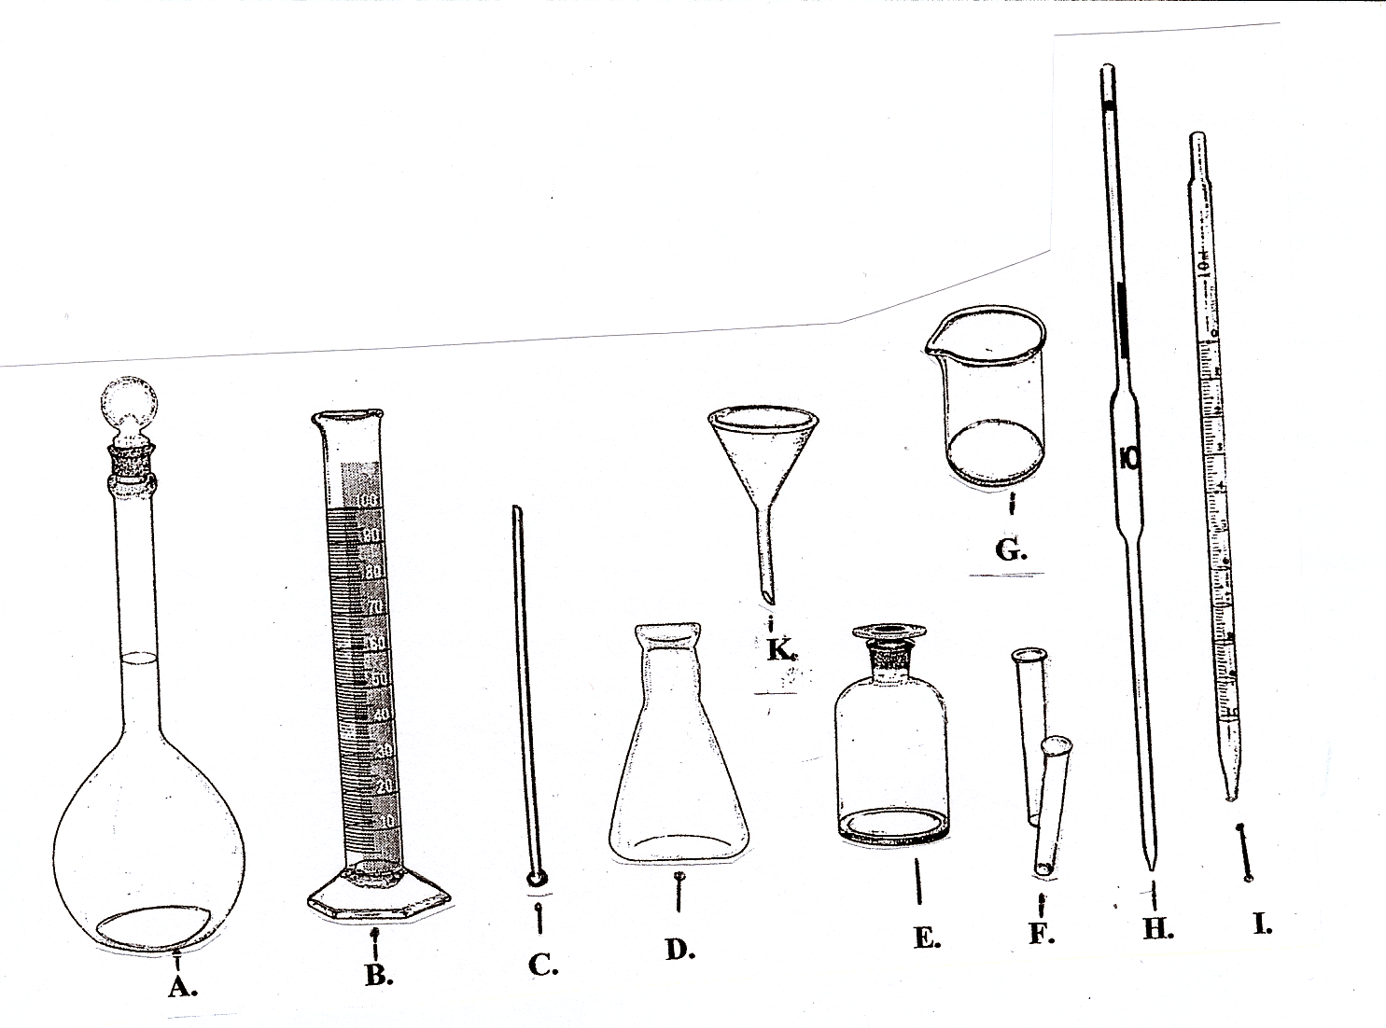
- Serological Pipette -
- Stirring Rod -
- Test Tubes -
- Volumetric Flask -
- Volumetric Pipette -

Directions: Match the glassware diagram with the correct description.

- Jar with pouring spout used for noncritical measurements (50mL -100mL). ____
- Straw-like device with a single graduation measurement (1mL – 20 mL). ______
- Common flask capable of measuring a single amount (25 mL – 1 L). _________
- Large storage container for reagents (size varies) . _________________________
- Graduated flask capable of measuring noncritical volumes (50 mL – 2 L). _____
- Small storage & testing container (size varies). ___________________________
- A reagent mixing instrument. _________________________________________
- Straw-like device with graduated lines down to 0.1 (1mL – 20 mL). ___________
- Cone shaped device used as a pouring aid. _______________________________
- Flared base tube with graduated lines for measuring multiple volumes
(50 mL – 2 L). _____________________________________________________

