Who’s Who in the World of Cell Biology?

Name: _____________________________ Date: ________________________

Instructions: Label the following microorganisms as a virus, prokaryote, or eukaryote. List three identifying factors about each one on the lines provided.

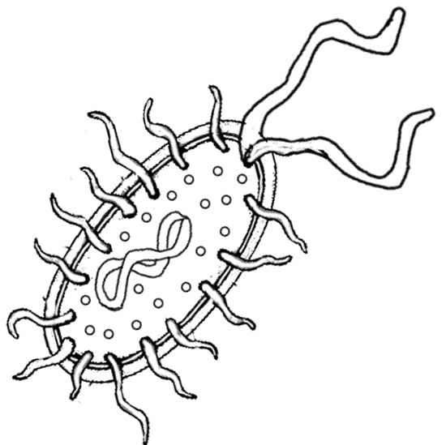
I’m a… ______________________________
Fact #1: ____________________________________ ___________________________________________
Fact #2: ____________________________________ ___________________________________________
Fact #3: ____________________________________ ___________________________________________

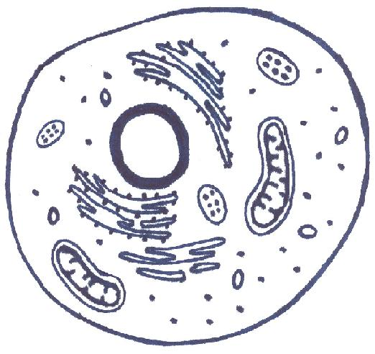
I’m a… ______________________________
Fact #1: ____________________________________ ___________________________________________
Fact #2: ____________________________________ ___________________________________________
Fact #3: ____________________________________ ___________________________________________

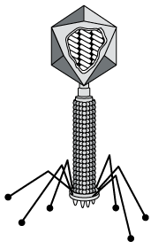
I’m a… ______________________________
Fact #1: ____________________________________ ___________________________________________
Fact #2: ____________________________________ ___________________________________________
Fact #3: ____________________________________ ___________________________________________

