Develop an accident prevention program.

Get a blue print of a house, have students write out a fire plan for exiting the house. You can also do this for a building. Have students highlight the exits. They should also look for windows and paths that may be blocked. If you want other images you can find them on google image.

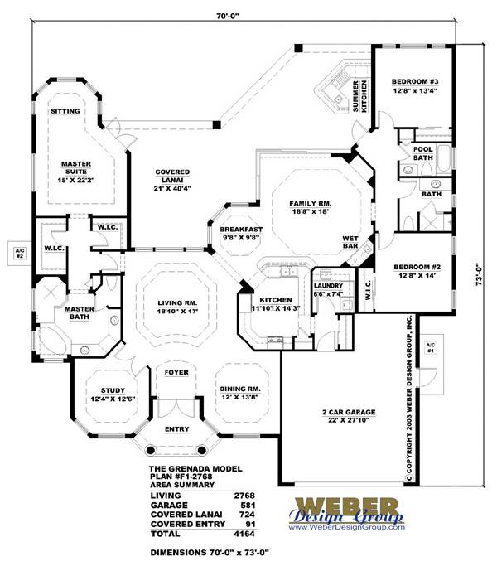

Develop a pre-fire planning diagram of a building. If you would like to choose another building, you can find other blueprints on google image.

