Identify the different types of sprinkler systems.
http://insurance-risk-mgmt.utoronto.ca
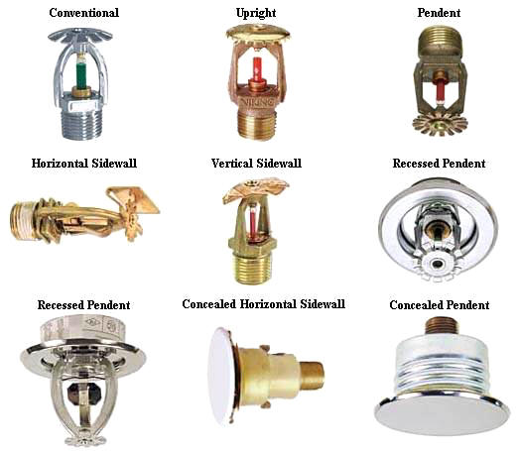

Note to instructor: You could use this handout as a means for students to identify each type of sprinkler by using the internet or demonstration. Where would you most likely see the above sprinklers?

