Introduction to Anatomy and Physiology Exam NAME: ______________________

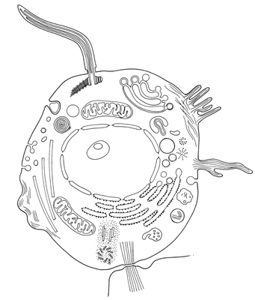
1
2
3
4
5
6
7
8
9

1-9. Human Cell. Label the following terms: cell membrane, lysosome, nucleus, nucleolus, rough endoplasmic reticulum, golgi apparatus, pinocytic vesicle, mitochondria, cytoskeleton. Three points each.

1. ______________________ 6. _____________________

2. ______________________ 7. _____________________

3. ______________________ 8. _____________________

4. ______________________ 9. _____________________

5. ______________________

10-20. Organ Systems. Identify the organ system that provides each of the following functions: respiratory, nervous, digestive, circulatory, integumentary, skeletal, muscular, lymphatic, urinary, endocrine, and reproductive. Three points each.

10. |  | Protects body from injury, infection, and dehydration; helps regulate body temperature.
11. |  | Creates framework of body, protects internal organs, produces blood cells, and acts as levers for muscles.
12. |  | Produces movement, produces body heat, maintains posture.
13. |  | Coordinates and controls body activities.
14. |  | Carries oxygen and nutrients to body cells; carries waste products away from cells.
15. |  | Carries some tissue fluid and wastes to blood; "streetsweeper" of the body.
16. |  | Breathes in oxygen and eliminates carbon dioxide.
17. |  | Digests food physically and chemically; absorbs nutrients, eliminates wastes.
18. |  | Filters blood to maintain fluid and electrolyte balance in the body.
19. |  | Produces and secretes hormones to regulate body processes.
20. |  | Provides for procreation or species. Abstinence prevents this. ☺

21- 28. Body Planes, Directions, and Cavities. Matching: Two points each.

_____21. Proximal A. Toward the head end of the body
_____22. Distal B. Away from the head/ Caudal
_____23. Lateral C. Front/ Ventral
_____24. Medial D. Away from the trunk or point or origin of a part
_____25. Posterior E. Dorsal/back
_____26. Anterior F. Toward or nearest to point or origin of a part
_____27. Inferior G. Toward the midline of the body
_____28. Superior H. Away from the midline of the body
29-40. Body Planes, Directions, and Cavities. Fill-in: Two points each.

29. The heart and lungs are located in the ______________ cavity.

30. The stomach, liver, spleen, and intestines are located in the ________________ cavity.

31. The brain is located in the ______________ cavity.

32. The ______________ plane divides the body into top and bottom.

33. The _________________ plane divides the body into right and left.

34. The _____________________ plane divides the body in front and back.

35. The knee is ___________________ to the hip.

36. The nose is _______________ to the ears.

37. The sternum (breastbone) is _________________ to the spinal column.

38. The chin is _____________ to the mouth.

39-40. In the anatomical position, the person is standing feet _____________, thumbs __________.

