Introduction to Anatomy and Physiology Exam Answer Key

NAME: ______________________

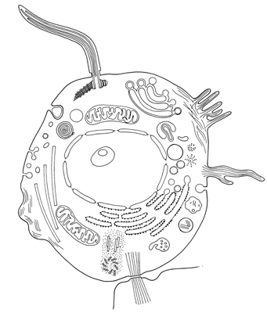
1
2
3
4
5
6
7
8
9

1-9. Human Cell. Label the following terms: cell membrane, lysosome, nucleus, nucleolus, rough endoplasmic reticulum, golgi apparatus, pinocytic vesicle, mitochondria, cytoskeleton. Three points each.

1. _PinocyticVesicle________ 6. _Golgi apparatus____________

2. _Nucleolus______________ 7. _Lysosome______________

3. _Nucleus_______________ 8. _Rough Endoplasmic Reticulum___

4. _Cytoskeleton___________ 9. __Cell Membrane_____________

5. _Mitochondria___________

10-20. Organ Systems. Identify the organ system that provides each of the following functions: respiratory, nervous, digestive, circulatory, integumentary, skeletal, muscular, lymphatic, urinary, endocrine, and reproductive. Three points each.

10. | Integumentary | Protects body from injury, infection, and dehydration; helps regulate body temperature.
11. | Skeletal | Creates framework of body, protects internal organs, produces blood cells, and acts as levers for muscles.
12. | Muscular | Produces movement, produces body heat, maintains posture.
13. | Nervous | Coordinates and controls body activities.
14. | Circulatory | Carries oxygen and nutrients to body cells; carries waste products away from cells.
15. | Lymphatic | Carries some tissue fluid and wastes to blood; "streetsweeper" of the body.
16. | Respiratory | Breathes in oxygen and eliminates carbon dioxide.
17. | Digestive | Digests food physically and chemically; absorbs nutrients, eliminates wastes.
18. | Urinary | Filters blood to maintain fluid and electrolyte balance in the body.
19. | Endocrine | Produces and secretes hormones to regulate body processes.
20. | Reproductive | Provides for procreation or species. Abstinence prevents this. ☺

21- 28. Body Planes, Directions, and Cavities. Matching: Two points each.

__F___21. Proximal A. Toward the head end of the body
__D___22. Distal B. Away from the head/ Caudal
_H___23. Lateral C. Front/ Ventral
__G___24. Medial D. Away from the trunk or point or origin of a part
__E___25. Posterior E. Dorsal/back
_C____26. Anterior F. Toward or nearest to point or origin of a part
__B___27. Inferior G. Toward the midline of the body
___A__28. Superior H. Away from the midline of the body
29-40. Body Planes, Directions, and Cavities. Fill-in: Two points each.

29. The heart and lungs are located in the ___thoracic____________ cavity.

30. The stomach, liver, spleen, and intestines are located in the ____Abdominal____________ cavity.

31. The brain is located in the __cranial____________ cavity.

32. The ____transverse__________ plane divides the body into top and bottom.

33. The __Median or Midsagittal________ plane divides the body into right and left.

34. The lateral or Sagittal________ plane divides the body in front and back.

35. The knee is ___inferior________________ to the hip.

36. The nose is __anterior_____________ to the ears.

37. The sternum (breastbone) is ______anterior___________ to the spinal column.

38. The chin is _inferior__________ to the mouth.

39-40. In the anatomical position, the person is standing feet __forward___________, thumbs ___out_______.

