Basic Life Support for Healthcare Providers
An American Heart Association
Emergency Cardiac Care Program

The following study guide is designed as a tool to help the participant learn the BLS guidelines from the American Heart Association (AHA). Each section is highlighted with the emphasis on new standards. If questions arise as the participant uses this study guide, the participant is directed to review the BLS for Healthcare Provider Student Textbook available through the St. Rose Dominican Hospitals (SRDH) Education Department.

BASIC LIFE SUPPORT IN PERSPECTIVE
Key Concepts

 Coronary heart disease is responsible for an estimated 330,000 out-of-hospital and
emergency department (ED) deaths in the United States in year.

 Many victims of Sudden Cardiac Arrest (SCA) demonstrate ventricular fibrillation (VF).

 Treatment of VF SCA requires early CPR and shock delivery with a defibrillator.

 High-quality bystander CPR can double or triple survival rates from cardiac arrest.
Unfortunately, fewer than one third of victims of SCA receive bystander CPR and even fewer
receive high quality CPR.

 Public Access Defibrillation (PAD Program is an AHA initiative that places AEDs
throughout the community in the hands of laypersons to decrease the time interval from
cardiac arrest.

 Some community lay person rescuer programs have reported high survival rates from SCA
because they provide early CPR and early defibrillation using computerized automated
external defibrillators (AEDs) that can be operated by trained operators.

 “The Chain of Survival is a metaphor for the sequence of actions that will maximize survival
after cardio-respiratory emergencies. Each link in the Chain of Survival represents a critical
intervention. If any of the links is missing or weak, the victim’s outcome is likely to be poor.”
Basic Life Support Instructor’s Manual, 2000.

 Until recently, care of the stroke patient was largely supportive care, with therapy focused on
treatment of complications. Now fibrinolytic therapy (“clot busting” drugs) offers the
opportunity to limit neurologic insult and improve survival and quality of life in eligible
patients with ischemic stroke.” Basic Life Support Instructor’s Manual, 2000.

ANATOMY AND PHYSIOLOGY
Key Concepts

- Lung, heart and brain function are interdependent.
- The function of the respiratory system is to bring oxygen from the air into the lungs and to eliminate carbon dioxide from the body.
- The function of the heart is to pump blood to the lungs, brain, and body.
- One function of the brain is to regulate body function, including the respiratory and cardiovascular systems.
- Sudden blockage of blood supply to specific areas of the brain can result in a stroke, with a reduction or loss of function on the opposite side of the body.
- Brain cells are extremely sensitive to oxygen deprivation and can begin to die within five minutes after oxygen supply has been cut off. When hypoxia lasts for longer periods of time, it can cause coma, seizures, and even brain death. In brain death, basic life functions such as breathing, blood pressure, and cardiac function are preserved, but there is no consciousness or response to the world around.

LIFE THREATENING EMERGENCIES

✰ Cardiac Arrest

- Sudden cardiac arrest (SCA) is a leading cause of death in the United States.

- In cardiac arrest, there is no blood flow to the vital organs because circulation stops.

- Absence of “adequate breathing” and pulse is demonstrated by the victim.

- “Victims in cardiac arrest often have agonal gasps.”

- Healthcare providers must be able to identify adequate breathing and should not be confused with “agonal gasps.”

✰ Heart Attack

- Also known as Myocardial Infarction (MI)

- Occurs when heart tissue is deprived of oxygen (usually more than 20 to 30 minutes) caused by:
a) Atherosclerosis – severe narrowing of an artery due to plaque formation
b) Thrombus (clot) formation

- Abnormal electrical rhythms (i.e. ventricular fibrillation [VF]) may develop as a result of the heart muscle being deprived of oxygen for a prolonged period of time

- “Out of hospital cardiac arrest from heart attack most often develops within the first 4 hours after onset of symptoms. For this reason, it is extremely important to activate the emergency response system when symptoms of prolonged angina (unrelieved by rest and nitroglycerin) or nocturnal angina develop.” AHA BLS for HCP Textbook, 2006.

- Warning signs of Heart Attack include:
- Chest discomfort (lasts for more than 15 to 20 minutes and is not relieved by nitroglycerin
- Sweating, nausea, vomiting, or shortness of breath

- “The elderly people with diabetes, and women are more likely than others to present unusual symptoms or only vague, nonspecific complaints.” AHA BLS for HCP Textbook, 2006.

✰ Stroke

- Fibrinolytic therapy is an effective treatment for acute ischemic stroke and limits disability if given within 3 hours of symptom onset.

- Treatment for acute ischemic stroke is time critical. Education of at-risk patients, early pre-hospital recognition, rapid assessment, and prompt transport with pre-arrival notification to a hospital capable of caring for patients with acute stroke are of key importance.

- About 85% of strokes are ischemic, making the patient possibly eligible for treatment with fibrinolytics
- Patients with hemorrhagic strokes are not eligible to receive fibrinolytic therapy. Generally they appear to be more seriously ill than those with ischemic stroke, and they have a more rapid course of deterioration
- Laypersons should be educated to phone 911 immediately when experiencing or recognizing symptoms of a stroke to ensure rapid assessment and transport to a hospital capable of caring for patients with acute stroke.
- Signs and symptoms of stroke may include:
- Sudden numbness or weakness of the face, arm, or leg especially on one side of the body.
- Sudden confusion, trouble speaking or understanding,
- Sudden trouble walking, dizziness, loss of balance or coordination
- Sudden severe headache with no known cause

✰ Choking

- “Early recognition of foreign-body airway obstruction (FBAO), or choking, is the key to successful outcome.”
- See section on Relief of Choking for more information on how to manage relief of choking for adult, child and infant.

RISK FACTORS FOR HEART DISEASES AND STROKE

Key Concepts

Knowledge of risk factors helps healthcare providers and BLS educators to evaluate their own risk, evaluate the risk of their patients and families, and use the information to obtain a history for patients in whom heart attack or stroke is suspected.
Risk factors have a cumulative effect. A person with 2 major risk factors has a significantly greater risk of cardiovascular disease than a person with 1 major risk factor.
Age, heredity, gender, and race are risk factors for heart attack and stroke that cannot be changed.
Smoking, high blood pressure, and high blood cholesterol are risk factors for heart attack and stroke that can be controlled or modified.
Secondhand smoke increases the risk of smoking-related diseases (cardiopulmonary diseases, heart disease and cancer).
Smoking increases the risk of sudden cardiac death.
According to the American heart Association, a cholesterol level less than 200 mg/dl and an HDL level greater than 35 mg/dl are desirable.
Cessation of smoking will eventually reduce the risk of CAD to near that of a nonsmoker.
Trans-ischemic attacks (TIAs), heart attack, and high red blood cell count are risk factors for stroke.
An effective heart-healthy and brain-healthy lifestyle should include regular exercise, avoidance of cigarette smoking, low-fat diet, control of weight and high blood pressure, and reduction in stress.

CHAIN OF SURVIVAL

ADULT

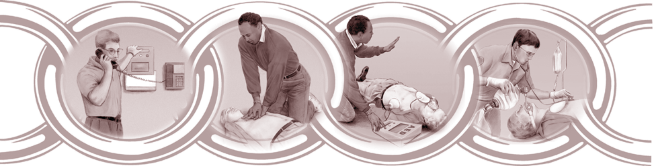

First Link: Early Access

The chain of survival begins with early access, in which the victim/patient is helped as quickly as possible. The resuscitation chain is initiated when a medical emergency is recognized and the emergency response system is activated.

Second Link: Early CPR

The next link in the chain of survival is early initiation of basic CPR. Basic CPR should be started immediately after cardiac arrest is recognized and should coincide with efforts to gain access to and activate the EMS system. The value of early CPR is that it can buy time for primary cardiac arrest patient by producing enough blood flow to the central nervous system and the myocardium to maintain temporary viability.

Third Link: Early Defibrillation

The purpose of early defibrillation is to reestablish a normal spontaneous rhythm in the heart. The rationale for early defibrillation emerges from data that demonstrate that almost 85% of persons with ambulatory, out-of-hospital, primary cardiac arrest experience ventricular tachyarrhythmias during the early minutes after collapse. The placement of AEDs in the hands of large numbers of trained rescuers may be the key intervention for increasing survival from out-of-hospital cardiac arrest.

Fourth Link: Early Advance Life Support

In many instances CPR and defibrillation alone doe not achieve or sustain resuscitation. The unique interventions of early advanced cardiac life support link – endotracheal intubation and intravenous medication – are necessary to further improve the chances of survival.

Source: Statement on the Chain of Survival, AHA
www.americanheart.org/presenter.jhtml?identifier=30120022

Pediatrics

Each link in the Pediatric Chain of Survival must be strong to maximize survival and decrease negative neurological outcomes.

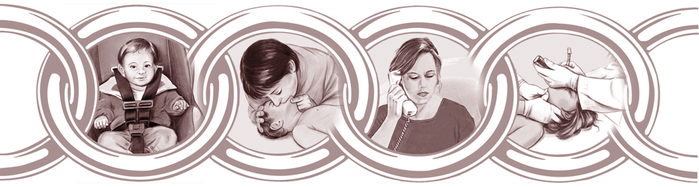

First Link: Prevention of arrest

In the United States, injury is the leading cause of death in children and adults 1 to 44 years of age. Healthcare providers are often in contact with prospective parents, parents, childcare providers, and teachers, as well as older children and adolescents. These contacts provide opportunities to educate children and those responsible for their care about the best way to reduce injuries.

Second Link: Early effective bystander CPR

When a child develops respiratory or cardiac arrest, immediate bystander CPR is crucial to survival. The greatest impact of bystander CPR will probably be on children with non-cardiac (respiratory) causes of out-of-hospital arrest.

Third Link: Rapid activation of the EMS

The lone Healthcare provider must provide 5 cycles of CPR when coming upon an unresponsive child be fore activating the emergency response system. When the collapse is witnessed, the lone healthcare provider must first activate the emergency response system and return to the child and begin CPR.

Fourth Link: Early and effective advanced life support

As in the Adult Chain of Survival, advanced life support provides the unique interventions (endotracheal intubation and intravenous medication), critical to improving the chances for survival.

Source: AHA BLS for Healthcare Providers Textbook, 2001

SPECIAL CONSIDERATIONS WHEN PERFORMING CPR

✰ Victim and Rescuer Safety

- Scene Safety – First ensure that both you (the rescuer) and victim are in a safe place. For example, if the victim is near water or a burning building, move the victim.

Note: In case of trauma, do not move the victim unless it is necessary to ensure the victim’s or your safety.

- Rescuer Safety – There is a low potential for acquiring infectious disease during CPR.

- Standard Precautions – “Occupational Safety and Health Administration (OSHA) requires that healthcare workers use standard precautions in the workplace when there is any exposure to blood or bodily fluids. Standard precautions include using barrier devices or bag-mask systems, gloves, and goggles.” BLS for HCP Textbook, 2006.

✰ Cricoid Pressure (Sellick’s technique)

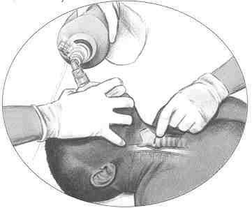
- Application of pressure to the unresponsive victim’s cricoid cartilage.

- Pressure pushes the trachea posteriorly, compressing the esophagus against the cervical vertebra.

- Goal: to prevent gastric inflation during positive-pressure ventilation of unresponsive victims (reducing the risk of vomiting and aspiration).

- Technique must be used only when an extra rescuer is present (one is not assisting with breathing, compressions or defibrillation).

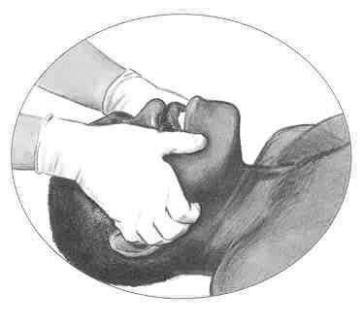
✰ Head, Neck, or Spine Injuries

- Jaw Thrust – maneuver where the jaw is lifted without tilting the head. Used when cervical spine injury is suspected.

Note: “Because maintaining a patent airway and providing adequate ventilation is a priority in CPR, use a head tilt-chin lift if the jaw thrust does no open the airway.”

- Log Roll – If you suspect trauma or if the victim has sustained trauma to the head and neck, and it is necessary to move the victim, turn the victim as a unit to avoid twisting of the neck or back.

✰ Agonal Gasps

- May occur in the first minutes of sudden cardiac arrest (SCA)

- Not considered “adequate breathing”\

- Rescuer must provide victim breaths

✰ Recovery Position

- Modified lateral position that maintains the alignment of the back and spine while
allowing rescuer to observe and maintain access to the victim.

- Victims must have adequate breathing.

- Not recommended in infants and small children as this position may block the airway if the head is not adequately supported.

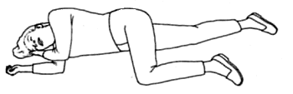

CPR SEQUENCE FOR ADULTS

1-Rescuer CPR

1. Assess for unresponsiveness and quickly make sure the scene is safe.
2. Phone 9-1-1 or other emergency response number & get the AED if available.
(If you are by yourself & no help is available)
- Open the airway (head tilt-chin lift or, if suspected trauma, jaw thrust)

Head tilt-chin lift Jaw Thrust
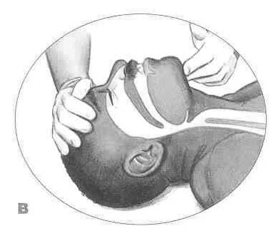

- Assess breathing (look, listen, and feel) (At least 5 seconds and no more than 10 seconds)

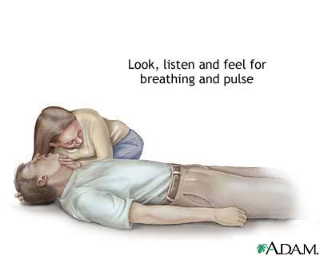

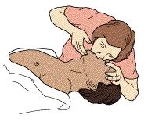
- Provide 2 breaths if no adequate breathing is noted (1 second each breath)

- Check for pulse (carotid). Take at least 5 to10seconds to check.

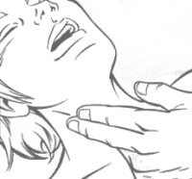

- If no pulse, perform 5 cycles of chest compressions and ventilations (at a rate of approximately 100 compressions per minute with a compression-ventilation ratio of 30:2).
▪ Hand position: On the breastbone at the nipple line with the heel of one hand on top of the first.
▪ Straighten arms, keep shoulders over hands.
▪ Push hard and fast, straight down on the victim’s breastbone (1 ½ to 2 inches in depth).
▪ Allow for the chest to recoil (re-expand completely) at the end of each compression (allows more blood to refill the heart between compressions).
▪ 30 compressions in less than 23 seconds

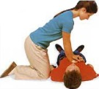

Note: Minimize interruptions in chest compressions to less than 10 seconds. In two- person rescue, be sure to determine if your colleague is compressing hard, fast, and deep enough to feel for a pulse.

2-Rescuer CPR with AED

- First rescuer is performing CPR and second rescuer arrives at the scene with the AED and puts the AED beside the victim.
- First rescuer continues chest compressions until the pad is applied. Second rescuer turns on the AED and follows the prompts.
▪ Applies pads to victim’s bare chest.
▪ Attaches connector to the AED
▪ Clears” the victim and lets the AED analyze heart rhythm.
▪ Presses the shock button (as prompted)
- Second rescuer will assist with CPR
▪ Takes over breathing, using a bag mask.
- First rescuer continues with chest compressions (30 compressions in less than 23 seconds). First rescuer pauses to allow second rescuer to provide 2 breaths.
▪ Completes 2 cycles before calling for a switch
- First rescuer calls for a “switch” (completes compressions before moving to taking over breathing). First rescuer indicates a switch by stating “Switch, 2, 3, 4, 5, etc.”
- Second rescuer completes providing the breaths and moves over to the chest of the victim.

Important:

- There should be minimal interruptions when rescuers are switching places.
- When an advance airway is in place (Endotracheal tube, Laryngeal Mask Airway [LMA]):
▪ Compression rate is approximately 100 per minute
▪ Ventilation rate approximately 1 breath every 6 to 8 seconds (8 to 10
breaths per minute)
▪ Do not pause chest compressions to provide breaths

AUTOMATED EXTERNAL DEFIBRILLATOR

Key Concepts

The most common initial rhythm in witnessed sudden cardiac arrest is ventricular fibrillation (VF). When VF is present, the heart quivers and does not pump blood.

The time from collapse to defibrillation is the single greatest determinant of survival from cardiac arrest.
Public Access Defibrillation expands the routine use of AEDs within the community to the broadest number of rescuers while maintaining safety.
The purpose of an AED is to provide the earliest possible defibrillations to victims of ventricular fibrillation (or ventricular tachycardia without signs of circulation).

STEPS OF AED OPERATION:

- Place the AED by the victim’s left ear. | 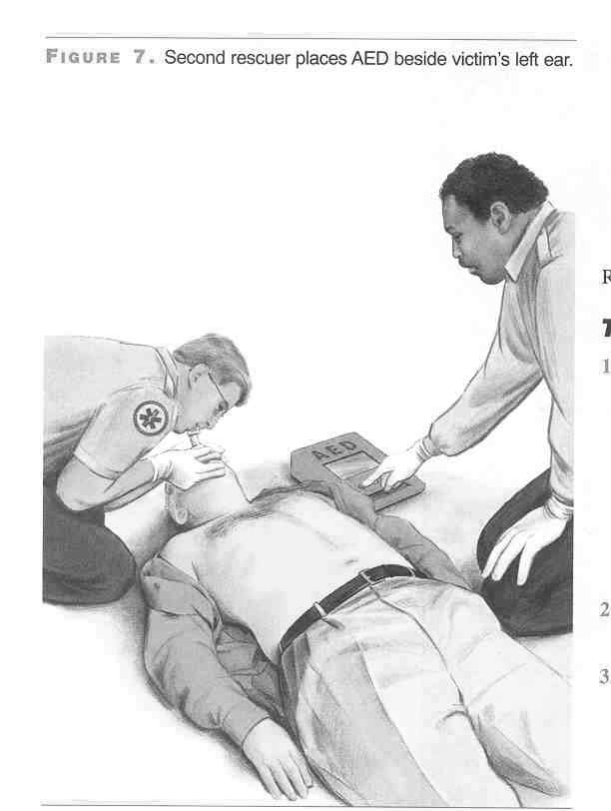
- Operator turns AED on and follows prompts. | 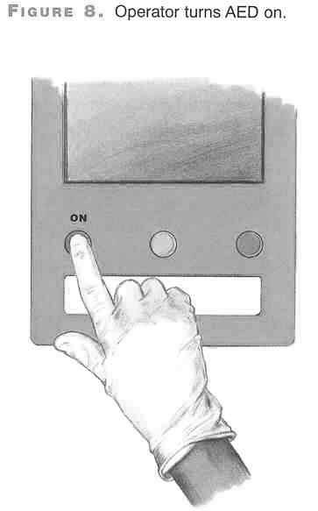

- Attach pads to the victim’s bare chest. The AED will then analyze the rhythm.  Note: Proper AED electrode placement can be achieved by viewing the illustration on the surface of the AED electrode pads. One pad is placed in the upper right sternal border directly below the clavicle. The other pad is placed lateral to the left nipple, with the top margin of the pad a few inches below the axilla. | 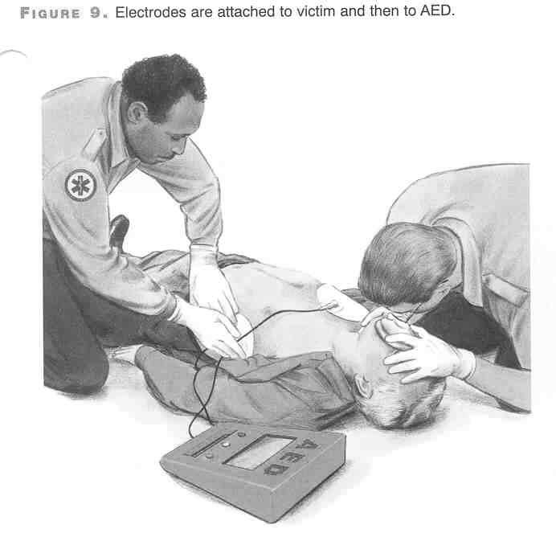
- If a shock is indicated, the operator will make sure that no one is touching the patient prior to discharging the paddles. This procedure is repeated every time a shock is indicated. | 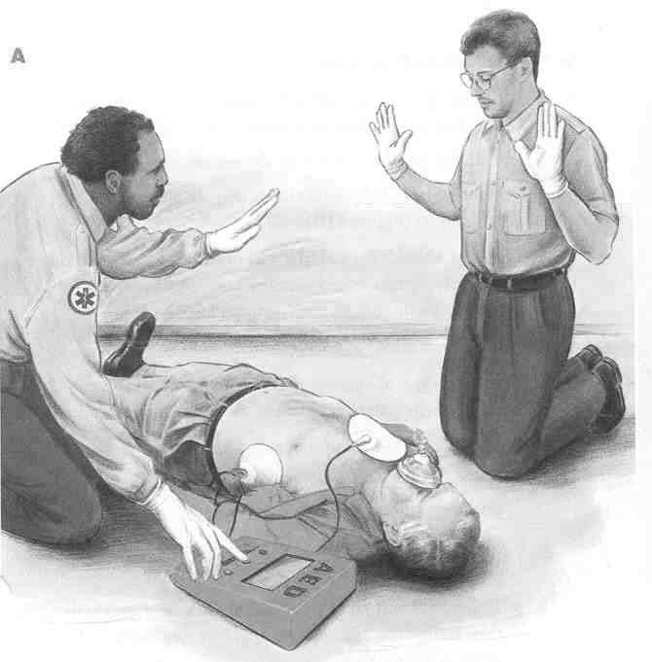
- The operator presses the “SHOCK” button and the pads are discharged. The victim’s muscles will jerk when the shock is delivered. | 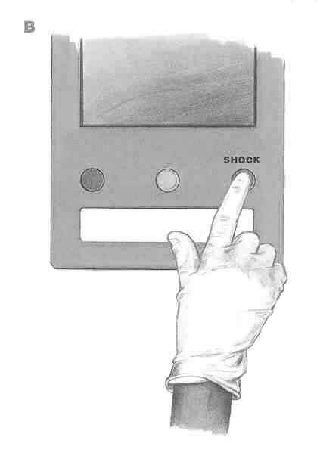
- Start CPR immediately after shock delivery beginning with chest compressions.  Note: Keep pads on the victim. | 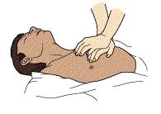

SPECIAL CONSIDERATIONS WHEN UTILIZING AEDs:

1. Use AED only when the victim is unresponsive, not breathing, and does not have a
pulse.

2. If the victim is lying in water, move the victim to a dry place and dry off the
chest prior to pad placement.

- If the victim has a permanent pacemaker or implanted defibrillator, place the AED
pad at least 1 inch to side of the implanted device.

- If the victim has a transdermal medication patch, remove the patch and wipe area
clean prior to pad placement.

RELIEF OF CHOKING
Key Concepts

Early recognition of airway obstruction is the key to successful outcome.

If a victim is pregnant or obese, perform chest thrusts instead of abdominal thrusts.

Use abdominal thrusts to relieve choking in adults and children over 1 year of age.

Do not use abdominal thrusts to relieve choking in infants.

If you find a responsive choking victim lying down, perform abdominal thrusts with the victim lying down.

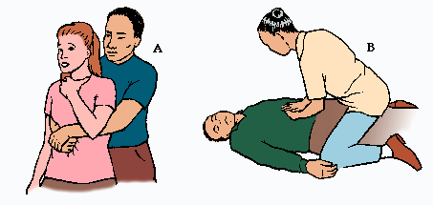

Abdominal Thrust Abdominal Thrust with victim
on the ground

Universal sign of choking

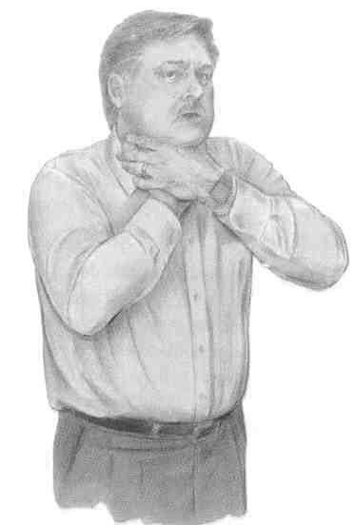

Sequence of Steps to Relieve Choking for both Adult and Child

Conscious Victim
  - Assess if the victim needs help (i.e. universal sign of choking, unable to speak, poor or no air exchange, etc.)
  - Stand/kneel behind the victim and put your arms around the victim’s waist.
  - Make a fist with one hand. Bring the thumb side of your fist against the victim’s abdomen (between the xiphoid process and the belly button).
  - Grasp your fist with the other hand and press into the victim’s abdomen with a quick upward push (thrusts).
  - Repeat abdominal thrusts until the object is expelled or the victim becomes unresponsive.

Unconscious Victim

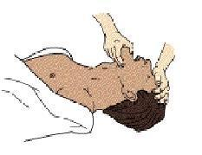
- If the victim was initially conscious and became unconscious, assist the victim to the ground.

- Activate the emergency response system.

- Open the victim’s airway and remove the object if you see it.

- Begin CPR.

Note: If you find that a victim that is already unconscious, activate the emergency response system and begin CPR.
You have successfully opened the airway in the unresponsive victim if you feel air movement and the chest rises when you give breaths.

After Relief of Choking in the unconscious victim:

1. Give 2 breaths.

2. Check pulse

3. If pulse and breathing is absent:
▪ Begin chest compressions
▪ Attach the AED

4. If pulse and breathing is present, place victim in the recovery position.

Note: Encourage victim to seek immediate medical attention to ensure that the
victim does not have a complication from abdominal thrust.

PEDIATRIC BASIC LIFE SUPPORT

Key Concepts

For Healthcare Providers performing CPR, the AHA age guidelines for infants is from newborn (0 yr) to 1 year of age.

For Healthcare Providers performing CPR, the AHA age guidelines for a child is from 1 year of age to puberty.

Puberty is defined by the presence of secondary sex characteristics (i.e., breast development in girls and armpit hair in boys.

When giving breaths to children, the volume should be enough to make the child’s chest rise.
Rescuers may need to try a couple of times to give a total of 2 breaths that make the victim’s chest rise.

Infants and children who develop cardiac arrest often do not have enough oxygen delivery to the brain and heart and other vital organs even before the heart stops pumping blood. It is very important to give effective breaths for infants and children during CPR.

For very small children, you have the option to use either 1 or 2 hands for chest compressions.

If the infant or child’s heart rate falls below 60 beats per minute with signs of poor circulation, start CPR. (Take at least 5 seconds and no more than 10 seconds to check and then calculate the pulse).

If you are a lone rescuer and you find an unresponsive child, start CPR (about 5 cycles; Compression to ventilation ratio of 30:2) before activating the emergency response system.

If the child collapses suddenly, the lone healthcare provider should follow the adult sequence. He/she must activate the emergency response system (and get the AED if available) first, then return to the victim to use the AES as soon as possible and begin CPR.

In an out-of-hospital setting, the healthcare provider should provide 5 cycles of CPR for a child before using the AED.

Compression to ventilation ratio changes to 15:2 for 2 rescuer CPR.

The 2 thumb-encircling hands technique is the preferred 2-recuer chest compression technique when physically feasible. The technique produces better blood flow and more consistently results in appropriate depth or force of compression and may generate higher blood pressures. (AHA 2005 Guidelines)

CHILD CPR (1 Yr. Old – Puberty)

1 Rescuer CPR

Establish unresponsiveness | - If no response, shout for help  - If someone responds, send that person to activate the emergency response system (call 911) and get the AED
A (Airway) | - Open the airway  - Head-tilt, chin lift or Jaw-thrust
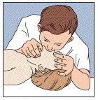  B (Breathing) | - Check for breathing (take at least 5 seconds and no more than 10 seconds)  - If no breathing, give 2 breaths (volume must be sufficient to make the chest rise)  - 1 second per each breath
C (Circulation)  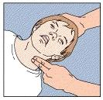  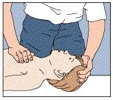 | - Check pulse (Carotid)  - Take at least 5 seconds but no more than 10 seconds  - If there is no pulse or if the heart rate is less than 60 beats per minute with signs of poor circulation, begin chest compressions  - Hand position: nipple line, lower half of the sternum  - Compression to ventilation ratio is 30:2  - Push hard, push fast at the depth of 1/3 to ½ the depth of the chest with the heel of one hand at the lower half of the sternum  - Perform 5 cycles at the rate of 100 compressions per minute  - After 5 cycles, if no one has responded, activate the emergency response system.

2-Rescuer CPR

Sequence of actions follows 2-Rescuer CPR for the Adult with the exception that the ratio of compression to ventilations is 15:2.

CHILD AED

Steps of AED Operation:

After 5 cycles or about 2 minutes of CPR, use the AED. Put the AED next to the child and follow prompts.

- Turn on the AED.

- Apply the appropriate pediatric AED pads to the child’s bare, dry chest.
(May use adult pads if child pads are not available).
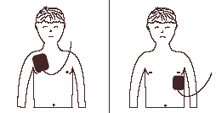

Note: Always follow manufacturer’s recommendation for pad placement.

- Plug in connector next to flashing light.

- Ensure that everyone is standing clear and not touching the child.

- Let the AED analyze the heart rhythm (or push the button marked “analyze”).

- Deliver a shock by pushing the shock button if prompted by the AED.

- Start CPR immediately after shock is delivered beginning with chest compressions.

INFANT CPR (0 to 1 Year of Age)

1-Rescuer CPR

Make sure that the scene is safe for you and the infant. Place infant on a flat, firm surface.

Establish unresponsiveness | - Tap baby’s foot.  - If unresponsive, shout for help.  - If someone responds, send him to activate the emergency response system.
A (Airway) | - Open the airway  - Tilt head back to a neutral or sniffing position  - Head-tilt, chin lift
B (Breathing)  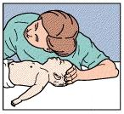  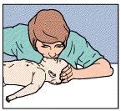 | - Check for breathing (take about 5 seconds but no longer than 10 seconds).  - Look for rise and fall of the chest  - Listen for air escaping during exhalation  - Feel for air on your cheeks  - If no breathing, give 2 breaths (each over 1 second)  - Make sure the volume is enough to make the chest rise.  - Methods: Mouth to mouth and nose  Mouth to mouth

C (Circulation)  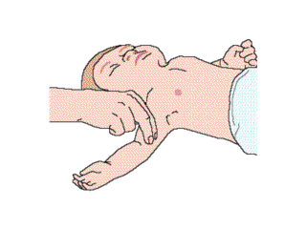  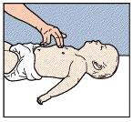 | - Check pulse (Brachial Artery) using the 2 fingers (index and middle) to palpate on the inside of the infant’s upper arm, between the shoulder and elbow.  - Take about 5 seconds but no longer than 10 seconds.  - If no pulse or if heart rate is less than 60 beats per minute, begin CPR  - If the infant has a pulse (greater than 60 beats/minute) but is not breathing, provide rescue breaths of 1 breath every 3 to 5 seconds.  - Using 2 fingers (index and middle fingers) position fingers 1 finger width below the nipple line.  - Push hard, push fast at the depth of 1/3 to ½ the depth of the chest  - Rate is 100 compressions per minutes  - Compression to ventilation ratio is 30:2  - 5 cycles of 30 compressions and 2 breaths  - Make sure you allow the chest to re-expand after each compression.

Note:
- Activate the emergency response system after 5 cycles of CPR, return to the infant and resume CPR.
- Activate the emergency response system first before providing CPR if you are alone and witness the collapse of an infant.

2-Rescuer CPR

Rescuer 1 | - Establishes unresponsiveness  - Sends 2nd rescuer to activate the emergency response system  - Opens the infant’s airway and checks for breathing.  - Provides 2 breaths (if infant is not breathing)  - Checks infant’s pulse  - If pulse is absent or pulse is less than 60 beats per minute with signs of poor circulation, begins CPR  - 30 compressions to 2 ventilations
Rescuer 2 | - Arrives at the scene  - Takes over chest compressions  - Uses 2 thumbs encircling hands technique  - Compression to ventilation ratio changes to 15:2

PEDIATRIC RELIEF OF CHOKING
Key Concepts

Small toys, balloons, food (i.e. hotdog, round candies, nuts and grapes) may be aspirated.

Foreign body airway obstruction should be suspected in infants and children who demonstrate sudden onset of respiratory distress associated with coughing, gagging, stridor (high-pitched sound) or wheezing.

Early recognition of airway obstruction is vital to successful outcomes.

“Back slaps” and Chest Thrusts” are the 2 maneuvers utilized to relieve choking in infants.

“Blind sweeps” are not performed in infants and children as this action may cause the object to be push back further into the throat causing further obstruction and injury.

When an infant becomes unresponsive, back slaps are discontinued CPR must be initiated.

Relief of Choking in a Child (Conscious or Unconscious)

Note: Follow sequence for Adult Relief of Choking with the exception of performing “blind finger sweeps.”

Relief of Choking in a Conscious (Responsive) Infant

Conscious (Responsive) Infant

1. Kneel or sit with infant in your lap.
2. Hold infant face down with head slightly lower than the chest.
Note: Support the baby’s head and jaw with your hand.
3. Deliver 5 back slaps between the shoulder blades.
4. “Sandwich” the infant using both your arms and turn infant to supine position.
Note: Make sure to turn the infant as a “unit” while carefully supporting
the head and neck.
5. Administer 5 chest thrusts (same position as chest compressions – 1 finger-width
below the nipple line)
Note: Rate of chest compressions is 1compression per second.
6. Continue with 5 back slaps and 5 chest thrusts until infant expels the object or
becomes unresponsive.

Back Slaps Chest Thrusts

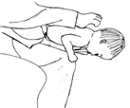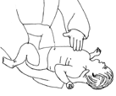

Unconscious (Unresponsive) Infant

When the infant becomes unresponsive, stop giving the back slaps & begin CPR:
1. Place infant on its back on a firm, flat surface (i.e. table)
2. Open the airway (head-tilt, tongue-jaw lift)
3. Look into the infant’s mouth (No blind finger sweep!)
4. Start CPR
Note: Each time you open the infant’s airway, look for the obstructing
object in the back of the throat. If you see an object, remove it.
5. Perform 5 cycles (about 2 minutes) of CPR, activate the emergency response
system.

