Creating a simple FLA file
To illustrate the basic steps of creating any FLA document, this tutorial guides you through the process in a simple tutorial. This short tutorial is just a sample of the workflow you'll use while authoring in Flash Professional. The first step is to create a new document:
- Choose File > New.
- In the New Document dialog box, Flash File (ActionScript 3.0) is selected by default. Click OK.
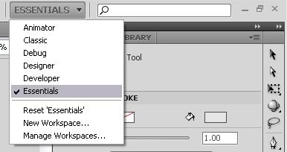
- Click the workspace drop-down menu in the upper right of the screen and select the Essentials workspace layout option (see Figure 2).
Figure 2. Choosing the Essentials option to see the workspace layout used by the tutorial
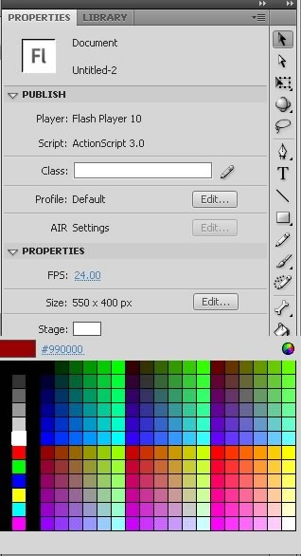
- Click the Properties tab in the upper right side of the user interface to view the Stage properties for the file.
- In the Property inspector, located by default vertically along the right side of the workspace, the Size button displays the current Stage size setting as 550 × 400 pixels (see Figure 3). The Background color swatch is set to white. You can change the color of the Stage by clicking the swatch and selecting a different color.
Figure 3. Property inspector showing the Stage size and background color
- Choose File > Save
- Choose a location for the file on your hard disk, name the file SimpleFlash.fla, and then click Save. Remember this location, because you'll need to find this directory at the end of this tutorial.

