Creating a symbol and adding animation
You can turn your new artwork into a reusable asset by converting it to a symbol. A symbol is a media asset that can be reused anywhere in your document without the need to re-create it. Symbols can contain images and animations along with other types of content.
- Click the Selection tool in the Tools panel (see Figure 7).
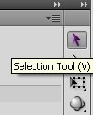
Figure 7. Tools panel with the Selection tool selected
- Click the circle on the Stage to select it. A bounding box selection appears around the circle.
- With the circle still selected, choose Modify > Convert to Symbol (or press F8) to bring up the Convert to Symbol dialog box (see Fig 8).
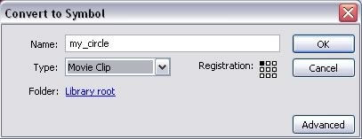
Note: You can also convert a graphic into a symbol by selecting it and dragging it into the Library panel.

Figure 8. Convert to Symbol dialog box
- Click OK. A square bounding box appears around the circle. You have now created a reusable asset, called a symbol, in your document. In this case, you created a movie clip symbol. (For more information about symbols, read the online documentation about them.)
If the Library panel is not open, choose Window > Library. The new symbol appears in the Library panel.

Animating the circle
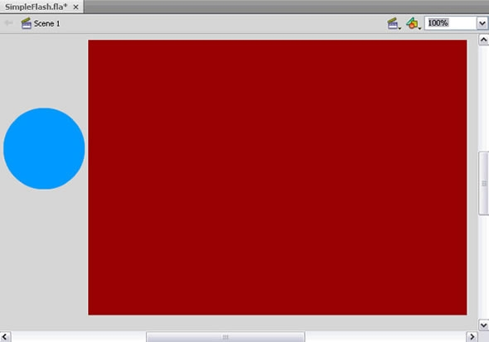
Now that you have some artwork in your document, you can make it more interesting by animating it to move across the Stage:
- Drag the circle to just left of the Stage area (see Figure 9).
Figure 9. Circle moved to the left of the Stage area
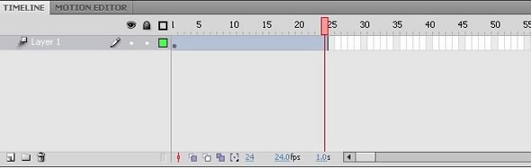
- Right-click the dot (also called the keyframe) on frame 1 of the Timeline and choose the Create Motion Tween option from the menu. Notice that the Timeline is automatically extended to frame 24 & the red marker (current frame indicator or playhead) is located at frame 24 (see Figure 10). This indicates that the timeline is ready for editing at 1 second—that is, at frame 24 when the frame rate is 24 fps.
Figure 10. Extended Timeline ready for editing on frame 24
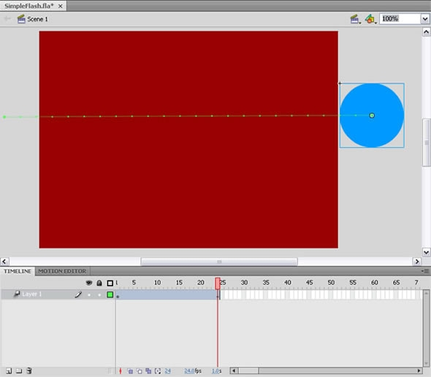
- Select the circle on the Stage and drag it to the right of the Stage area. This step just created the tweened animation. Notice the dot (keyframe) which appears at frame 24. Also notice the motion guide line showing the path of motion between frame 1 and frame 24 (see Figure 11).
Figure 11. A 24-frame animation showing the circle at the end of the animation on frame 24
- In the Timeline, drag the red playhead back & forth from frame 1 to frame 24 to preview the animation by scrubbing the Timeline.
- Add a change in direction in the middle of the animation by dragging the playhead to frame 12 and then moving the circle to another location on the screen. Notice the change in the motion guide line and the new dot on the Timeline at frame 10 (see Figure 12). The dots on the Timeline are keyframes which mark where (at what frame) objects change on the screen.
Figure 12. The tweened animation showing a change in direction at frame 12
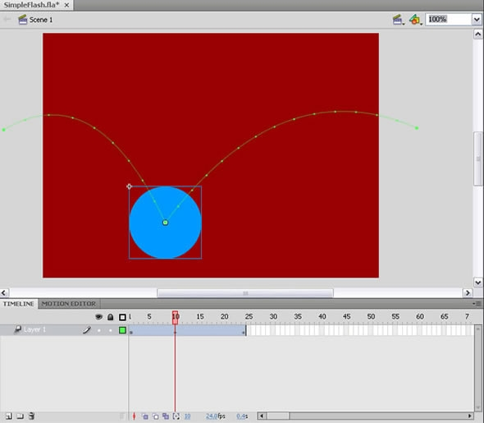
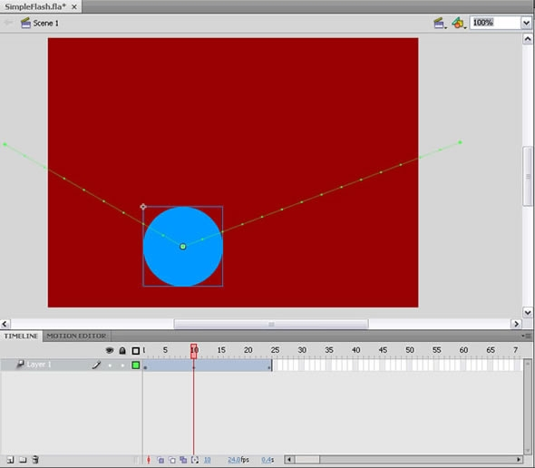
- Experiment with changing the shape of the motion guide path. Click the Selection tool in the Tools panel and then click a section of the motion guide line and drag it to bend the line shape (see Figure 13).
Figure 13. The tweened animation showing curves added to the motion guide line
- Choose Control > Test Movie to test the FLA file.
- Close the Test Movie window.

