Publishing your file
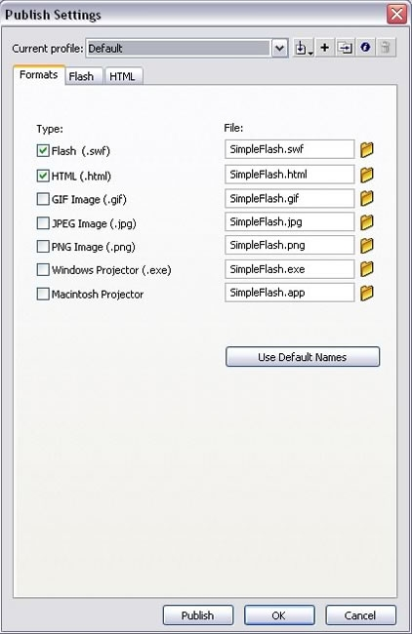
When you finish your FLA file, you are ready to publish it so it can be viewed in a browser. When you publish the file, Flash Professional compresses it into the SWF file format. This is the format that you place in a web page. The Publish command can automatically generate an HTML file with the correct tags in it for you.
To publish the FLA file and view the SWF in a browser:
- Choose File > Publish Settings.
- In the Publish Settings dialog box, select the Formats tab and verify that only the Flash and HTML options are selected (see Figure 14). This action causes Flash to publish only the SWF file and an HTML file. The HTML file is used to display the SWF file in a web browser.
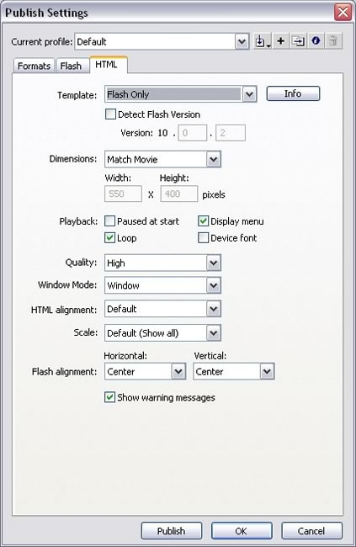
Figure 14. Flash and HTML options on the Formats tab
- In the Publish Settings dialog box, select the HTML tab and verify that Flash Only is selected in the Template pop-up menu (see Figure 15). This template creates a simple HTML file that contains only your SWF file when displayed in a browser window.
Figure 15. Choosing Flash Only from the Template menu
- Click OK.
- Choose File > Publish and open your web browser.
- Choose File > Open in the web browser.
- Navigate to the folder where you saved your FLA file. The SimpleFlash.swf and SimpleFlash.html files are there. Flash Professional creates these files when you click Publish.
- Select the file named SimpleFlash.html.
- Click Open. Your application displays in the browser window.
Congratulations! You have now completed your first FLA file.

