CURRENCY REMIX PROJECT INSTRUCTIONS
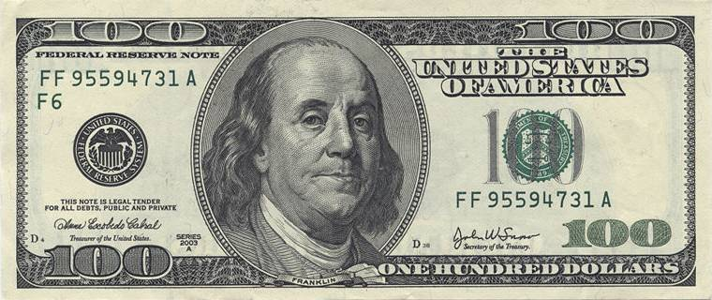

Create 1 paper currency design (front & back) & 1 coin currency design (front & back) for a country of your choosing. Research this country’s current design and then create an updated version for both coin and paper currency for your country. You may use the layout of the current currency but just changing colors around will not suffice.

Countries are usually known for something… structures, famous people, geography, political involvements, etc. Use your country’s history to help you in designing their new and improved currency.

These designs should be created using Image Editing Software. This project should be taken seriously… no pictures of explosions, convicts, anything questionable, etc. Once complete, compile the four images on a Word Document to be graded.

You will be graded on originality, craftsmanship/technical skill, composition, & following of directions.

