Editing with an Image Editor Activity Key
Using http://guides.hsl.unc.edu/content.php?pid=122104&sid=1049944 and the corresponding tabs across the tops, answer the following questions.
**A few hints when working with Photoshop: If tools or layers are not accessible or locked then either of the following measures must be followed – 1. Image menu > Mode > change to RGB Color 2. To unlock the background layer > double click on the layer and press enter**
1. Why is it recommended to work on a copied image of the original?
In case you make a mistake and want to start over
2. What does this tool do?
The Crop Tool allows you to remove parts of the image you do not want to appear
3. Where should my cursor be placed if I want to rotate the cropping box?
Just outside of one of the corner handles, where it turns into a curved cursor
- Open the Lincoln.gif picture in Photoshop and follow the cropping instructions. Crop out the bottom of the picture so the top button of his vest can no longer be seen and save as “cropped Lincoln.gif” and insert that picture here:
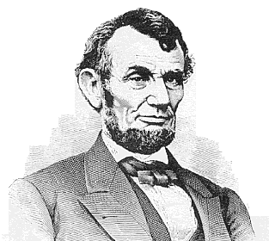
4. If I want to increase contrast which way should I move the first and last triangles in the Levels dialog box?
Move the left and right sliders toward the middle
5. What does Auto Color attempt to do?
Auto Color attempts to color correct images automatically by analyzing the highlights, shadows, and midtones of each channel
6. Use the Clone tool to remove the gray shading around Lincoln’s shoulders and save as “clone tool lincoln.gif” and insert here:
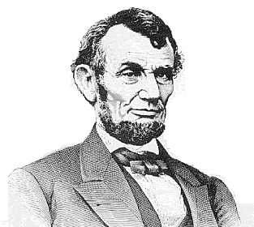
7. Under the “More Image Editing” tab, read the section entitled “Selection Techniques” and use the Polygon Lasso to copy and paste Lincoln’s left ear here:
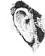
8. The Magic Wand Tool selects adjacent portions of the image based on color __brightness___. The higher the _tolerance__ entered in the Options palette, the more pixels are selected.
9. What does feathering do?
Gives a selection a softer edge
10. Read the “Working with Layers” section and open the original Lincoln image and select the layer containing Lincoln’s face & duplicate the layer and move it off center so it is obvious a new layer has been added. Save the layered picture as “layered Lincoln.gif” and insert here:
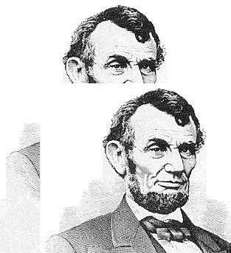
11. Read the “Adding Type” section and add any text to the layered Lincoln picture and save as “text lincoln.gif” and insert here:
