Activity 2 – Image Gallery or Photo Album
Assignment 1: Using a GUI Editor such as Dreamweaver, create an image gallery of a travel trip.
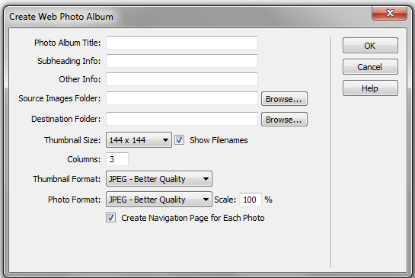
- Save six photographs into a gallery folder.
- In Dreamweaver, click on Commands and then Create Web Photo Album.
- Click in the Photo Album Title and name the photo album The Best of Alaska
- In the Subheading Info area key in Summer Trip 2011
- Browse the Source Images Folder and Click on the Alaska Images Folder
- Select the Destination Folder of the Dreamweaver Folder
- Change the Thumbnail Size to 144 x 144
- Select 3 Columns
- Click OK

Assignment 2: Using a GUI Editor such as Dreamweaver, create an image gallery of your choice following the directions above.
- Select a topic. Your topic may be an athletic team, place, animal or animals, or activity.
My topic is __________________________________________________
- Create an image gallery or photo album with at least 6 photos.

