Activity 1 – Rollover Buttons
Directions: Create the web page as shown using the rollover button option.
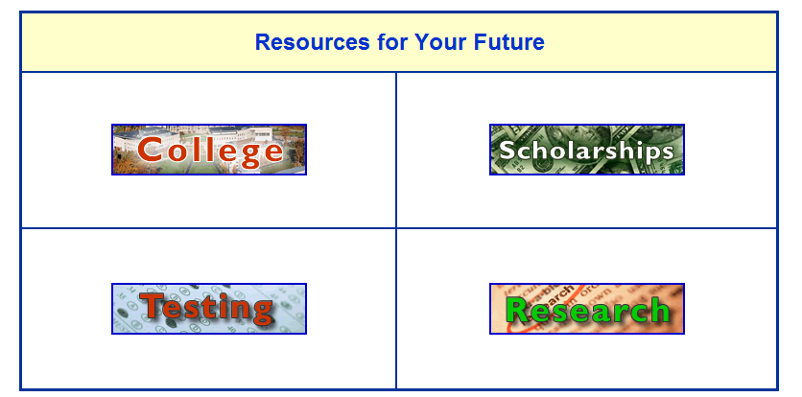
Instructions for Dreamweaver:
- Insert a table with three rows and two columns. Center the table vertically on the page. Each column should be 400 pixels wide. The top row is 60 pixels high and the middle and bottom rows are 165 pixels high.
- Merge the top row and center the title Resources for Your Future. Center the title horizontally and vertically and change the font style to Arial, heading size 2, and royal blue (#0033CC). Make the background of the cell light yellow (#FFFFCC).
- In the second row and first column insert an interactive image, rollover image. Name the Image College. Make the Original Image Activity_1_College_Button.gif. Make the alternate text: College. When Clicked, go to URL: http://www.collegebound.net
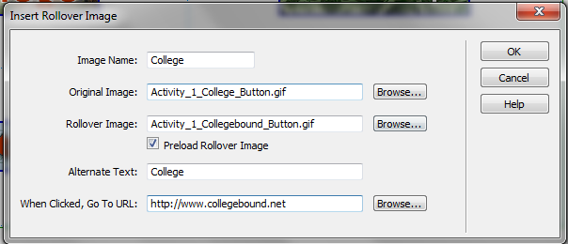
- Repeat Step 3 for the remainder of the buttons with the following settings:
  - Scholarships Button
    - Image Name: Scholarships
    - Original Image: Activity_1_Scholarship_Button.gif
    - Rollover Image: Activity_1_Fastweb_Button.gif
    - Alternate Text: Scholarship
    - When Clicked, Go To URL: http://www.fastweb.com
  - Testing Button
    - Image Name: Testing
    - Original Image: Activity_1_Testing_Button.gif
    - Rollover Image: Activity_1_SAT_Test_Button.gif
    - Alternate Text: Testing
    - When Clicked, Go To URL: http://www.collegeboard.org/
  - Research Button
    - Image Name: Research
    - Original Image: Activity_1_Research_Button.gif
    - Rollover Image: Activity_1_Galileo_Button.gif
    - Alternate Text: Research
    - When Clicked, Go To URL: http://www.galileo.usg.edu/welcome/
- Save the Page as Rollover_Buttons

