Activity 3 – Rollover Images
Directions: Create the web page as shown using rollover images from the interactive images option under the insert menu. You will insert the question image first followed by the answer image.
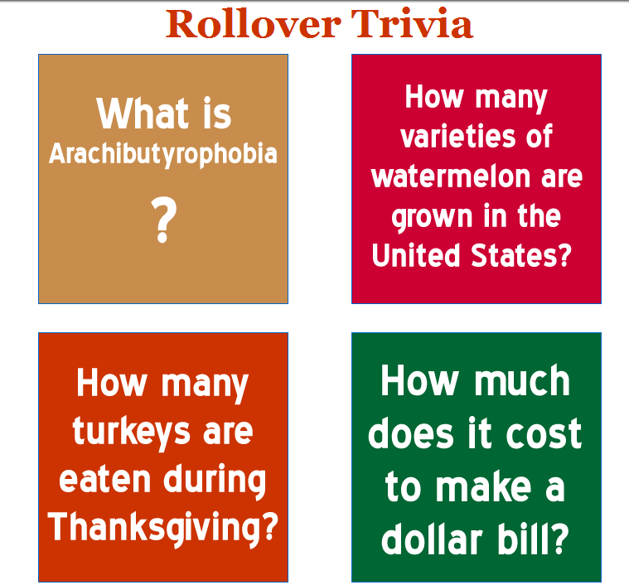
Instructions for Dreamweaver:
- Create a custom table using layout view found under the layout tab. Draw a 680 wide by 740 high table. Draw the table cells as follows:
  - Row 1: one cell - 680 wide x 74 high
  - Row 2: three cells – 302 wide x 302 high (right), 76 wide x 302 high (center), and 302 wide x 302 high (left)
  - Row 3: one cell – 680 wide x 34 high
  - Row 4: three cells – 302 wide x 302 high (right), 76 wide x 302 high (center), and 302 wide x 302 high (left)
  - Row 5: one cell – 680 wide x 28 high
- Switch to Standard View under the Layout Tab and use the align option under the properties to align the entire table to center.
- In Row 1, key in the text Rollover Trivia. Change the font to Georgia, size +6, and dark red (#CC3300). Center align the text vertically and horizontally in the cell.
- In Row 2, click in the first cell on the right. Click on the Insert option on the menu bar and select interactive images. Click on the rollover images. Name the rollover image PB. Browse and insert the Question 1 Image in the original image box and insert Answer 1 Image in the rollover image box. In the Alternate Text box, key in PB Q&A. Click OK. Click on the image and add a border in size 2.
- In Row 2, click on the last cell on the left. Click on the Insert option on the menu bar and select interactive images. Click on the rollover images. Name the rollover image Watermelon. Browse and insert the Question 3 Image in the original image box and insert Answer 3 Image in the rollover image box. In the Alternate Text box, key in Watermelon Q&A. Click OK. Click on the image and add a border in size 2.
- In Row 4, click on the first cell on the right. Click on the Insert option on the menu bar and select interactive images. Click on the rollover images. Name the rollover image Turkeys. Browse and insert the Question 4 Image in the original image box and insert Answer 4 Image in the rollover image box. In the Alternate Text box, key in Turkey Q&A. Click OK. Click on the image and add a border in size 2.
- In Row 4, click on the last cell on the left. Click on the Insert option on the menu bar and select interactive images. Click on the rollover images. Name the rollover image Dollar. Browse and insert the Question 2 Image in the original image box and insert Answer 2 Image in the rollover image box. In the Alternate Text box, key in Dollar Q&A. Click OK. Click on the image and add a border in size 2.
- Save the page as Rollover_Trivia. Preview the page in Internet Explorer and test the page. When you rollover the question, the answer should appear.

