Storyboard Project

Special note to teachers: Prior to this assignment students should have completed and selected an idea from Unit 3, Lesson 7: Brainstorming.

Directions: With your teachers help gather your materials (see the list below). Then follow the steps below to complete your first storyboard sketchboard using your favorite brainstorming idea from Lesson 7.

Materials & Equipment:
- Bulletin board paper. To create the sketch-board.
- Post-It notes. Try to find the ‘Super Sticky’ ones as they stay in place when we roll up the sketch-board.
- You can color code them. Example: use green ones to identify ideas you like, pink for ideas you hate, and yellow ones to remind you need to do something.
- Marker pens. Sharpies fine tip, the other ultra fine. Students can use a red marker for bringing attention to something, such as movement or errors. A highlighter pen always comes in useful to increase attention to important areas.
- Sticky dots or double sided tape - for sticking sketches to the sketch-board.
- Blu-Tac or double sided tape -for sticking your sketch-board to the wall.

Step 1 – Set up your Storyboard Sketchboard
Roll out your bulleting board paper. Ideally you should have a piece that is about 6-8 feet. Stick your bulletin board paper to a wall with lots of Blu-Tac or double sided tape – the sketchboard gets progressively heavier and may fall off the wall if don't use enough sticky stuff. If there aren't enough walls in your classroom use the floor or a table but you will have to carefully roll up your sketchboard at the end of class.
Step 2 – Inputs
Gather any information that you’ll need to guide you through your sketching, whether it’s research you've done on the internet, flowcharts, scope items, user needs or personas or any inspiration that you think will help, and stick these to the left hand side of your sketchboard. A good example of items would also be a list of what the main ideas of your website will be. For instance if your site is a restaurant you might want to include menus, relevant pictures, types of foods, relevant graphics, etc.

Step 3 – Thumbnail sketches
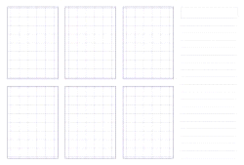
- Start with a 6-up template (see handout) and give yourself a fixed amount of time (say 10 to 15 minutes) to draw as many different versions of the interface you’re going to work on.
- Try out any idea that springs to mind. Don’t like the vertical navigation? Try horizontal tabs. Too many photos on the home page? Try a slideshow.
- Use the lined area on the right of the page for text annotations, notes-to-self and anything else that helps to communicate your idea. Fine detail isn’t important here (as you’ll see from the following photo) – the point is to get your ideas down on paper. Don’t know where to start? – just do something, then change it.
- Once you’ve done your thumbnail sketches take a step back and think about which one works best. Maybe you like some parts of one, and parts of another. Do another thumbnail sketch if this is the case, then refine it in the next step.

Step 4 – Refinement sketch
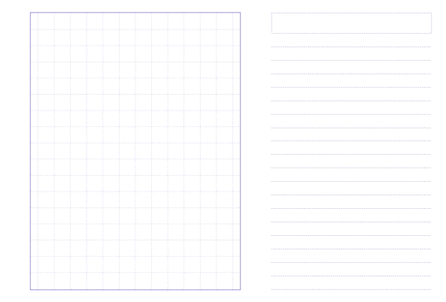
- Now take a 1-up template (see handout) and start refining your preferred thumbnail sketch.
- Again, give yourself a fixed amount of time to complete the task, say 10 minutes.
- The extra space in the 1-up template allows you more freedom to think about details such as visual weight, headings, content and functional elements.
- Again, you’re trying to communicate how an interface may work, so the details are more important than tidiness of your sketch.

Step 5 – Stick up your sketches
- Once you’ve completed your refinement sketch, stick it to your sketchboard, then think about what problem you’re going to tackle next.
- Return to step 3 and repeat until you’ve sketched everything you needed to when you set out.
- Try to keep your sketches in logical groups – use a Post-It note to give your group a heading.
- Once you’re happy with the position and grouping of your sketches, replace the Post-It headings with inked ones – a big chisel tip Sharpie works well (just make sure the ink doesn’t bleed through the brown paper and onto the wall!)
Step 6 – Evaluate, then evaluate again
- Now that you’ve fleshed out your ideas, it’s time to test your assumptions and gather real-time feedback.
- Ideally, you’ll do this more than once.
- Have a review session with your group first, then have other groups evaluate your sketchboard.
- Explain to your classmates that your feelings won’t be hurt if the sketches are criticized – indeed, this is the object of the exercise.
- If you’re feeling particularly brave, start a ‘black-hat’ session where everyone in your class tries their hardest to point out the shortcomings of your sketches.
- These quick insights will challenge your assumptions, encouraging creative speculation and innovative thinking.
- You can take note of their feedback using sticky notes or highlighters.

Reality Check:
- In the real world you would take your sketchboard and pop it in a tube and make our way to our client’s offices where you would take it over to the nearest wall (don’t forget the Blu-Tac) and show it to them. They would then give you feedback and tell you what they like and dislike.
- You would also explain to your client that you’re not trying to sell an idea and that feelings won’t be hurt if the sketches are criticized – indeed, this is the object of the exercise.
- Your clients will appreciate being involved at this stage, and it makes for an enjoyable and productive session – so much better than emailing wireframes back and forth.
- During the evaluation sessions, annotate your sketches, use Post-It notes, and amend or create new sketches as required to capture feedback, suggestions and corrections.

