
HTML Page Assignment– Part 3
Creating a Frameset
1. Create a frameset that will display your “heading.html” page in the “Top” frame, the “navigation.html” page in the “Left” frame, and the “main.html” page initially displayed in the “Main” frame.
<html>
<head>
<title>My Page</title>
</head>
<frameset rows="100,*">
<frame src="top.html" NAME="top">
<frameset cols="160,*">
<frame src="left.html" NAME="left">
<frame src="right.html" NAME="right">
</frameset>
</frameset>
<body>
</body>
<noframes>
<a href="your main page.html">Click Here</a>
</noframes>
</html>
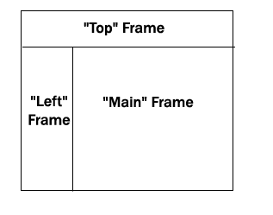
2. Save the frameset as “index.html” within your "All About Us" folder. Use the “index.html” file created in class as the example for the frameset.
<html>
<head>
<title>My Page</title>
</head>
<frameset rows="100,*">
<frame src="top.html" NAME="top">
<frameset cols="160,*">
<frame src="left.html" NAME="left">
<frame src="right.html" NAME="right">
</frameset>
</frameset>
<body>
</body>
<noframes>
<a href="your main page.html">Click Here</a>
</noframes>
</html>

3. Add hyperlink tags to your button images in the “navigation.html” page so that these pages open within the “Main” frame (Using the attribute of target=”Main” within the link tag.)
Example: <a href = “biography.html” target = “Main”>
RESIZING:
(1) You may need to change the percentage values of the rows and/or columns so that the frameset displays the pages correctly.
(2) You may also need to change the image size of your title graphic or buttons by using the width and height attributes within the <img src> tag.
What to turn in:
• Print the source code for each page, including the frameset. Staple together all the pages and turn in.

