
HTML Table Activity
Fill out the missing pieces in the code by using the table below as your guide.
<______>
<table _________="5" __________="blue" _________="6" _____padding="4" _______="500">
<________>My Schedule</__________>
<tr><_____>Period</th><th>Class</_______></tr>
<tr><td align="_______">1</td><td>Senior English</td></tr>
<___><td align="center">_____</td><td>Advanced Marketing</______></_____>
<tr><td align=__ _______ __>3</____><____>AP Calculus</td></tr>
<tr><td align="center">4</td><td>Fundamentals of Web Design</td></tr>
<____><td ________="2">Lunch</td></tr>
<tr><____ align=__center__>6</td><td>__________</td></tr>
<tr><td align="center">_____</td><td>AP Economics</td></____>
</_______>
</html>
6
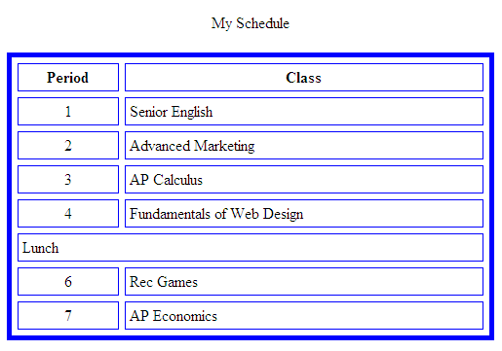
500
5
4

