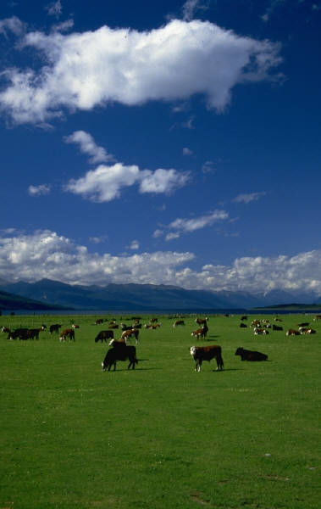
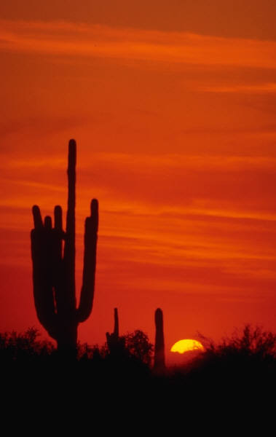
Earth Biomes
Web Project
DIRECTIONS:
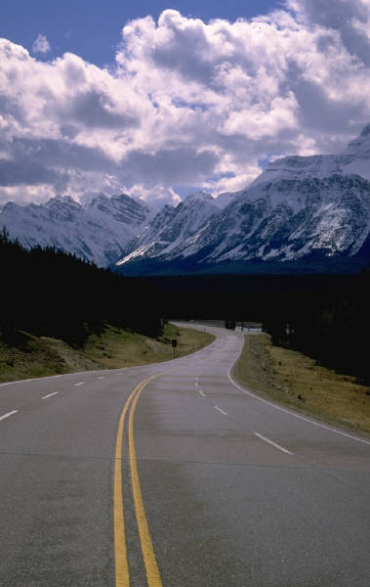
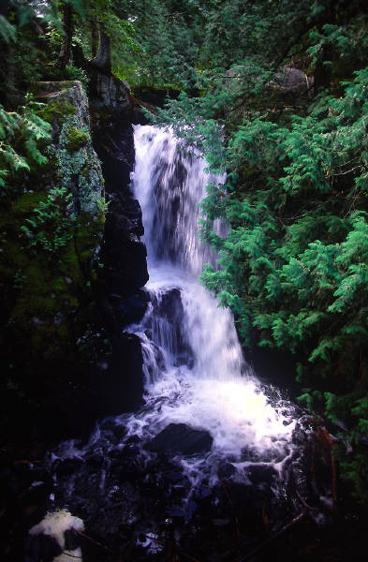
You will be creating a website using an HTML editor (Microsoft Publisher) that highlights the 5 major biomes of the earth. You will not need to know HTML to complete this assignment.
Assume your audience knows nothing about biomes. Each page of your website will highlight a biome. Information to include on each page is Climate/Location, Vegetation, Animals, Health Issues/Dangers, and any other pertinent information. Be sure to include graphics, charts, videos, and any other visual aids you think would help your website become more visually pleasing. You will create 6 pages in total (5 biomes & homepage).
Copyright laws are very important in web design. Include references of where you obtained information or images on each page. You will present this project to the class.
GRADING CRITERIA:
Your grade will be based on:
Following of Directions (10pts) Creativity (10pts)
Grammar/Spelling (10pts) Formatting (25pts)
Information Accuracy (20pts) Copyright Info (10pts)
Presentation (15pts) ________ out of 100

