
Sample Form Example

Example:
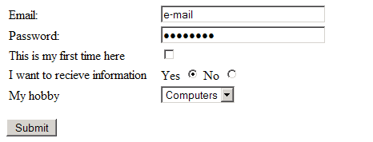

Example code:
<html xmlns="http://www.w3.org/1999/xhtml">
<head>
<meta http-equiv="Content-Type" content="text/html; charset=iso-8859-1" />
<title>Untitled Document</title>
</head>

<body>
<form id="form1" name="form1" method="post" action="mailto:brandycollin@hotmail.com">
<table width="1183" border="0">
<tr>
<td width="185">Email:</td>
<td width="982"><label>
<input name="textfield" type="text" value="e-mail" size="30" maxlength="30" />
</label></td>
</tr>
<tr>
<td>Password:</td>
<td><label>
<input name="textfield2" type="password" value="password" size="30" maxlength="10" />
</label></td>
</tr>
<tr>
<td>This is my first time here </td>
<td><label>
<input type="checkbox" name="checkbox" value="checkbox" />
</label></td>
</tr>
<tr>
<td>I want to recieve information </td>
<td>Yes
<label>
<input name="radiobutton" type="radio" value="radiobutton" checked="checked" />
No
<input name="radiobutton" type="radio" value="radiobutton" />
</label></td>
</tr>
<tr>
<td>My hobby </td>
<td><label>
<select name="select">
<option selected="selected">Computers</option>
<option>Pets</option>
<option>Movies</option>
<option>Music</option>
<option>Reading</option>
<option>Sports</option>
</select>
</label></td>
</tr>
</table>
<p>
<label></label>
<input type="submit" name="Submit" value="Submit" />
</p>
</form>
</body>
</html>

