Left Frame Activity
Directions: Use frames to design the page below.
- Create a page with a left frame and main frame (In Dreamweaver, click on the frames tab and select the option for left frame)
- Click on the outside border of the frames and save the entire frameset as ACTIVITY2_FRAMESET.htm
- Click on the left frame and save it as ACTIVITY2_LEFT.htm
- Click in the main frame and save it as ACTIVITY2_CONTENT.htm
- Access the graphics folder and insert the Navigation Image into the left frame.
- Add the text, and images (Marina Image and Beach Image) as shown to the content frame. Left align the marina image and right align the beach image.
- Save all frames and the entire frameset.

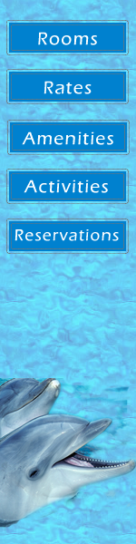 | Holiday Harbor Hotel & Marina  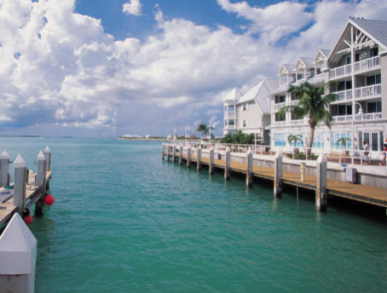  The Holiday Harbor Hotel & Marina is located in Key West, Florida. The hotel offers luxurious rooms at affordable rates on a beautiful scenic beach. Whether you are planning an extended vacation or weekend retreat you will find what you are looking for on the beautiful shores of Key West.  Rich in history and recreational opportunities, the Keys offer something for the entire family. Dive or snorkel in the pristine waters or fish for over a 200 species of game fish just off the shore or in the gulf stream.  Visit historic landmarks such as Mile Marker Zero or the Famous Hemingway House. Dine in restaurants owned by the stars or under the stars. Relax in a beach chair and soak up the sunshine.  Holiday Harbor Hotel & Marina is your ideal vacation destination. For more information, call 1-800-HOLIDAY!  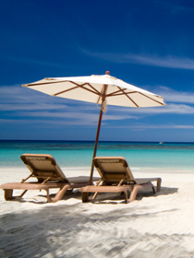  Holiday Harbor Hotel & Marina – 100 Holiday Avenue, Key West, FL 98000  1-800-HOLIDAY ▪ www.holidayharbor.com

