Membership Form Activity
Directions: Use the form tools to design the form below. Follow the directions on the next page. Preview the form using a browser and press the print screen button on the keyboard to copy the page. Open MS Word. Make the page orientation landscape. Paste the page into Word and resize to fit the entire page. Add your name in the header and print.
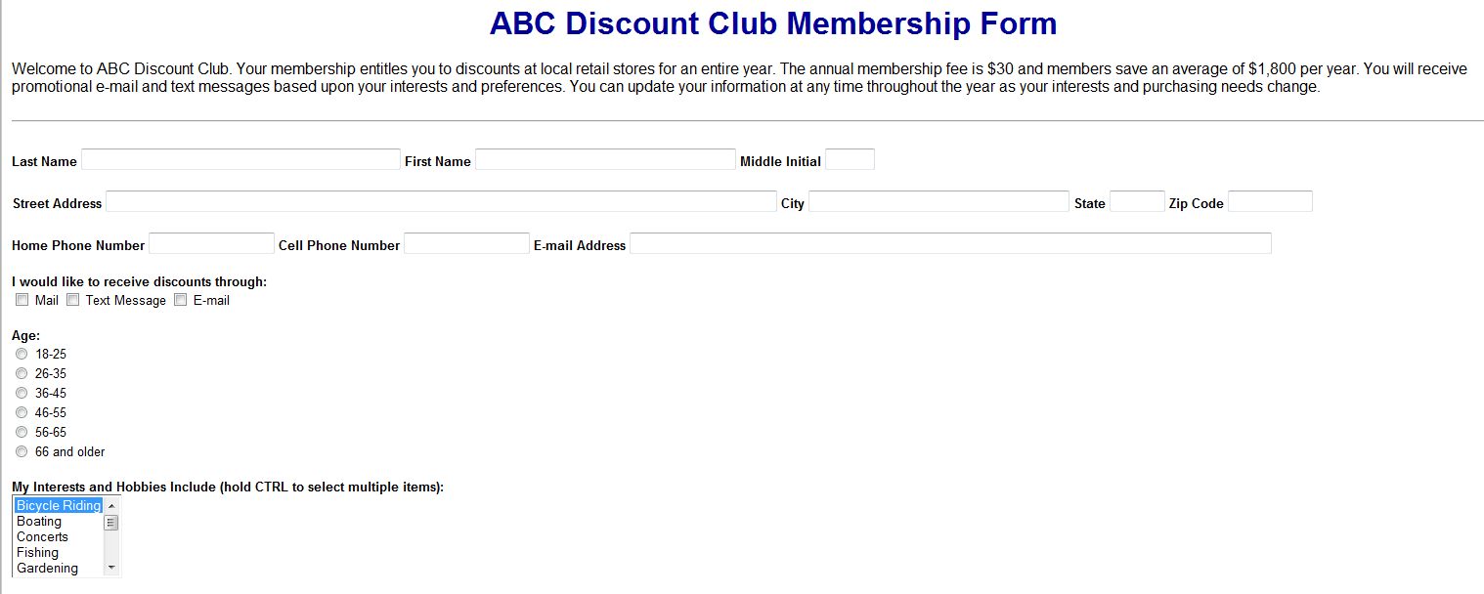
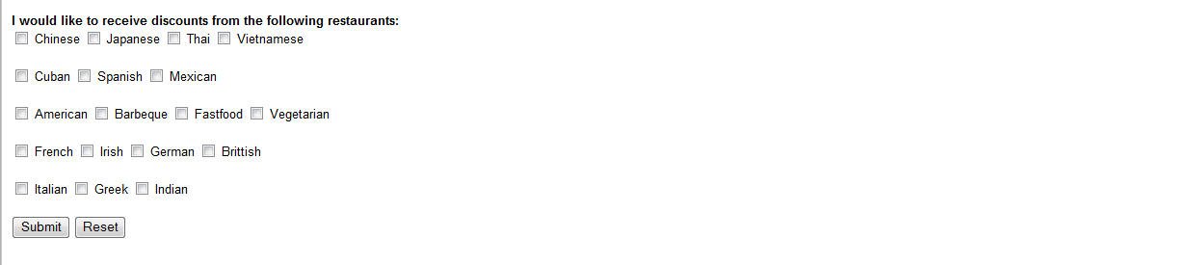

Directions:
- Add the heading ABC Discount Club Membership Form in size Heading 3 (+3) and make the color dark blue (#009900) and the font style Times New Roman and bold.
- Add the membership club introduction below the heading. (Welcome to ABC Discount Club. Your membership entitles you to discounts at local retail stores for an entire year. The annual membership fee is $30 and members save an average of $1,800 per year. You will receive promotional e-mail and text messages based upon your interests and preferences. You can update your information at any time throughout the year as your interests and purchasing needs change.)
- Insert a horizontal rule line. Optional to change the color using code.
- Insert the Form onto the page.
- On a new line, key in the words Last Name (character size=40). Use the form tools to add a text field. Key in the words First Name (character size=40). Use the form tools to add a text field. Key in middle initial and add the text field (character size=10).
- On a new line, key in the Street Address and add the text field (character size =105), key in the City and add the text field (character size =50), key in the State and add the text field (character size =10 and max characters=2), key in the Zip Code and add the text field (character size =10 and max characters=5).
- On a new line, key in the text I would like to receive discounts through and add a check box before each of the three selections. □ Mail □ Text Message □ E-mail. Add a space between each of the options.
- Add the radio group for the age area. Title the group Age:. The radio options are as follows:
  - 18-25
  - 26-35
  - 36-45
  - 46-55
  - 66 and older
- Add the text: My Interests and Hobbies Include (hold CTRL to select multiple items): The list includes the following options:

  - Bicycle Riding
  - Boating
  - Concerts
  - Fishing
  - Gardening
  - Hiking
  - Movies
  - Plays
  - Photography
  - Quilting
  - Rafting
  - Theme Parks
  - Woodworking

- Add the text: I would like to receive discounts from the following restaurants: and add the check boxes for the following types of food: Chinese, Japanese, Thai, Vietnamese, Cuban, Spanish, Mexican, American, Barbeque, Fast food, Vegetarian, French, Irish, German, British, Italian, Greek, and Indian.
- Add a Submit Button and a Reset Button (use the submit button and change the name) below the song list.
- Save the Page as ABC Discount Club and follow the directions at the top of the page for printing.

