Prom Ticket Order Form Activity
Directions: Use the form tools to design the form below. Follow the directions. Preview the form using a browser and press the print screen button on the keyboard to copy the page. Open MS Word. Make the page orientation landscape. Paste the page into Word and resize to fit the entire page. Add your name in the header and print.
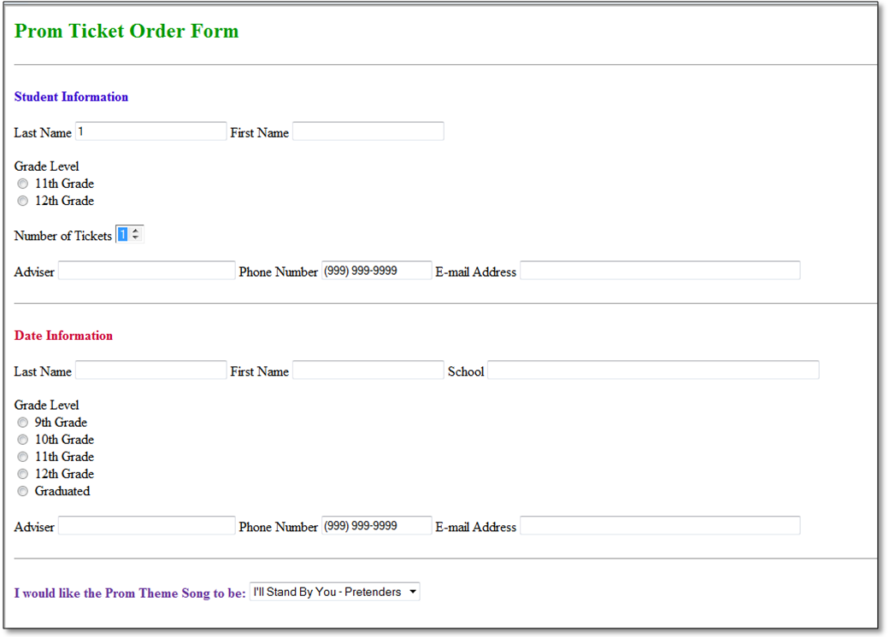
- Add the heading Prom Ticket Order Form in size Heading 2 (+2) and make the color green (#009900) and the font style Times New Roman and bold.
- Insert the Form onto the page.
- Insert a horizontal rule line. Optional to change the color using code.
- Add the text Student Information. Bold the text and change the color to blue (#3300CC).
- On a new line, key in the words Last Name. Use the form tools to add a text field. Make the field size a character width of 25. Key in the words First Name. Use the form tools to add a text field. Make the field size a character width of 25.
- On a new line, insert a radio group. Title the radio group Grade Level and add radio buttons for 11th and 12th grade as shown.
- On a new line add the text Number of Tickets. Insert a list menu and add 1 as the initial value and add 2 to the pull-down list.
- On a new line add Adviser with a text field in character size 30, Phone Number with a text field in character size 17. Add the sample phone number format shown. Add E-mail Address text with a text field of 50 characters.
- Insert a horizontal rule line. Optional to change the color using code.
- Add the text Date Information. Bold the text and change the color to red (#CC0033).
- On a new line, key in the words Last Name. Use the form tools to add a text field. Make the field size a character width of 25. Key in the words First Name. Use the form tools to add a text field. Make the field size a character width of 25. Add the text School Name and use the form tools to add a text field. Make the field size a character width of 60.
- Add the grade level radio buttons as shown.
- On a new line add Adviser with a text field in character size 30, Phone Number with a text field in character size 17. Add the sample phone number format shown. Add E-mail Address text with a text field of 50 characters.
- Insert a horizontal rule line. Optional to change the color using code.
- Add the text: I would like the Prom Theme Song to be: Bold the text and change the color to purple (#663399). Insert a pull down list and add the song I’ll Stand by You – Pretenders. Choose five more songs and artists and add them to the pull down list. Make all songs show when the page is viewed.
- Add a Submit Button and a Reset Button (use the submit button and change the name) below the song list.
- Save the Page as Prom Ticket Sales and follow the directions at the top of the page for printing.

