Top and Bottom Frames Activity
Directions: Use frames to design the page below.
- Create a page with a top, bottom, and main frame (In Dreamweaver, click on the frames tab and select the option for top and bottom frames)
- Click on the outside border of the frames and save the entire frameset as FRAMESET.htm
- Click in to top frame and save it as BANNER.htm
- Click in the middle frame and save it as CONTENT.htm
- Click in the bottom frame and save it as INFORMATION.htm
- Access the graphics folder and insert the Bowling Banner Image into the banner frame.
- Add the content and Bowling Image as shown to the content frame. Left align the image.
- Add the company information to the information frame.
- Save all frames and the entire frameset.

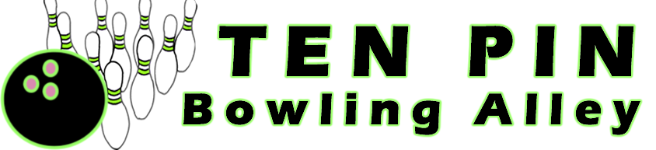
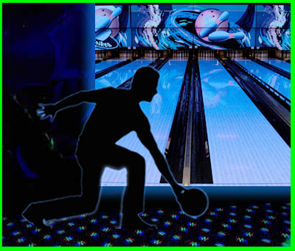
Ten Pin is Georgia’s favorite bowling and entertainment venue. Our bowling center features modern bowling technology, cosmic bowling, 30 state-of-the-art plasma screens, gourmet snack counter, and games galore. With over 40,000 square feet of fun, Ten Pin is the perfect place to host your birthday party or next corporate event. Our large hospitality room will cater to your food and beverage needs.

Georgia’s best laser tag provides adventure for the entire family. Bring a team or join in with others as you dodge and shoot through five different adventure areas including ship wreck island, jungle mountain, and the Georgia woods. The entertainment center also features Balladium, a brand new blasting game with 3D props and music, bumper cars, a video arcade, interactive gaming, and 15 pool tables.

Ten Pin offers league bowling, bowling lessons, family fun nights, and school activity nights.
Ten Pin Entertainment Center
33987 Alley Lane ▪ Township , Georgia 30000
Telephone: 777-398-2976
Fax: 777-398-2876

