Historical Periods Chart
Name: __________________________________ Date:_________
The following is a list of the major periods that influenced furniture in America. Use textbooks and reliable Internet sources to find the required information listed below.
Instructions:
- Use notes you have taken from the furniture style video to help complete the facts.
- For each historical era (A, B, C, D, E) list three major identifying characteristics of the furniture styles.
- For each historical era (A, B, C, D, E) note the method of production and how technology has influenced the designs.
- For each specific period (noted as bullets), find a piece of furniture showing seating (chair or sofa) and a table or case good for each.
- Colonial Period 1600-1720
- Seventeenth century
- William and Mary

- Late Colonial also called 18th Century furniture 1720 - 1787
- Queen Anne Style
- Chippendale Style
- Federal 1787 - 1800
- Federal Style
- Duncan Phyfe
- Shaker Furniture
- Industrial Revolution
- Victorian
- Arts and Crafts

- Modern Period 1901 – Present
- International Style
- Contemporary Designs

Historical Period | Major Characteristics | Pictures
Colonial
 | 17th Century | 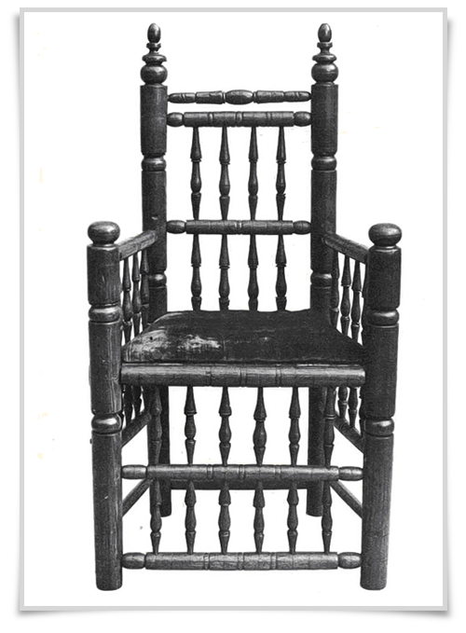
 | William and Mary | 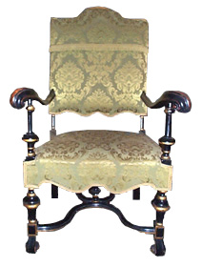
Late Colonial
 | Queen Anne Style
 | Chippendale Style
Federal
 | Federal Style
 | Duncan Phyfe
 | Shaker Furniture
Industrial Revolution
 | Victorian
 | Arts and Craft
Modern Period
 | International Style
 | Contemporary Designs

