Building Code Requirements for Accessible Rooms

Name: __________________________________ Date: ________

To make the task of meeting building code requirements easier, the National Kitchen and Bath Association (NKBA) publishes a list of standard building code requirements. Helping homeowners design and build safe, accessible rooms. Some of the basic requirements are:

- Toilet enclosures – bathroom stall enclosures must have at least 36” X 66” of space
- Toilets – center at least 15” from walls and tubs; 21” clearance in front.
- Faucets –for bathroom shower and combination tub/showers must include anti-scald devices
- Bathroom Light fixture – at least one that is permanent, controlled by a wall switch
- Wall switch – at least 60” from tub and showers
- Waste and drain lines – must slope ¼” per foot toward the main DWV stack; to aid flow and prevent blockage
- All receptacles must be GFCI-protected
- Acquire complete NKBA guidelines by calling 1-800-843-6522, or visit the NKBA web site at www.nkba.org.
For custom built houses, be sure to include wheelchair accessible construction in your plan. Although you may not need it now, planning for it by making slight alterations is a small price to pay. Basically, the Fair Housing Accessibility Guidelines adopted in 1988 require:
1. Doorways wide enough to accommodate a wheelchair;
2. No steps to this entrance;
3. Accessible hall ways throughout the home;
4. Switches and fixtures low enough to be reached from a wheelchair;
5. Reinforced bathroom walls that allow installation of grab bars, and
6. Kitchen and bathrooms built for wheelchair accessibility.

For existing homes, making homes wheelchair accessible will require renovation, the extent of which depends on the particular home. In general, this is usually easier and less costly in newer homes, as they were constructed under building codes that partially reflected the new guidelines. Some older homes, especially multistory homes, will prove to be prohibitively expensive to renovate. As with any remodeling project, discuss your project with several reputable contractors.

The most common renovation for making homes wheelchair accessible is to modify the main entryway. If the door is wide enough, most homes will need installation of an exterior ramp to replace the steps. As local building codes vary slightly, check the appropriate authority before construction. In general, the ramps should be at least three feet wide and have an incline of somewhere between 1:16 and 1:20. Long ramps should also include landings.
The next area to consider is the bathroom.
It needs to be spacious enough to maneuver in with a wheelchair and to include grab bars on the wall.
Sinks and vanity countertops also may need to be lowered so that they are at the proper height for wheelchair access, which is about 30" from the floor.
A total renovation of anything but the smallest bathrooms with narrow doors is usually possible, but at a greater cost than for installing an entryway ramp.
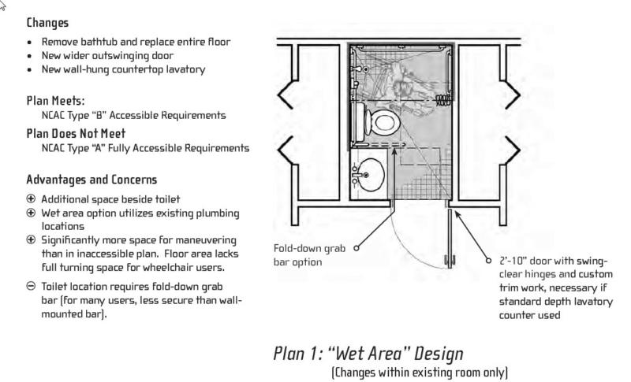
For multistory homes with second floor bedrooms, the obvious best solution is to move the bedroom downstairs. If this solution is not possible, stair lifts can be installed or a new bedroom can be constructed on the ground floor. Usually, building an addition is the better solution, albeit an expensive one, especially if a new bathroom and sometimes an entryway are incorporated into the design.

