
TECHNICAL TEXTILES

Interior Design
To accompany the Georgia Healthcare Science and Georgia Engineering and Technology Curriculums.
CTAE Resource Network, Instructional Resources Office, 2010
Georgia Performance Standards:
FCS-TS-10. Students will discuss the continuing use of technology in advancing textile products using innovative skills and tests.
- Discuss the role textiles play in sports equipment.
- Identify how textiles are being used in the medical field
- Discuss the careers that rely on wearing textiles and how they vary from uniforms to body armor.
See the end of this document for complete GPS listing

Student Information Guide
Directions:

Use the information in this student information sheet to complete the accompanying student study sheet. Complete all items on the study sheet and turn in to the teacher.
 Technical Textiles

A technical textile is a textile product manufactured for non-aesthetic purposes, where function is the primary criterion. It is a large and growing sector and supports a vast array of other industries. Technical textiles include textiles for automotive applications, medical textiles (e.g., implants), geotextiles (reinforcement of embankments), agrotextiles (textiles for crop protection), and protective clothing (e.g., heat and radiation protection for fire fighter clothing, molten metal protection for welders, stab protection and bulletproof vests), and spacesuits). The most widely-used technical textile materials are used in filter clothing, furniture, hygiene medicals and construction material.

Smart and Intelligent Textiles

There is a substantive difference between the terms smart and intelligent; smart materials or textiles can be defined as the materials and structures which have sense or can sense the environmental conditions or stimuli, whereas intelligent textiles can be defined as textile structures which not only can sense but can also react and respond to environmental conditions or stimuli. These stimuli, as well as the responses, could be thermal, chemical, mechanical, electric, magnetic or from other sources.
Smart fabrics are being developed to be able to sense what is happening to the wearer or its immediate surroundings. An example of this would be the capacity to know when the wearer’s heart rate spikes or drops unexpectedly, then being able to send such information to a paramedic. There are two more modern types of smart fabrics; one using nanotechnology such as carbon nanotubes or fireproof treatments, the other a combination of electronics and conductive fabrics for sensing a person’s vital signs. The promise of smart fabrics is that everyday clothing will be able to perform the task of comfort and protection more effectively or add internet connectivity to allow people to be cared for when something goes wrong.

Medical Textiles

Biotextiles are structures composed of textile fibers designed for use in specific biological environments where their performance depends on biocompatibility and biostability with cells and biological fluids. Biotextiles include implantable devices such as surgical sutures, hernia repair fabrics, arterial grafts, artificial skin and parts of artificial hearts.
Medical textiles are a broader group which also includes stitches, bandages, wound dressings, hospital linen, preventive clothing, etc. Antiseptic biotextiles are textiles used in fighting against bacteria growth on skin.
EXAMPLE 1: STENTS
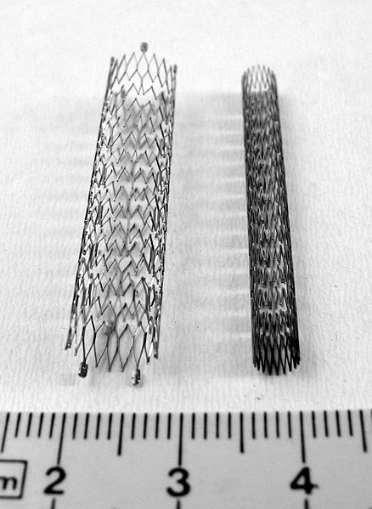
A stent is a tubular device made of woven metal mesh which is inserted into a tube into the body and expanded; afterwards, it remains locked in the open position, holding the tube open. A common usage of stents is to open blood vessels that have become clogged, as treatment for or in order to prevent heart attacks or other forms of thrombosis. After a stent has been placed, the body may perceive it as a foreign object, resulting in a process known as restenosis that causes the clog to re-form around the stent. An alternative which can minimize this risk is the drug-eluting stent, which slowly releases a drug to prevent cells around the stent from growing. Once the body has healed itself, the stent is no longer necessary, and its continued presence can interfere with future medical interventions or imaging; for this reason, research is being conducted into bioresorbable stents, which are made of advanced textiles, rather than metal, that slowly deteriorate and are absorbed harmlessly into the body. Research into new materials to make stents, as well as their construction, is an example of medical textile engineering.
(Above: Stents for peripheral vessels)

EXAMPLE 2: ARTIFICIAL SKIN
For persons who have suffered from traumatic burns or skin disease, one avenue of treatment is the implantation of artificial skin. This comes in many forms, such as spray-on skin and skin grown in culture; cultured skin requires a scaffolding to be grown on, which is a textile. The development of a textile that is strong, flexible, permeable, and biocompatible enough to work in conjunction with cultured cells to replace skin, and to then dissolve once the new skin has successfully grafted, is a great challenge in medical textile engineering.

Sports Textiles

Textiles used in sportswear must fulfill many unique requirements such as comfort, durability, breathability, water resistance, etc. For high-contact sports such as football and rugby, textiles are designed to protect the user from injury. For cyclists, who perform repetitive motions, fabrics are designed to not chafe. The sails of sailboats must be light, strong, and water-resistant.

EXAMPLE 1: Gore-Tex

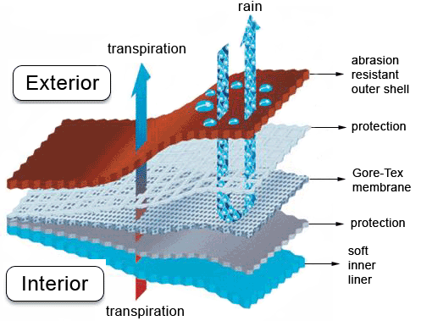
Gore-Tex fabrics are used in a wide variety of applications such as medical implants, insulation, and filter media; however, they are best known for their waterproof sportswear. The key innovation of Gore-Tex clothing is an inner layer of porous fluoropolymer membrane (Teflon) coating that is bonded to a fabric. Each pore is approximately 1/20,000 the size of a water droplet, making it impenetrable to liquid water while still allowing the smaller-sized water vapor molecules to pass through. This allows the wearer’s perspiration to pass out of the fabric while keeping rain out, such that waterproofing need not come at the cost of breathability. Co-inventors Wilbert L. Gore, his son Robert W. Gore, and Rowena Taylor filed patents on their new technologies in 1976 and 1980. For his invention, Robert W. Gore was inducted into the National Inventors Hall of Fame in 2006.
EXAMPLE 2: BioHarness by Zephyr
BioHarness is an excellent example of a “smart” fabric. It is a fabric embedded with sensors that monitor the wearer’s physiological conditions. It detects such variables as heart rate, respiration rate, skin temperature, posture and activity. Coupled with a Bluetooth connection and software, it allows for the recording and analysis of complex biometric data. Exercisers can use this technology to access extreme detail about their workout to optimize their routine. Coaches can monitor their athletes in real time to know when to cycle players out. This technology can also have military applications; commanders can be constantly monitoring the condition of their troops to better gauge their readiness and make more effective tactical decisions. As fabrics like these become more complex, they may have medical applications such as remote monitoring of at-risk individuals or diagnostic use. The possible applications of this breaking field are vast and exciting.

Protective Textiles

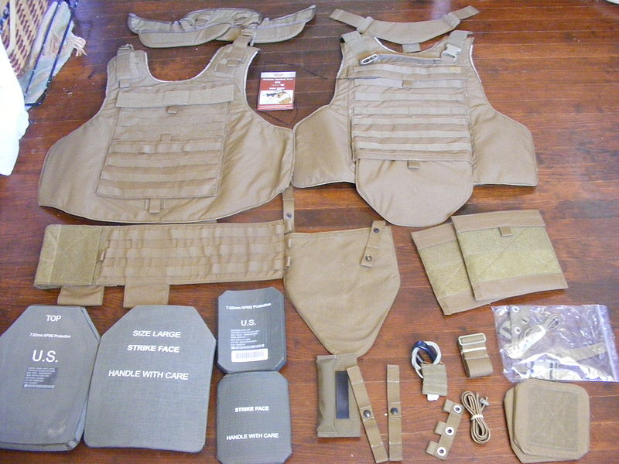
Protection against heat and radiation for fire fighter clothing, against molten metals for welders, for bullet proof jackets, etc., are all obtained by usage of technical textiles with high-performance fibers. In bulletproof jackets, special aramid fibers are used which have high tenacity, high thermal resistance and low shrinkage. Glass fiber is also used in fireproof jackets due to its high strength, chemical and flame resistance. Protective clothing is also used by the astronauts when they go in space; lunar landing suits are coated with chemicals such as lead to shield from solar radiation.
EXAMPLE 1: BALLISTIC BODY ARMOR
Body armor designed to stop stabbing attacks, bullets and explosive shrapnel are of critical importance in the military and in law enforcement. Because metal armor is often heavy and cumbersome, many modern armors are based on fabrics. Kevlar is a well-known example, but new technologies hold promise for improved performance and reduced weight. One key need is for soft textiles which can stop not only handgun rounds, which is within current capabilities, but also rifle rounds, which can pierce soft textile armors. Research is being done into the chemical composition of fibers and weaving methods, with one example being the possible biomimicry of spider silk. A related area of research is nanomaterials; the incorporation of carbon fibers into body armor is of particular interest.
EXAMPLE 2: NBC Suits
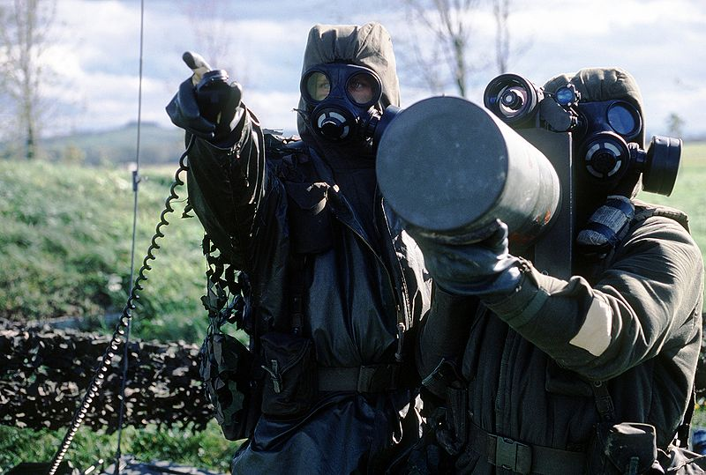
NBC (Nuclear, biological and chemical) suits are a piece of military personal equipment designed to protect the wearer from radioactive, biological and chemical substances. The design of materials for NBC suits is particularly challenging because of the many criteria which they must meet; as their primary goals they must shield against radiation, block liquid and gaseous chemicals, and resist contamination and degradation by biological substances. Additionally, they must meet the needs of military personnel in high-performance situations by being durable, lightweight, flexible, and breathable. Consider the difficulty in designing a material which will permit the wearer’s evaporated sweat to exit while preventing mustard gas from entering; these are the sort of design challenges which textile engineers face.
(Above: Canadian Soldiers in NBC suits.)

Agro-Textiles
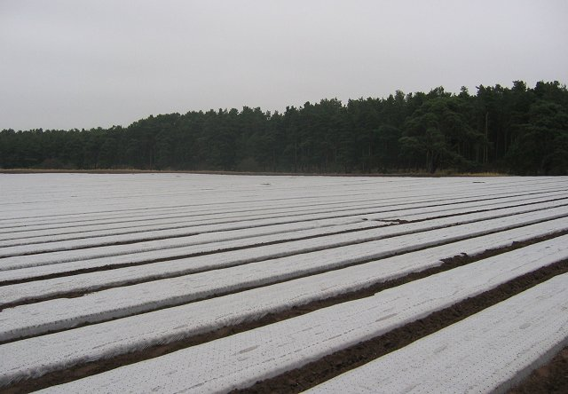
Textiles used in agriculture are termed as agro-textiles. There are a wide variety of uses; catching fruit falling from trees, as ground cover to prevent weed growth, and to cover and protect crops from pests, excessive sunlight, wind and hail. The essential properties required are strength, elongation, stretching, stiffness, and bio-degradation, resistance to sunlight and resistance to toxic environment. All these properties help with the growth and harvesting of crops and other foodstuffs. There is a growing interest in using materials which gradually degrade (biodegradables).

(Above: Crops Covered in a polyethylene agro-textile.)

Construction Textiles

Textiles used in construction - concrete reinforcement, façade foundation systems, interior construction, insulations, proofing materials, air conditioning, noise prevention, visual protection, protection against the sun, and building safety.
An interesting and aesthetically appealing application is the use of textile membranes for roof construction. This area is also referred to as textile architecture. PVC-coated high-tenacity PES, Teflon-coated glass fiber fabrics or silicone coated PES are used for their low creep properties. Splendid examples of such construction are found in football stadiums, airports and hotels.
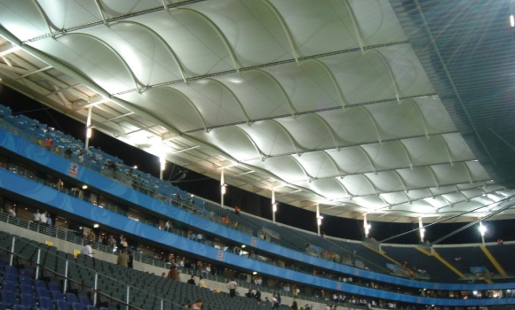

(Above: The rigid textile roof of the Commerzbank-Arena in Frankfurt, Germany.)

Domestic Textiles

Textiles used in a domestic environment like a house or apartment - interior decoration and furniture, carpeting, protection against the sun, cushion materials, fireproofing, floor and wall coverings, and textile-reinforced structures/fittings.
In the contract market such as for large area buildings, ships, caravans, busses, etc., fire-retardant materials are used. Fire-retardant properties are obtained either through the use of inherently fire-retardant fibers such as modacryl or through the application of a coating with fire-retardant additives (bromide or phosporus compounds).

Industrial Textiles

Textiles used for chemical and electrical applications and textiles related to mechanical engineering. Examples include silk-screen printing, filtration, plasma screens, propulsion technology, lifting/conveying equipment, sound-proofing elements, melting processes, roller covers, grinding technology, insulations, seals, and fuel cells.

Georgia Performance Standards
HS-IBT-3. Students will understand the basis for biotechnology products and how such products affect the quality of life.
b. Identify examples of technologies used in the biotechnology industry.
d. Review current trends in the biotechnology industry.
HS-IBT-4. Students will analyze careers in human health and diagnostics, biomanufacturing, environmental applications, and agriculture that utilize biotechnology.
a. Examine careers in human health and diagnostics that utilize biotechnology.
b. Examine careers in biomanufacturing that utilize biotechnology.
c. Examine careers in agriculture that utilize biotechnology.
HS-ABT-8. Students will demonstrate understanding of advanced applications in biotechnology.
a. Describe how biotechnology has contributed to the advancement of biology impacting human well being to include: forensics, cell biology, cancer treatment, epidemiology of infectious disease, nanotechnology, bioinformatics, genomics, stem cell biology, transgenics, and gene therapy.
HS-IHS-9. Students will analyze economic, social, and ethical issues related to the use of biotechnology.
a. Differentiate between moral, ethical, and legal biotechnology issues.
b. Research ethical issues presented by evolving science, including genetically modified foods, cloning, bioterrorism, gene therapy, and stem cells.

License & Verification
Text is available under the Creative Commons Attribution-ShareAlike License; additional terms may apply. See Terms of Use for details. - http://creativecommons.org/licenses/by-sa/3.0/
Wikipedia® is a registered trademark of the Wikimedia Foundation, Inc., a non-profit organization.

Website Sources: http://en.wikipedia.org/wiki/Biomedical_engineering
This document, originally from Wikipedia, has been modified
and the information has been independently verified.

