Functional Finishes Crossword
Name: ____________________ Date: ___________
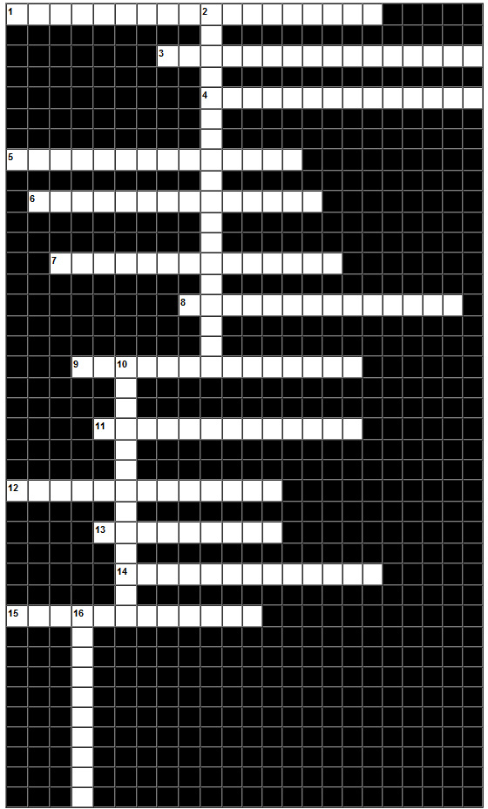

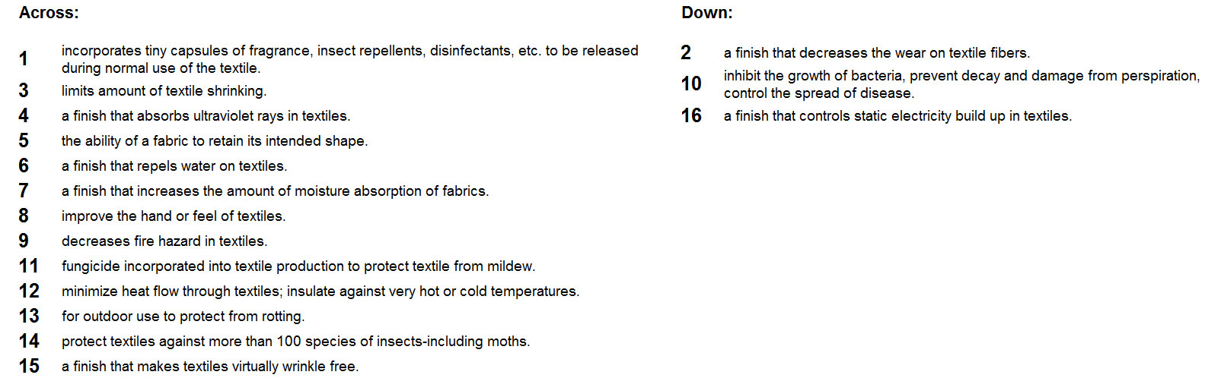

Functional Finishes Crossword Key
