Textile Dyeing Crossword
Name: ______________ Date: ___________
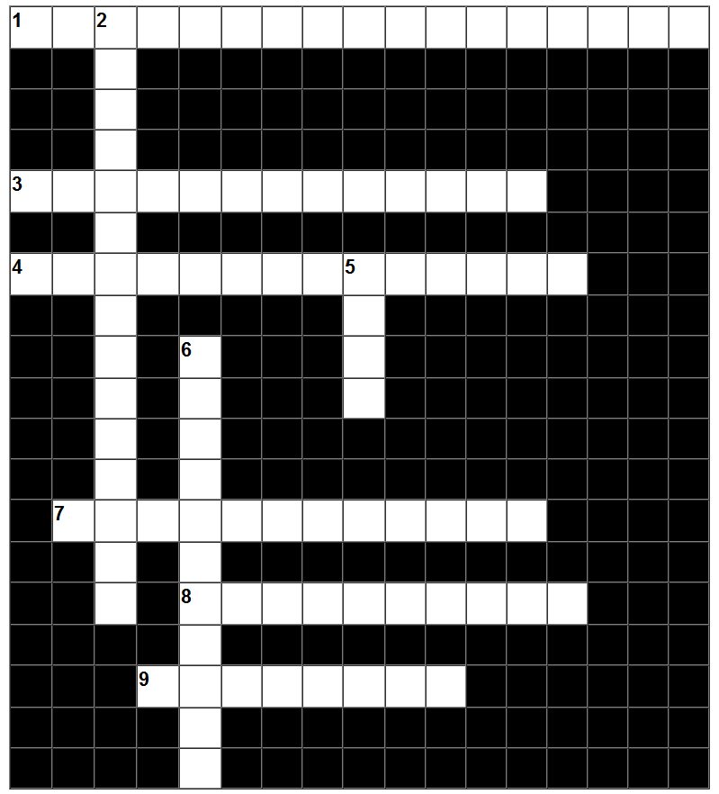

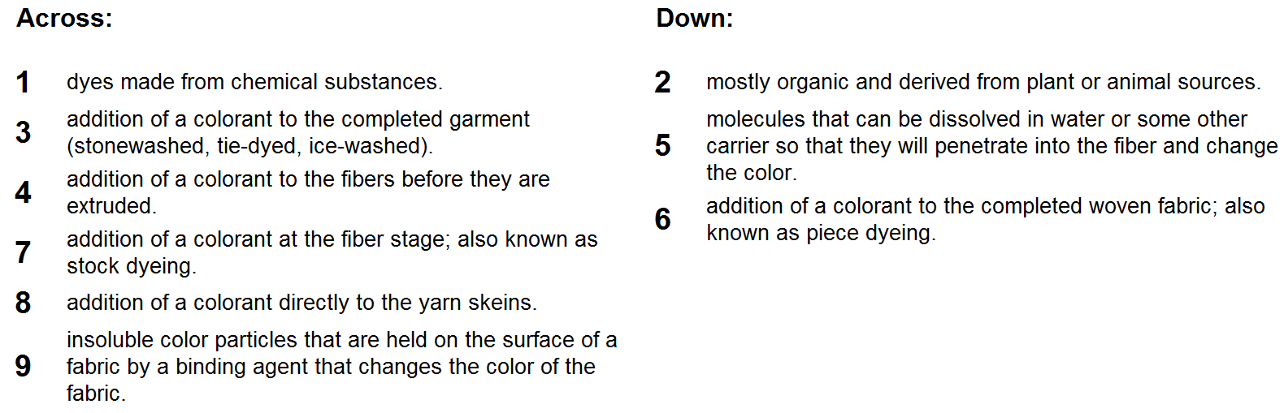
Textile Dyeing Key
