Milan Morsels: Fritz Hansen Introduces Nap Stacking Chair
14 April, 2010
-By Stacy Straczynski
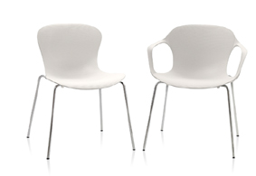
Stacking chairs are not normally associated with comfort—especially when users must remain seated for long meetings or convention events. However, the Nap chair, designed by Kasper Salto for the Republic of Fritz Hansen and launching this week at Milan Furniture Fair 2010, is surprisingly so, as the moulded bucket seat is flexible to allow for approximately the full range of back and forth movement—and support—found in typical task chairs.
Constructed from an eco-friendly, recyclable nylon and Thermo Plastic Elastimer (TPE) mix, Salto’s chair focuses on the theory that sitting is an activity—consisting of normal, active, and passive movement—rather than a resting position. Whether sitting down, leaning back, or standing back up, the seat’s shape and bendable composition comfortably supports any range of motion the user may enact. Nap comes in 14 powder-dyed colors or in a variety of seat-cushion upholstery options, including fabric and leather. The seat comes with or without arms and is stackable up to 10 chairs high.
The seat is now on display from April 14-19, 2010 at the Republic of Fritz Hansen’s showroom in Milan on Corso Garibaldi 77. A celebratory launch event will be held starting at 18:00 (6:00 p.m.) Thursday, April 15.

Nap by Fritz Hansen 