Crime Zone For Dummies
Chapter 1- The Basic Scene
MAKING THE BUILDING
- To open the program, double click on “My Computer” which should be located on the desktop. Double click on “Local Disk (C:). Double click on “Program Files.” Double click on “CAD Zone.” Double click on “Crime Zone 8.” Double click on Crime Zone icon. (The crime zone icon is a gun with a laser pointer on it, and a magnifying glass with the number 85 on it.)

- When the program opens, you should see a screen pop up that says “Let’s get started” on the top left hang corner. Click on where it says “New.” Then name your drawing and make sure “Feet & Inches” is selected for where it says units. For “Pick a starting tool” click the last one (No method- Blank Screen). And, for “approximate site size” click small – 50’ (50m).

- After the pop-up closes, you should get a screen that looks like this.
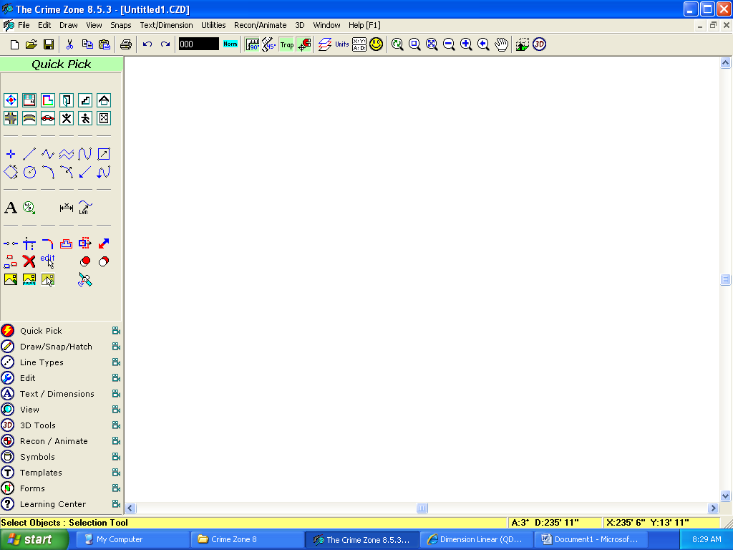

- At the top left corner click on the “easy lines” button from the “Quick Pick Bin.”
- When the Easy Lines toolbox appears on the screen, click the “Start” icon  in the center of the Easy Lines compass. Click in the drawing window at approximately the point shown here to set the end-point of the first line segment.
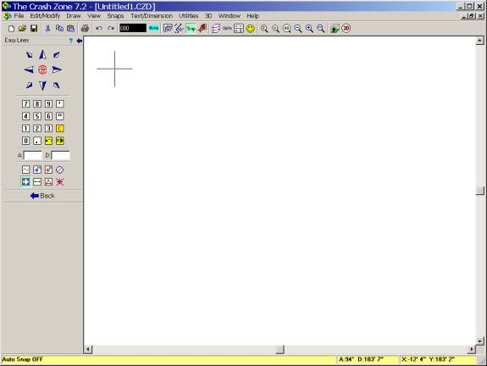
This sets the first endpoint of the line, which will become the upper-left corner of the building. The Easy Lines toolbox has arrow buttons that correspond to each different direction. To draw each line segment you click on the arrow button for the desired direction, then key in the length of the line using the numeric keypad on the toolbox. If you want to draw at some angle other than those available on the compass, click in the Angle box (A:) on the toolbox and then type in the desired angle. After entering the direction and length click the line icon.

To add doors and windows click on the doors/windows icon in the quick pick bin of the left hand toolbox.

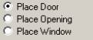
Click in the width field and enter the value for the width of the door. Do the same for height and footer height. Then make sure place door is clicked.

Then click place button.

Click the wall you wish to place the door, and then pick a hinge point (the point from which the door swings). A green ghost image of the door will appear, move and adjust the door until satisfied then click the mouse to finish placing the door.

PLACING SYMBOLS
1.Open the symbol manager by clicking its button on the left hand toolbox.
2. Choose the crime category from the drop-down menu located in the top right hand of the symbol window.
3. Then click on the “home button,” and find the fixtures you are looking for. Click once on it then drag it unto the canvas. You will see the ghost image of the symbol. Place symbol where desired.
4. To scale the symbol, click the Dynamic Scale 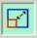 button at the bottom of the Symbol Manager to turn it on. Then, place the symbol you want.

ADDING TEXT

Select the Text 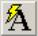 icon. The Text dialogue box will open.

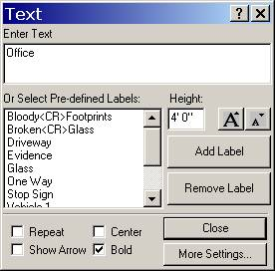
Change the text font, size, rotation, etc.

The text size is entered as a measurement in feet, which will be printed to the designated scale when the diagram is printed on paper. You can adjust the size of the text by clicking the Text Larger and Text Smaller icons on the toolbox.
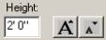

ADDING DIMENSIONS

Select the Dimension 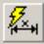 command from the Quick Pick menu of the left-hand toolbox.

Make sure Auto Snap is turned on and position the mouse pointer crosshairs over the upper-left hand corner of the building.

Click your mouse button to snap the first dimension point exactly to the corner of the building.

Move the mouse pointer to the upper right-hand corner of the building and click again to snap to the second point.

Move the mouse pointer upwards and notice the dimension stretches out from the building. A small green box shows an outline of the text so you can see its size. To adjust the font size:
Click on the “Text Larger” or “Text Smaller” icons on the Quick Label toolbox, until the size is set.

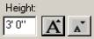

Click again to place the dimension text where you want it.

