1. A B X D E F
- Explain the purpose of photographic evidence. Identify at least four. Which step is the most valuable?

  - To record the original scene and related areas
  - To record the initial appearance of physical evidence
  - It will provide investigators and others with this permanent visual record of the scene for later use
  - Photographs are also used in court trials and hearings

Most Valuable: reasonable choice

- What are the four steps of crime scene processing? Which step is most critical?

  - Secure the scene
  - Record the scene
  - Search the scene
  - Collect evidence from scene

Most Critical: reasonable choice

2. A X C D E F

3. A B X D E F

4. X B C D E F

5. A B C X E F

6. A X C D E F

7. A X C D E F

8. X B C D E F

9. A B X D E F

10. A X C D E F

11. X B C D E F

12. A X C D E F

13. A B C X E F

14. A B X D E F

15. X B C D E F

16. A X C D E F

17. A B C X E F

18. A X C D E F

19. A B C D X F

20. X B C D E F

- Describe crime scene reconstruction listing the four main steps. Defend the value of alternate theories.

  - Starts with initial walk through
  - Hypothesis is clarified by evidence and data
  - Examination, testing and further analysis may be required
  - Final theory is carried forward

Alternative Theories: Alternate theories not ignored – because evidence may later substantiate them

- Explain the ADAPT method of securing a crime scene. Appraise each and determine which is most critical from a legal perspective.

Assess scene and assist injured
Detain witness(es)
Arrest perpetrator
Protect scene – exclude people
Take notes – particularly scene log

Most Critical: reasonable
Application: 10 points each for 20 points. Allow for ten minutes. Use the answer sheet to record your response.

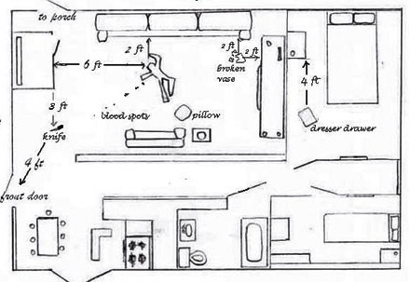

1. What five additional pieces of information would need to be added to this crime scene sketch before it could be submitted? Mark them on the diagram above

Should be added: name of the criminalist, date, time, “not to scale”, reference points (including north point), name of the victim, labeling evidence, a key or legend of the evidence

- In the den/family room formulate a plan on how a criminalist would document the crime scene using photography. Indicate on the diagram above where you would have taken shots using the symbol for camera shots.
- :

Shots from the corners of the room, all four sides of the victim, and one shot of each of the key pieces of evidence.

