1. A B C D E F
- Explain the purpose of photographic evidence. Identify at least four. Which step is the most valuable?

_

_

_

_

Most Valuable:

- What are the four steps of crime scene processing? Which step is most critical?

_

_

_

_

Most Critical:

2. A B C D E F

3. A B C D E F

4. A B C D E F

5. A B C D E F

6. A B C D E F

7. A B C D E F

8. A B C D E F

9. A B C D E F

10. A B C D E F

11. A B C D E F

12. A B C D E F

13. A B C D E F

14. A B C D E F

15. A B C D E F

16. A B C D E F

17. A B C D E F

18. A B C D E F

19. A B C D E F

20. A B C D E F

- Describe crime scene reconstruction listing the four main steps. Defend the value of alternate theories.

_

_

_

_

Alternative Theories:

- Explain the ADAPT method of securing a crime scene. Appraise each and determine which is most critical from a legal perspective.

A:

D:

A:

P:

T:

Most Critical:
Application: 10 points each for 20 points. Allow for ten minutes. Use the answer sheet to record your response.

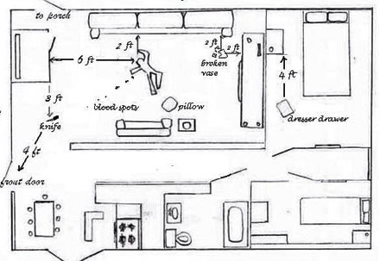

1. What five additional pieces of information would need to be added to this crime scene sketch before it could be submitted? Mark them on the diagram above

- In the den/family room formulate a plan on how a criminalist would document the crime scene using photography. Indicate on the diagram above where you would have taken shots using the symbol for camera shots.
- :

