Your arrival time – 06:00 hours

Location:
Tri-County Stop-Shop-N-Ride
100 State Highway 99
Nowhere, Ga 30076

Restrooms located in Trailways Bus Stop at this location (don’t worry about mapping the whole place – just the bathroom)

Body:
The body is barely warm to the touch.
When you raise the arms it is resistant to move, but yields with slight force.
There is some bleaching on the topside skin and some reddening on the bottom side skin.

Identification found in pocket:
Florida Drivers License

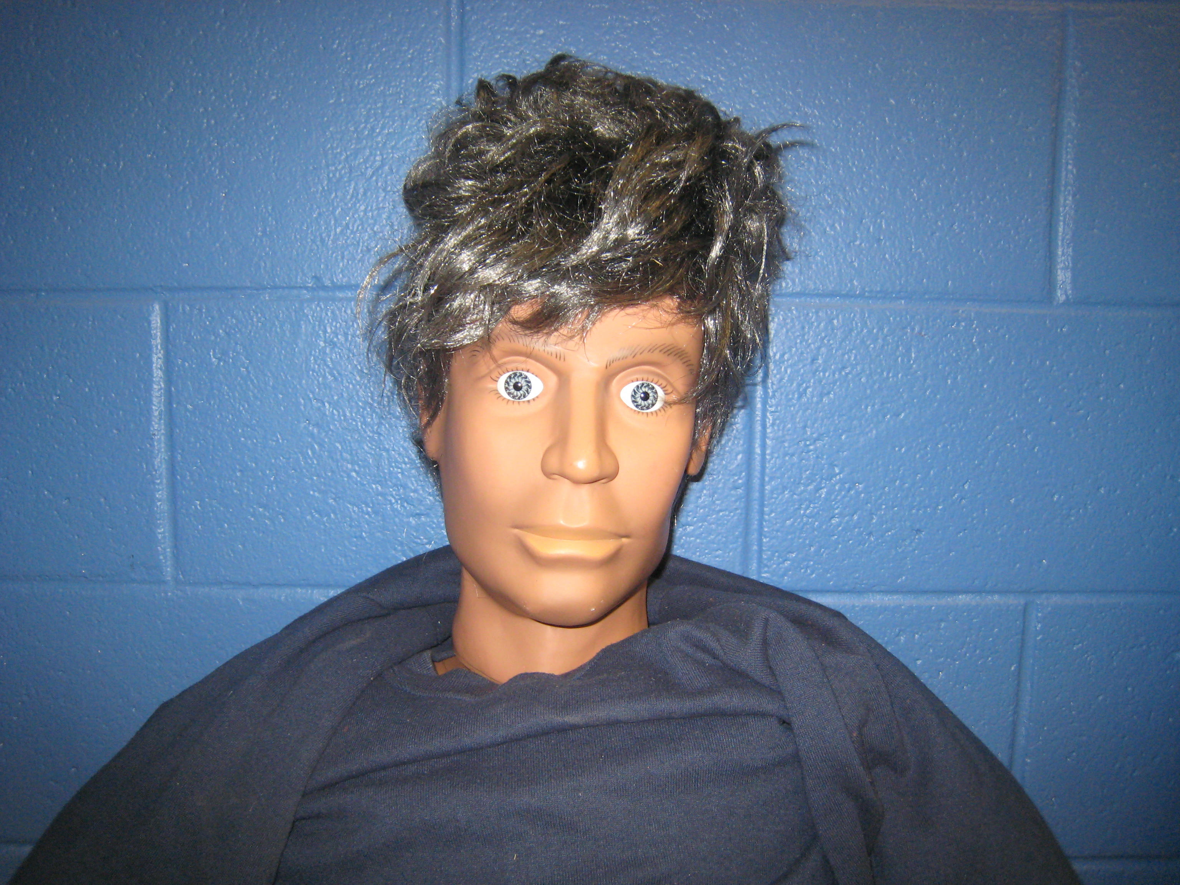
#: 123456789 Expires: 10/10/2008

Name: John Billy Doe
111 Beach Drive
Somewhere, Fl 20030

Sex: M Race: White DOB: 10/10/1988
Height: 5-09 Weight: 145

