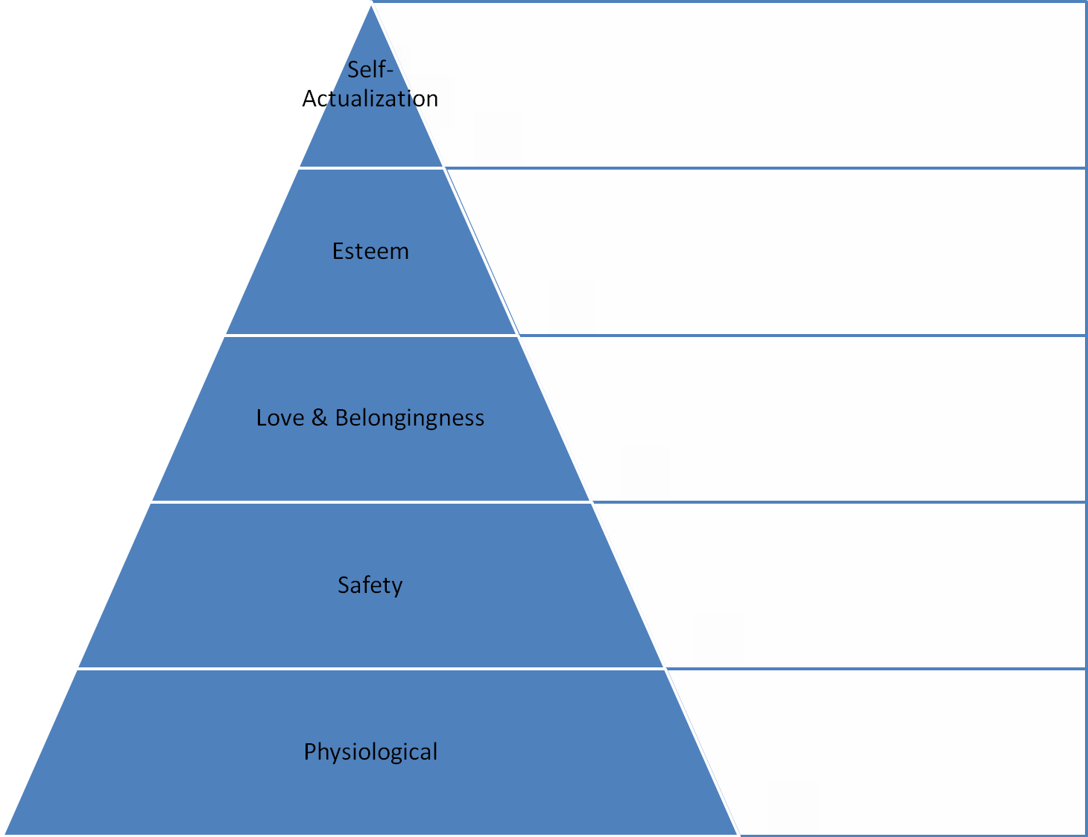
Maslow’s Hierarchy of Needs

