Multiple Choice: Write your answers on the answer sheet provided. Allow thirty minutes. (1 point each for 55 points total)

1. The reliability of eye witness accounts can be affected by:
a. | the type of crime
b. | the interviewing technique used by the investigator
c. | the time between the crime and the interview
d. | all of the above

ANS: D PTS: 1

2. Which is the following is NOT considered physical evidence?
a. | fiber | c. | toolmarks
b. | testimony | d. | soil

ANS: B PTS: 1

3. If evidence has class characteristics, it
a. | can link a suspect to a crime with certainty
b. | has more probative value than direct evidence
c. | can exonerate innocent suspects
d. | all of the above

ANS: C PTS: 1

4. A term that means supplying proof or evidence is:
a. | material | c. | probative
b. | direct | d. | prima facie

ANS: C PTS: 1

5. Known or control sample could come from:
a. | the crime scene | c. | the victim
b. | a known suspect | d. | all of the above

ANS: D PTS: 1

6. Which of the following is NOT true about the value of physical evidence
a. | it can prove that a crime has been committed
b. | it is always individual evidence
c. | it can link a suspect with a victim or crime scene
d. | it can allow investigators to reconstruct a crime
e. | b and d are not true
f. | none of these are true

ANS: B PTS: 1

7. If a forensic scientist can piece together broken pieces of glass from a bottle that was used as a weapon, it has:
a. | individual characteristics | c. | identification characteristics
b. | class characteristics | d. | comparative characteristics

ANS: A PTS: 1

8. Which of the following would be considered individual evidence?
a. | DNA | c. | paint
b. | soil | d. | blood type

ANS: A PTS: 1

9. Which of the following would have the most probative value?
a. | soil | c. | fingerprint
b. | glass | d. | fiber

ANS: C PTS: 1

10. If evidence has individual characteristics, it
a. | can link a suspect to a crime with certainty
b. | has probative value
c. | can exonerate innocent suspects
d. | all of the above

ANS: D PTS: 1

11. Microscopic examination of hair can determine:
a. | whether or not the hair is human or animal
b. | the age of the person
c. | the gender of the person
d. | all of these
e. | none of these

ANS: A PTS: 1

12. Generally, a human hair can be distinguished from an animal hair by examining:
a. | the cortex | c. | the color
b. | the medulla | d. | the texture

ANS: B PTS: 1

13. The racial origin of a hair can be determined:
a. | always | c. | never
b. | sometimes | d. | only if it doesn’t have a root

ANS: B PTS: 1

14. Human hair can be characterized by having a medulla that is:
a. | less than 1/3 of the hair diameter | c. | greater than 1/2 of the hair diameter
b. | absent of a scale pattern | d. | that is colorless

ANS: A PTS: 1

15. Nuclear DNA can be identified from:
a. | the hair shaft | c. | both
b. | the hair root or follicle | d. | neither

ANS: B PTS: 1

16. An unidentified hair is examined and found to have been dyed. The dye begins 3 cm from the root. This indicates that it was dyed:
a. | one month ago | c. | three months ago
b. | two months ago | d. | not possible to determine

ANS: C PTS: 1

17. In a cross section, the hair of an African American would look:
a. | round | c. | crescent moon
b. | oval | d. | none of these

ANS: C PTS: 1

18. This medulla pattern would be considered:
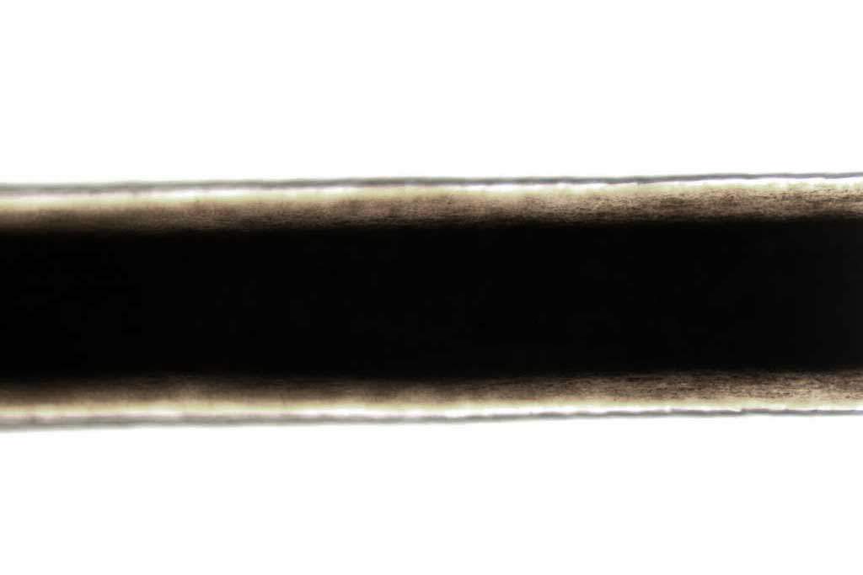
a. | fragmented | c. | continuous
b. | interrupted | d. | stacked

ANS: C PTS: 1

19. Mark on your sheet letter that indicates the cortex:

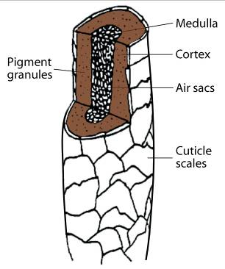

A
B

C

20. Mark on your sheet the pattern that would be imbricate:
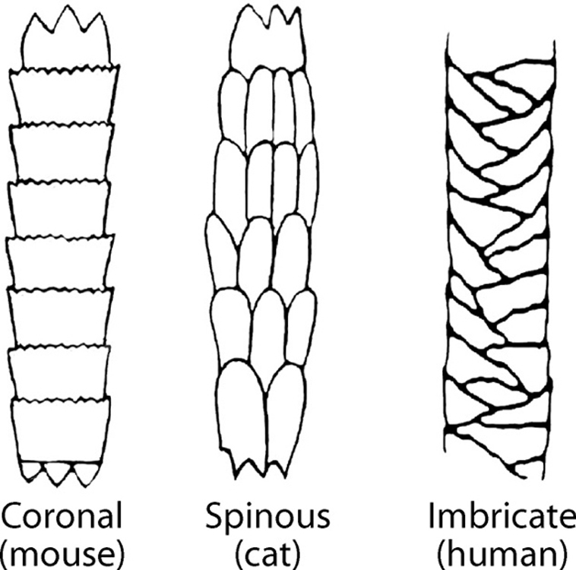
A
B
C

21. Some examples of natural fibers are:
a. | jute, rayon, silk and wool | c. | linen, cotton, acetate, rayon
b. | wool, cotton, cashmere | d. | linen, cotton, wool, Dacron

ANS: B PTS: 1

22. Fibers that are polymers are:
a. | natural | c. | all fibers are polymers
b. | synthetic | d. | no fibers are polymers

ANS: C PTS: 1

23. To test the dye in a particular fiber, it can be extracted and then tested using:
a. | a burn test | c. | chemical tests
b. | a thermal decomposition test | d. | any of these

ANS: C PTS: 1

24. Out of seven analytical tests performed to match a questioned fiber to a known, you find one discrepancy. The cross-section is triangular rather than round. What do you do?
a. | don’t worry about it; six out of seven is good evidence
b. | report that there is no association between the questioned fiber and the known
c. | assume that the one test was wrong
d. | only testify about the six tests that matched

ANS: B PTS: 1

25. Which of the following will fluoresce under ultraviolet light?
a. | polyester | c. | nylon
b. | cotton | d. | acrylic

ANS: B PTS: 1

26. Who was the person convicted on the basis of fiber evidence?
a. | Ronald Cotton | c. | Wayne Williams
b. | Amanda Davies | d. | Richard Vorder Bruegge

ANS: C PTS: 1

27. Which of the following properties should be examined when comparing two fibers?
a. | birefringence | c. | color
b. | diameter | d. | all of these

ANS: D PTS: 1

28. Which of the following fibers DO NOT come from an animal source?:
a. | asbestos | d. | wool
b. | mohair | e. | cashmere
c. | silk | f. | all of these come from animals

ANS: A PTS: 1

29. Fibers that are made by plants or animals are called:
a. | natural | c. | synthetic
b. | plain | d. | real

ANS: A PTS: 1

30. Wool, when burned, smells like:
a. | tar | c. | vinegar
b. | burning hair | d. | diesel fuel

ANS: B PTS: 1
31. Trace evidence found at a crime scene may include:
a. | sand, soil
b. | any physical evidence found in small amounts
c. | powders, explosive residue, metal or glass particles
d. | all of the above

ANS: D PTS: 1

32. Determining the density of a metal by observing whether it sinks or floats in bromoform is a:
a. | chemical test | c. | both a and b
b. | physical test | d. | neither a or b

ANS: B PTS: 1

33. To examine the chemical properties of metal add __________ and look for a color change or the evolution of bubbles.
a. | an acid and/or base | c. | a magnet
b. | water and heat | d. | any of these would work

ANS: A PTS: 1

34. Common metals that are magnetic are:
a. | iron, nickel, and copper | c. | chromium, zinc, and iron
b. | nickel, copper, and chromium | d. | iron and nickel

ANS: D PTS: 1

35. When using chromatographic techniques, it is important to keep the sample spot above the solvent level because:
a. | the spot will travel up the stationary phase and be deposited on the strip
b. | the spot will mix with the solvent and travel faster than it is supposed to
c. | the spot will dissolve in the solvent and not go anywhere
d. | all of these could happen

ANS: C PTS: 1

36. One of the tests used to classify white powders is based on solubility. The solubility of a substance is based on:
a. | its ability to turn brown with the addition of iodine
b. | the evolution of gas when an acid is added
c. | its ability to turn bright pink when phenolphthalein is added
d. | its ability to dissolve when a solvent such as water is added

ANS: D PTS: 1

37. The solubility of a substance is considered:
a. | a physical property | c. | both a and b
b. | a chemical property | d. | neither a or b

ANS: A PTS: 1

38. When one substance is added to another, the evolution of gas bubbles indicates:
a. | a physical change | c. | both a and b
b. | a chemical change | d. | neither a or b

ANS: B PTS: 1

39. The pH of a substance indicates whether it is acidic or basic. Acids have a pH of:
a. | less than 7 | c. | greater than 7
b. | 7 | d. | it depends on the substance that is added

ANS: A PTS: 1

40. Which of these indicates that a chemical reaction has taken place?
a. | color changes | c. | formation of a precipitate
b. | gas bubbles | d. | all of these

ANS: D PTS: 1
41. The forensic definition of soil is:
a. | a mixture of mineral grains and decayed organic matter
b. | a mixture of mineral grains, organic matter, and any other materials mixed with the sample
c. | decayed organic matter only
d. | anything that looks like dirt

ANS: B PTS: 1

42. Soil evidence is analyzed based on its:
a. | physical properties
b. | chemical properties
c. | settling rate
d. | all of the above

ANS: D PTS: 1

43. A topographic map is one that shows:
a. | the same as a roadmap with all major and minor roads
b. | geographic features of an area
c. | the soil composition of an area
d. | all of the above
e. | none of the above

ANS: B PTS: 1

44. A soil horizon is something that shows
a. | the relative density of soil particles | c. | the rate of settling
b. | the pH of soil | d. | a soil profile showing distinct layers

ANS: D PTS: 1

45. The organic part of soil is called:
a. | humus | c. | rock particles
b. | minerals | d. | loam

ANS: A PTS: 1

46. The amounts of light transmitted through a sample can be measured as a function of wavelength through which procedure?
a. | chromatography | c. | electrophoresis
b. | spectroscopy | d. | none of these

ANS: B PTS: 1

47. Glass evidence is considered:
a. | individual evidence
b. | class evidence
c. | sometimes individual, sometimes class depending on the circumstances
d. | not very good evidence because it’s everywhere

ANS: C PTS: 1

48. A glass fragment is dropped into a test tube filled with a particular liquid. If the fragment floats on the surface, the density of the glass is __________ the density of the liquid.
a. | more than | c. | equal to
b. | less than | d. | it could be any of the above

ANS: B PTS: 1

49. A glass fragment is dropped into a test tube filled with a particular liquid. If the fragment is suspended in the middle of the liquid, the density of the fragment is __________ the density of the liquid.
a. | more than | c. | equal to
b. | less than | d. | it could be any of the above

ANS: C PTS: 1

50. Another term for a known source would be:
a. | a questioned | c. | a verification
b. | an exemplar | d. | none of these

ANS: B PTS: 1

51. A piece of glass has a bullet hole that is larger on one side of the glass than on the other. This indicates:
a. | a high powered shot gun made the hole
b. | the larger side is the entrance
c. | the larger side is the exit
d. | the bullet was traveling at low velocity

ANS: C PTS: 1

52. In examining a glass fracture pattern, the radial lines are:
a. | cracks that form in circles around the point of impact
b. | cracks that extend out from the point of impact
c. | directional lines that seem to go nowhere
d. | cracks known as Becke lines

ANS: B PTS: 1

53. A man claims that someone broke into his house through the window; the investigator believes that the window was broken from the inside of the house. What evidence would lead the investigator to believe this?
a. | the window had concentric lines in the fracture pattern
b. | the window had radial lines in the fracture pattern
c. | the edge of the window had stress makes perpendicular to the outside and parallel to the inside
d. | there were no visible cracks at all

ANS: C PTS: 1

54. If two fracture lines meet, it is easy to determine which fracture occurred first because:
a. | the fracture line will terminate at the crack that happened first
b. | the fracture line will terminate at the crack that happened second
c. | the second fracture will not have concentric cracks
d. | the second fracture will not have radial cracks

ANS: A PTS: 1

55. It is useful to find the Becke line when examining:
a. | radial cracks | c. | refractive index
b. | concentric cracks | d. | density

ANS: C PTS: 1

Matching: Write your answers on the answer sheet provided. Allow five minutes. (1 point each for 5 points total)

Match the following terms with the statements below.
a. | Becke line | d. | filament
b. | blend | e | viscosity
c. | chromatography | f. | density

56. a method of separating components of mixtures
57. a halo-like shadow around an object immersed in a liquid of a different refractive index3
58. mass divided by volume
59. the resistance of a fluid to flow 5
60. fabric made up of two or more different types of fiber

1. ANS: C PTS:
2. ANS: A PTS: 1
3. ANS: F PTS: 1
4. ANS: E PTS: 1
5. ANS: B PTS: 1

Short Answer/Essay: 40 total points. Allow for fifteen minutes. Use the answer sheet to record your response. 10 points each.

1. State the difference between class and individual evidence.

Describe how one piece of evidence could show class and individual characteristics.

ANS:
Individualized evidence has a common origin, while class evidence only shares common characteristics.

Answer will vary. One example would be blood type (class evidence) and blood DNA (individual evidence) or hair color or race (class evidence) and hair mitochondrial DNA (individual evidence)

2. Describe 3 characteristics of hair that make it useful in forensic investigations.

ANS:
Answer will vary

3. There is a bloody shirt and blanket next to a body. You have been directed to collect it by your supervisor.

- Assuming all other procedures are complete (photographing, diagramming, etc) how do you collect these pieces of evidence? Explain your choices.
- Once back at the lab you begin to process the shirt. What is the best way to identify & collect any fiber evidence?

ANS:
Answer will vary

4. Answer the question based on this diagram.

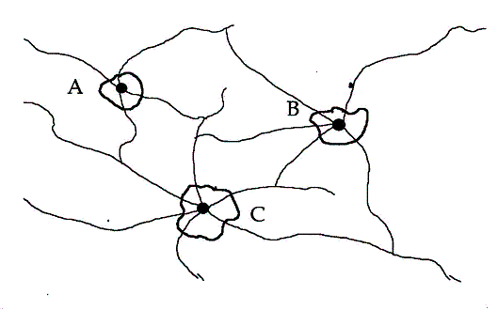

In which order did these bullet holes occur?

Explain your reasoning for the order:

ANS:
CAB

Both A and B radial lines stop when they reach the radial lines of C. This means that C had to have occurred first. The radial lines of B stop when they reach A. This means that A occurred before B.

PTS: 5

