Multiple Choice: Write your answers on the answer sheet provided. Allow thirty minutes. (1 point each for 55 points total)

1. The reliability of eye witness accounts can be affected by:
a. | the type of crime
b. | the interviewing technique used by the investigator
c. | the time between the crime and the interview
d. | all of the above

2. Which is the following is NOT considered physical evidence?
a. | fiber | c. | toolmarks
b. | testimony | d. | soil

3. If evidence has class characteristics, it
a. | can link a suspect to a crime with certainty
b. | has more probative value than direct evidence
c. | can exonerate innocent suspects

4. A term that means supplying proof or evidence is:
a. | material | c. | probative
b. | direct | d. | prima facie

5. Known or control sample could come from:
a. | the crime scene | c. | the victim
b. | a known suspect | d. | all of the above

6. Which of the following is NOT true about the value of physical evidence
a. | it can prove that a crime has been committed
b. | it is always individual evidence
c. | it can link a suspect with a victim or crime scene
d. | it can allow investigators to reconstruct a crime
e. | b and d are not true
f. | none of these are true

7. If a forensic scientist can piece together broken pieces of glass from a bottle that was used as a weapon, it has:
a. | individual characteristics | c. | identification characteristics
b. | class characteristics | d. | comparative characteristics

8. Which of the following would be considered individual evidence?
a. | DNA | c. | paint
b. | soil | d. | blood type

9. Which of the following would have the most probative value?
a. | soil | c. | fingerprint
b. | glass | d. | fiber

10. If evidence has individual characteristics, it
a. | can link a suspect to a crime with certainty
b. | has probative value
c. | can exonerate innocent suspects
d. | all of the above

11. Microscopic examination of hair can determine:
a. | whether or not the hair is human or animal
b. | the age of the person
c. | the gender of the person
d. | all of these
e. | none of these

12. Generally, a human hair can be distinguished from an animal hair by examining:
a. | the cortex | c. | the color
b. | the medulla | d. | the texture

13. The racial origin of a hair can be determined:
a. | always | c. | never
b. | sometimes | d. | only if it doesn’t have a root

14. Human hair can be characterized by having a medulla that is:
a. | less than 1/3 of the hair diameter | c. | greater than 1/2 of the hair diameter
b. | absent of a scale pattern | d. | that is colorless

15. Nuclear DNA can be identified from:
a. | the hair shaft | c. | both
b. | the hair root or follicle | d. | neither

16. An unidentified hair is examined and found to have been dyed. The dye begins 3 cm from the root. This indicates that it was dyed:
a. | one month ago | c. | three months ago
b. | two months ago | d. | not possible to determine

17. In a cross section, the hair of an African American would look:
a. | round | c. | crescent moon
b. | oval | d. | none of these

18. This medulla pattern would be considered:
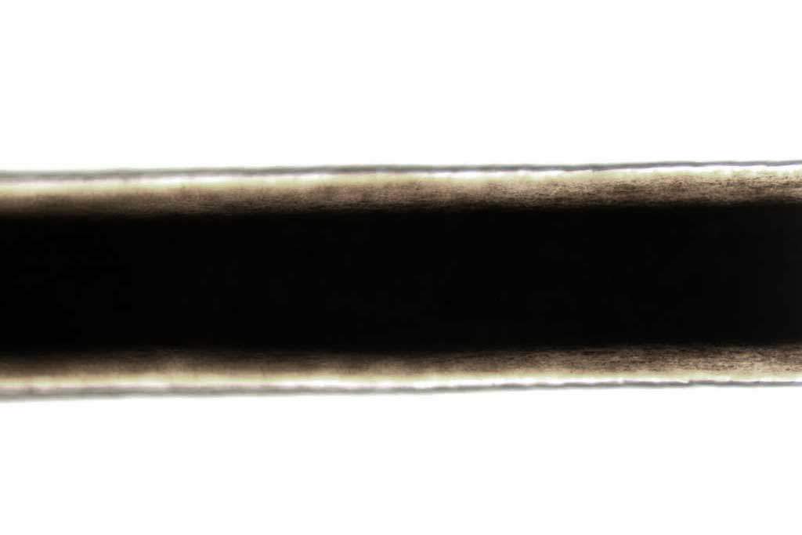
a. | fragmented | c. | continuous
b. | interrupted | d. | stacked

19. Mark on your sheet letter that indicates the cortex:

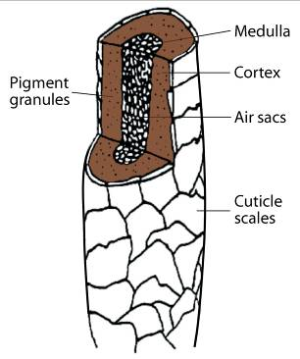

A
B

C

20. Mark on your sheet the pattern that would be imbricate:
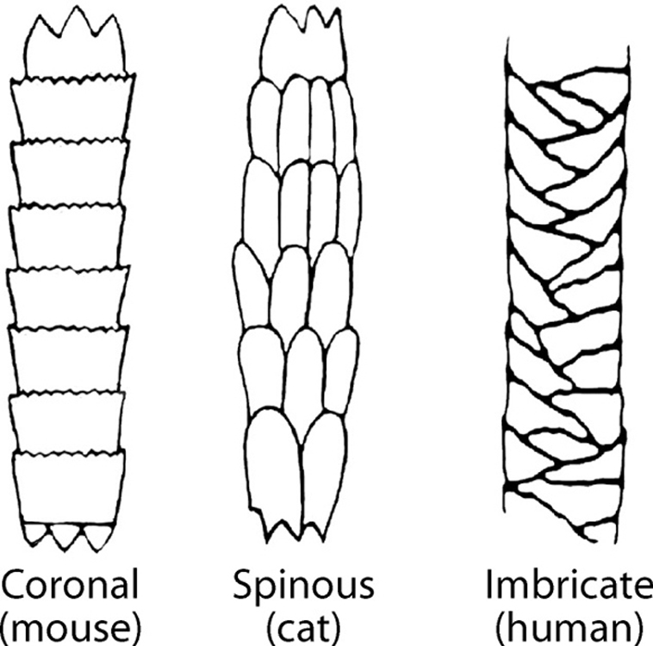
A
B
C

21. Some examples of natural fibers are:
a. | jute, rayon, silk and wool | c. | linen, cotton, acetate, rayon
b. | wool, cotton, cashmere | d. | linen, cotton, wool, Dacron

22. Fibers that are polymers are:
a. | natural | c. | all fibers are polymers
b. | synthetic | d. | no fibers are polymers

23. To test the dye in a particular fiber, it can be extracted and then tested using:
a. | a burn test | c. | chemical tests
b. | a thermal decomposition test | d. | any of these

24. Out of seven analytical tests performed to match a questioned fiber to a known, you find one discrepancy. The cross-section is triangular rather than round. What do you do?
a. | don’t worry about it; six out of seven is good evidence
b. | report that there is no association between the questioned fiber and the known
c. | assume that the one test was wrong

25. Which of the following will fluoresce under ultraviolet light?
a. | polyester | c. | nylon
b. | cotton | d. | acrylic

26. Who was the person convicted on the basis of fiber evidence?
a. | Ronald Cotton | c. | Wayne Williams
b. | Amanda Davies | d. | Richard Vorder Bruegge

27. Which of the following properties should be examined when comparing two fibers?
a. | birefringence | c. | color
b. | diameter | d. | all of these

28. Which of the following fibers DO NOT come from an animal source?:
a. | asbestos | d. | wool
b. | mohair | e. | cashmere
c. | silk | f. | all of these come from animals

29. Fibers that are made by plants or animals are called:
a. | natural | c. | synthetic
b. | plain | d. | real

30. Wool, when burned, smells like:
a. | tar | c. | vinegar
b. | burning hair | d. | diesel fuel

31. Trace evidence found at a crime scene may include:
a. | sand, soil
b. | any physical evidence found in small amounts
c. | powders, explosive residue, metal or glass particles
d. | all of the above

32. Determining the density of a metal by observing whether it sinks or floats in bromoform is a:
a. | chemical test | c. | both a and b
b. | physical test | d. | neither a or b

33. To examine the chemical properties of metal add __________ and look for a color change or the evolution of bubbles.
a. | an acid and/or base | c. | a magnet
b. | water and heat | d. | any of these would work

34. Common metals that are magnetic are:
a. | iron, nickel, and copper | c. | chromium, zinc, and iron
b. | nickel, copper, and chromium | d. | iron and nickel

35. When using chromatographic techniques, it is important to keep the sample spot above the solvent level because:
a. | the spot will travel up the stationary phase and be deposited on the strip
b. | the spot will mix with the solvent and travel faster than it is supposed to
c. | the spot will dissolve in the solvent and not go anywhere
d. | all of these could happen

36. One of the tests used to classify white powders is based on solubility. The solubility of a substance is based on:
a. | its ability to turn brown with the addition of iodine
b. | the evolution of gas when an acid is added
c. | its ability to turn bright pink when phenolphthalein is added
d. | its ability to dissolve when a solvent such as water is added

37. The solubility of a substance is considered:
a. | a physical property | c. | both a and b
b. | a chemical property | d. | neither a or b

38. When one substance is added to another, the evolution of gas bubbles indicates:
a. | a physical change | c. | both a and b
b. | a chemical change | d. | neither a or b

39. The pH of a substance indicates whether it is acidic or basic. Acids have a pH of:
a. | less than 7 | c. | greater than 7
b. | 7 | d. | it depends on the substance that is added

40. Which of these indicates that a chemical reaction has taken place?
a. | color changes | c. | formation of a precipitate
b. | gas bubbles | d. | all of these

41. The forensic definition of soil is:
a. | a mixture of mineral grains and decayed organic matter
b. | a mixture of mineral grains, organic matter, and any other materials mixed with the sample
c. | decayed organic matter only
d. | anything that looks like dirt

42. Soil evidence is analyzed based on its:
a. | physical properties
b. | chemical properties
c. | settling rate
d. | all of the above

43. A topographic map is one that shows:
a. | the same as a roadmap with all major and minor roads
b. | geographic features of an area
c. | the soil composition of an area
d. | all of the above
e. | none of the above

44. A soil horizon is something that shows
a. | the relative density of soil particles | c. | the rate of settling
b. | the pH of soil | d. | a soil profile showing distinct layers

45. The organic part of soil is called:
a. | humus | c. | rock particles
b. | minerals | d. | loam

46. The amounts of light transmitted through a sample can be measured as a function of wavelength through which procedure?
a. | chromatography | c. | electrophoresis
b. | spectroscopy | d. | none of these

47. Glass evidence is considered:
a. | individual evidence
b. | class evidence
c. | sometimes individual, sometimes class depending on the circumstances

48. A glass fragment is dropped into a test tube filled with a particular liquid. If the fragment floats on the surface, the density of the glass is __________ the density of the liquid.
a. | more than | c. | equal to
b. | less than | d. | it could be any of the above

49. A glass fragment is dropped into a test tube filled with a particular liquid. If the fragment is suspended in the middle of the liquid, the density of the fragment is __________ the density of the liquid.
a. | more than | c. | equal to
b. | less than | d. | it could be any of the above

50. Another term for a known source would be:
a. | a questioned | c. | a verification
b. | an exemplar | d. | none of these

51. A piece of glass has a bullet hole that is larger on one side of the glass than on the other. This indicates:
a. | a high powered shot gun made the hole
b. | the larger side is the entrance
c. | the larger side is the exit
d. | the bullet was traveling at low velocity

52. In examining a glass fracture pattern, the radial lines are:
a. | cracks that form in circles around the point of impact
b. | cracks that extend out from the point of impact
c. | directional lines that seem to go nowhere
d. | cracks known as Becke lines

53. A man claims that someone broke into his house through the window; the investigator believes that the window was broken from the inside of the house. What evidence would lead the investigator to believe this?
a. | the window had concentric lines in the fracture pattern
b. | the window had radial lines in the fracture pattern
c. | the edge of the window had stress makes perpendicular to the outside and parallel to the inside
d. | there were no visible cracks at all

54. If two fracture lines meet, it is easy to determine which fracture occurred first because:
a. | the fracture line will terminate at the crack that happened first
b. | the fracture line will terminate at the crack that happened second
c. | the second fracture will not have concentric cracks
d. | the second fracture will not have radial cracks

55. It is useful to find the Becke line when examining:
a. | radial cracks | c. | refractive index
b. | concentric cracks | d. | density

Matching: Write your answers on the answer sheet provided. Allow five minutes. (1 point each for 5 points total)

Match the following terms with the statements below.
a. | Becke line | d. | filament
b. | blend | e | viscosity
c. | chromatography | f. | density

56. a method of separating components of mixtures
57. a halo-like shadow around an object immersed in a liquid of a different refractive index3
58. mass divided by volume
59. the resistance of a fluid to flow 5
60. fabric made up of two or more different types of fiber

Short Answer/Essay: 40 total points. Allow for fifteen minutes. Use the answer sheet to record your response. 10 points each.

1. State the difference between class and individual evidence.

Describe how one piece of evidence could show class and individual characteristics.

2. Describe 3 characteristics of hair that make it useful in forensic investigations.

3. There is a bloody shirt and blanket next to a body. You have been directed to collect it by your supervisor.
- Assuming all other procedures are complete (photographing, diagramming, etc) how do you collect these pieces of evidence? Explain your choices.
- Once back at the lab you begin to process the shirt. What is the best way to identify & collect any fiber evidence?

4. Evaluate the evidence in the diagram and answer the inquires below.

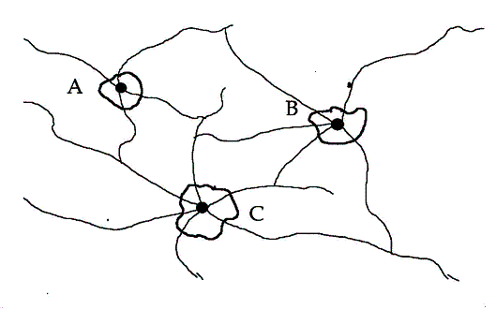

a. In which order did these bullet holes occur?

b. How do you justify your evaluation?

