1. 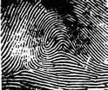 2. 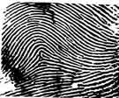 3. 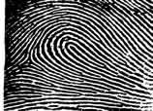
Whorl - Accidental Arch - Tented Loop

4. 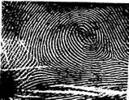 5. 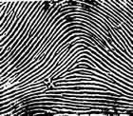 6. 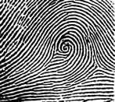
Whorl - Plain Arch - Plain Whorl - Central Pocket

7. 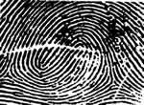 8. 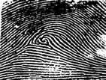 9. 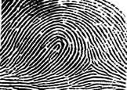
Whorl - Double Loop Whorl - Central Pocket Loop
10.  Bonus Print: 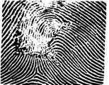
Arch - Plain Scarred or Burned
(Plain arch approximating a tented arch Ridge count cannot be determined
as the rising ridge cannot accurately but it would be classified
be considered an upthrust because it is as a loop.
a continuous, and
not an ending, ridge)
1. Match the search print to one of the five candidates:
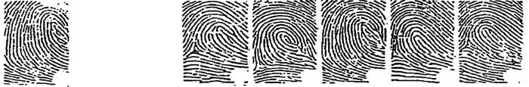
Search A B C D E
2. Match the search print to one of the three candidates:
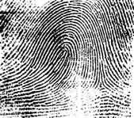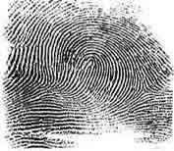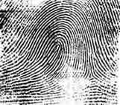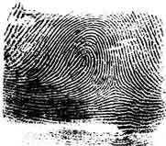
Search A B C
3. Match the search print to one of the three candidates:
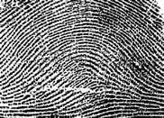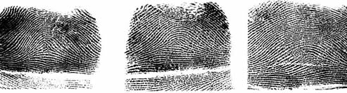
Search A B C
4. Match the search print to one of the three candidates:
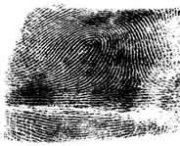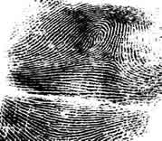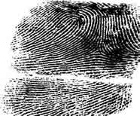
Search A B C
5. Match the search print to one of the three candidates:
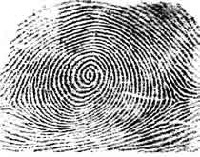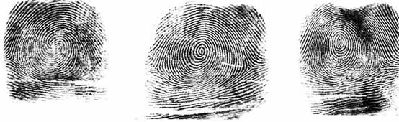
Search A B C

Now for the hard stuff.....The correct terminology for stating that a print is a match or not is: Hit or No-Hit.

6. : Declare a Hit or No-hit on the following two latent prints:
HIT
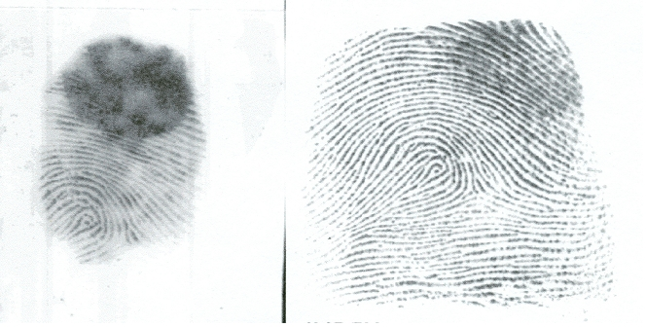

7. : Declare a Hit or No-hit on the following two latent prints:
HIT
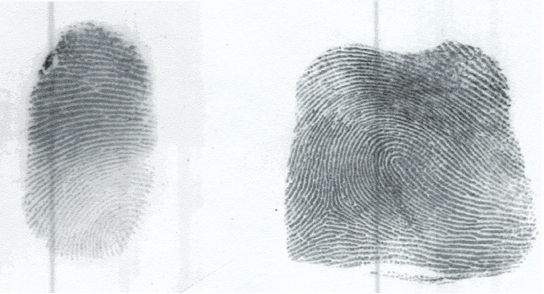
8. : Declare a Hit or No-hit on the following two latent prints:
NO-HIT
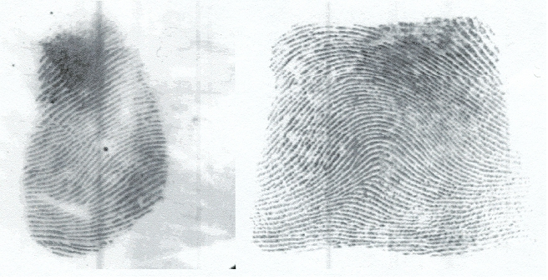
How did you do? Not as easy as it seems?
Now you understand the skill required and demanded of every AZAFIS Tenprint Technician and Latent Print Examiner. All AZAFIS Operators are highly skilled in their profession and dedicated to the job that they perform......making identifications that put criminals in jail!
Taken from: http://afis.azdps.gov/skills.asp

