Multiple Choice: Write your answers on the answer sheet provided. Allow thirty minutes. (1 point each for 55 points total)

1. The most common type of fingerprint pattern is the:
a. | loop | c. | whole
b. | arch | d. | delta

ANS: A PTS: 1

2. The person most responsible for the fingerprint classification system used in the US today is:
a. | William Herschel | d. | Francis Galton
b. | Henry Faulds | e. | Edward Henry
c. | Alphonse Bertillon | f. | Juan Vucetich

ANS: E PTS: 1

3. Which of the following are found in an arch pattern?
a. | delta | d. | minutiae
b. | core | e. | all of these are found in an arch
c. | composites | f. | none of these are found in an arch

ANS: D PTS: 1

4. How large an area of a latent print is needed to make a positive comparison?
a. | a whole fingerprint | c. | at least 5 ridge characteristics
b. | at least half a print | d. | at least 8 to 12 characteristics

ANS: D PTS: 1

5. What type of fingerprint would be left on skin?
a. | latent | c. | visible
b. | plastic | d. | fingerprints cannot be placed on skin

ANS: A PTS: 1

6. What type of fingerprint would be left in putty?
a. | latent | c. | visible
b. | plastic | d. | any of the above

ANS: B PTS: 1

7. What would be the best way of visualizing a print found on a document?
a. | dusting and lifting
b. | superglue fuming
c. | ninhydrin
d. | you cannot visualize prints on a matchbook

ANS: C PTS: 1

8. What would be the best way of visualizing a print found on a glass bottle?
a. | dusting and lifting | d. | all of these
b. | superglue | e. | either a or b
c. | iodine fuming

ANS: E PTS: 1

9. A fingerprint left at the scene of a crime must be developed:
a. | within 24 hours | c. | in less than a month
b. | within a week | d. | may last for years

ANS: D PTS: 1

10. A fingerprint is composed mainly of:
a. | salt | c. | water
b. | organic compounds | d. | amino acids

ANS: C PTS: 1

11. Ridge characteristics can be found in:
a. | fingerprints | d. | only a and b
b. | footprints | e. | only a and c
c. | palm prints | f. | all of these

ANS: F PTS: 1

12. Which of these types of chemical methods should be used first?
a. | ninhydrin | c. | silver nitrate
b. | iodine fuming | d. | superglue

ANS: B PTS: 1

13. The study of fingerprints is called
a. | anthropometry | c. | printology
b. | dactyloscopy | d. | none of these

ANS: B PTS: 1

14. The person responsible for a system known as anthropometry was:
a. | William Herschel | d. | Francis Galton
b. | Henry Faulds | e. | Edward Henry
c. | Alphonse Bertillon | f. | Juan Vucetich

ANS: C PTS: 1

15. The person responsible for the system that is currently used in Spanish-speaking countries.
a. | William Herschel | d. | Francis Galton
b. | Henry Faulds | e. | Edward Henry
c. | Alphonse Bertillon | f. | Juan Vucetich

ANS: F PTS: 1

16. The FBI’s database used for storing fingerprints is:
a. | IBIS | c. | CODIS
b. | AFIS | d. | USDA

ANS: B PTS: 1

17. The first time that silver nitrate was used to visualize fingerprints was:
a. | the Lindbergh kidnapping | c. | the OJ case
b. | the Hamm kidnapping | d. | Sam Sheppard case

ANS: B PTS: 1

18. Which of these is a whorl?
a. | central pocket | d. | only a and c
b. | double loop | e. | all of these
c. | accidental

ANS: E PTS: 1

19. A loop that opens toward the thumb is called a(an)
a. | ulnar | c. | plain
b. | radial | d. | accidental

ANS: B PTS: 1

20. Another term for a ridge characteristic is:
a. | match | c. | core
b. | delta | d. | minutia

ANS: D PTS: 1

21. Protein (amino acid) residues are best developed into fingerprint impressions with:
a. | ninhydrin | c. | silver nitrate
b. | dusting powder | d. | iodine

ANS: A PTS: 1

22. When a solid is heated and transforms into a vapor, the process is called:
a. | evaporation | c. | sublimation
b. | precipitation | d. | condensation

ANS: C PTS: 1

23. What substance is found in superglue that reacts with and visualizes a fingerprint?
a. | iodine | c. | ninhydrin
b. | cyanoacrylate ester | d. | silver nitrate

ANS: B PTS: 1

24. Which method of visualizing fingerprints takes into account that perspiration contains a variety of components that fluoresce?
a. | iodine | c. | ninhydrin
b. | silver nitrate | d. | lasers

ANS: D PTS: 1

25. The specific part of the skin that gives us our fingerprints is the:
a. | epidermis | c. | dermis
b. | papillae | d. | pores

ANS: B PTS: 1

26. How a print is developed depends on:
a. | the amount of sweat | d. | the skill of the technician
b. | the amount of oil | e. | all of these
c. | the surface it is on | f. | none of these

ANS: C PTS: 1

27. Approximately 25% of the population falls into which primary identification?
a. | 0/0 | d. | 20/20
b. | 1/1 | e. | 50/50
c. | 25/25 | f. | none of these

ANS: B PTS: 1

Competion: Write your answers on the answer sheet provided. Allow thirty minutes. (1 point each for 55 points total)

28. The three basic fingerprint patterns are ____________________, ____________________, and ____________________.

ANS: loops, arches, whorls

PTS: 3

29. The fingerprint pattern that has one or more ridges entering from one side and then going out from the same side it entered is a (an) ____________________.

ANS: loop

PTS: 1

30. The fingerprint pattern that enters from one side of the finger and exits the other while rising upward in the middle is a (an) ____________________.

ANS: arch

PTS: 1

31. The triangular area in a fingerprint pattern is called a (an) ____________________.

ANS: delta

PTS: 1

32. Area found near the center of some fingerprint patterns is the ____________________.

ANS: core

PTS: 1

33. In fingerprints, ridge characteristics are also known as ____________________.

ANS: minutiae

PTS: 1

34. The two types of loops are ____________________ and ____________________.

ANS: radial, ulnar

PTS: 2

35. When a substance sublimes it goes from ____________________ to ____________________ without going through the ____________________ phase.

MATCHING

Match these minutiae with their name.
a. | 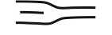 | d. | 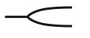
b. | 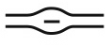 | e. | 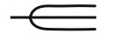
c. | 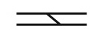 | f. | 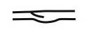

36. bridge C

37. island or short ridge B

38. ridge ending A

39. spur F

40. trifurcation E

Match the following patterns with their name. Assume that all prints come from the right hand.
a. | 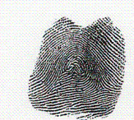 | d. | 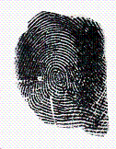
b. | 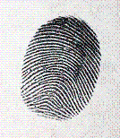 | e. | 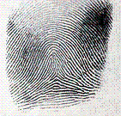
c. | 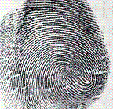 | h. | 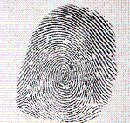

41. accidental A

42. central pocket D

43. double loop C

44. plain whorl F

45. tented arch E

For 45-50 use the following matching bank:
a. bifurcation d. island
b. bridge e. ridge ending
c. eye

45. Minutiae # 1 is a(n): D
46. Minutiae # 2 is a(n): A
48. Minutiae # 3 is a(n): B
49. Minutiae # 4 is a(n): C
50. Minutiae # 5 is a(n): E

For 45-50 use the following matching bank:
a. bifurcation c. trifurcation
b. spur d. bridge
one of these will be used twice

51. Minutiae # 6 is a(n): D
52. Minutiae # 7 is a(n): C
53. Minutiae # 8 is a(n): B
54. Minutiae # 9 is a(n): A
55. Minutiae # 10 is a(n): A

Short Answer/Essay: 40 total points. Allow for fifteen minutes. Use the answer sheet to record your response. 15 points each.

1. Determine the primary identification number for the following patterns taken from a suspect. Show your work.

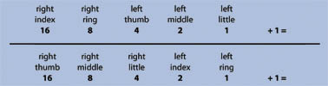

right index | right ring | left thumb | left middle | left little
whorl | arch | loop | loop | whorl

right thumb | right middle | right little | left index | left ring
Loop | arch | whorl | whorl | arch

ANS:

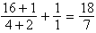

PTS: 5

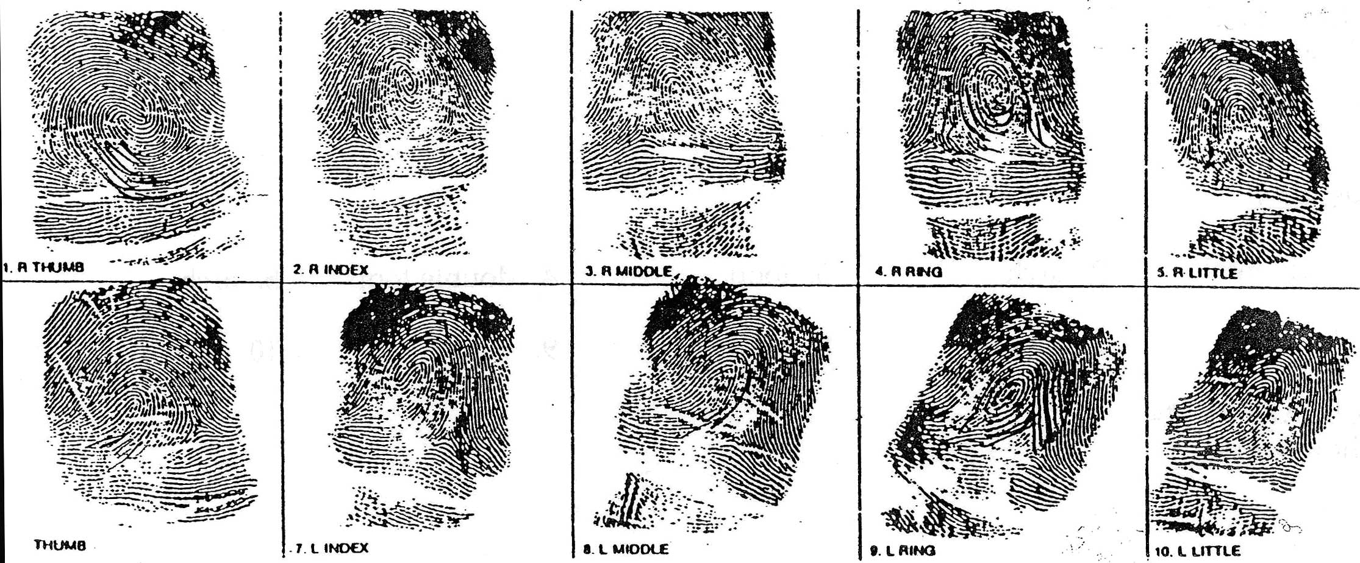

2. Record the general fingerprint pattern for the MO card above.

Determine the primary identification number for this MO card.

Show your work.

What is the primary identification number? ____________________

ANS:
right hand is whorl, whorl, loop, whorl, loop
left hand is loop, whorl, loop, whorl, loop

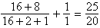

Primary Identification number is 25/20.

PTS: 10

3. These prints were found on the window sill where a burglary occurred.

Look at the suspect and victim prints on the next two pages. Answer the questions below:

Do these prints match either (if so which one)? Suspect

Could you testify in court that they are a match? Yes – points of minutiae

Why or why not? Points of minutiae

These are the suspect’s prints:
These are the victim’s prints:

