Multiple Choice: Write your answers on the answer sheet provided. Allow twenty minutes. (1 point each for 27 points total)

1. The most common type of fingerprint pattern is the:
a. | loop | c. | whole
b. | arch | d. | delta

2. The person most responsible for the fingerprint classification system used in the US today is:
a. | William Herschel | d. | Francis Galton
b. | Henry Faulds | e. | Edward Henry
c. | Alphonse Bertillon | f. | Juan Vucetich

3. Which of the following are found in an arch pattern?
a. | delta | d. | minutiae
b. | core | e. | all of these are found in an arch
c. | composites | f. | none of these are found in an arch

4. How large an area of a latent print is needed to make a positive comparison?
a. | a whole fingerprint | c. | at least 5 ridge characteristics
b. | at least half a print | d. | at least 8 to 12 characteristics

5. What type of fingerprint would be left on skin?
a. | latent | c. | visible
b. | plastic | d. | fingerprints cannot be placed on skin

6. What type of fingerprint would be left in putty?
a. | latent | c. | visible
b. | plastic | d. | any of the above

7. What would be the best way of visualizing a print found on a document?
a. | dusting and lifting
b. | superglue fuming
c. | ninhydrin
d. | you cannot visualize prints on a matchbook

8. What would be the best way of visualizing a print found on a glass bottle?
a. | dusting and lifting | d. | all of these
b. | superglue | e. | either a or b
c. | iodine fuming

9. A fingerprint left at the scene of a crime must be developed:
a. | within 24 hours | c. | in less than a month
b. | within a week | d. | may last for years

10. A fingerprint is composed mainly of:
a. | salt | c. | water
b. | organic compounds | d. | amino acids

11. Ridge characteristics can be found in:
a. | fingerprints | d. | only a and b
b. | footprints | e. | only a and c
c. | palm prints | f. | all of these

12. Which of these types of chemical methods should be used first?
a. | ninhydrin | c. | silver nitrate
b. | iodine fuming | d. | superglue

13. The study of fingerprints is called
a. | anthropometry | c. | printology
b. | dactyloscopy | d. | none of these

14. The person responsible for a system known as anthropometry was:
a. | William Herschel | d. | Francis Galton
b. | Henry Faulds | e. | Edward Henry
c. | Alphonse Bertillon | f. | Juan Vucetich

15. The person responsible for the system that is currently used in Spanish-speaking countries.
a. | William Herschel | d. | Francis Galton
b. | Henry Faulds | e. | Edward Henry
c. | Alphonse Bertillon | f. | Juan Vucetich

16. The FBI’s database used for storing fingerprints is:
a. | IBIS | c. | CODIS
b. | AFIS | d. | USDA

17. The first time that silver nitrate was used to visualize fingerprints was:
a. | the Lindbergh kidnapping | c. | the OJ case
b. | the Hamm kidnapping | d. | Sam Sheppard case

18. Which of these is a whorl?
a. | central pocket | d. | only a and c
b. | double loop | e. | all of these
c. | accidental

19. A loop that opens toward the thumb is called a(an)
a. | ulnar | c. | plain
b. | radial | d. | accidental

20. Another term for a ridge characteristic is:
a. | match | c. | core
b. | delta | d. | minutia

21. Protein (amino acid) residues are best developed into fingerprint impressions with:
a. | ninhydrin | c. | silver nitrate
b. | dusting powder | d. | iodine

22. When a solid is heated and transforms into a vapor, the process is called:
a. | evaporation | c. | sublimation
b. | precipitation | d. | condensation
23. What substance is found in superglue that reacts with and visualizes a fingerprint?
a. | iodine | c. | ninhydrin
b. | cyanoacrylate ester | d. | silver nitrate

24. Which method of visualizing fingerprints takes into account that perspiration contains a variety of components that fluoresce?
a. | iodine | c. | ninhydrin
b. | silver nitrate | d. | lasers

25. The specific part of the skin that gives us our fingerprints is the:
a. | epidermis | c. | dermis
b. | papillae | d. | pores

26. How a print is developed depends on:
a. | the amount of sweat | d. | the skill of the technician
b. | the amount of oil | e. | all of these
c. | the surface it is on | f. | none of these

27. Approximately 25% of the population falls into which primary identification?
a. | 0/0 | d. | 20/20
b. | 1/1 | e. | 50/50
c. | 25/25 | f. | none of these

Completion: Write your answers on the answer sheet provided. Allow five minutes. (1 point each for 8 points total)

28. The three basic fingerprint patterns are don’t write here , don’t write here and don’t write here

29. The fingerprint pattern that has one or more ridges entering from one side and then going out from the same side it entered is a (an) don’t write here

30. The fingerprint pattern that enters from one side of the finger and exits the other while rising upward in the middle is a (an) don’t write here

31. The triangular area in a fingerprint pattern is called a (an) don’t write here

32. Area found near the center of some fingerprint patterns is the don’t write here

33. In fingerprints, ridge characteristics are also known as don’t write here

34. The two types of loops are don’t write here and don’t write here

35. When a substance sublimes it goes from don’t write here to don’t write here without going through the don’t write here phase.

Matching: Write your answers on the answer sheet provided. Allow ten minutes. (1 point each for 20 points total)

Match these minutiae with their name.

a. | 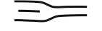 | d. | 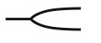
b. | 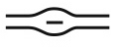 | e. | 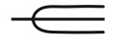
c. | 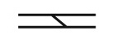 | f. | 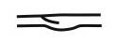

36. bridge

37. island or short ridge

38. ridge ending

39. spur

40. trifurcation

Match the following patterns with their name. Assume that all prints come from the right hand.

a. | 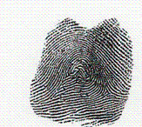 | d. | 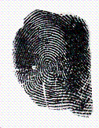
b. | 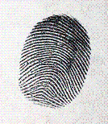 | e. | 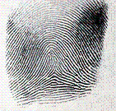
c. | 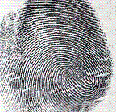 | f. | 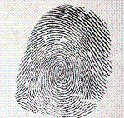

41. accidental

42. central pocket

43. double loop

44. plain whorl

45. tented arch

For 45-50 use the following matching bank:

a. bifurcation d. island
b. bridge e. ridge ending
c. eye

46. Minutiae # 1 is a(n):
47. Minutiae # 2 is a(n):
48. Minutiae # 3 is a(n):
49. Minutiae # 4 is a(n):
50. Minutiae # 5 is a(n):

For 45-50 use the following matching bank:

a. bifurcation c. trifurcation
b. spur d. bridge
one of these will be used twice

51. Minutiae # 6 is a(n):
52. Minutiae # 7 is a(n):
53. Minutiae # 8 is a(n):
54. Minutiae # 9 is a(n):
55. Minutiae # 10 is a(n):

Short Answer/Essay: 45 total points. Allow for ten minutes. Use the answer sheet to record your response. 15 points each.

1. Determine the primary identification number for the following patterns taken from a suspect.

SHOW YOUR WORK ON THE ANSWER SHEET!

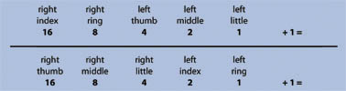

right index | right ring | left thumb | left middle | left little
whorl | arch | loop | loop | whorl

right thumb | right middle | right little | left index | left ring
Loop | arch | whorl | whorl | arch

2. Determine the primary identification number for these prints.
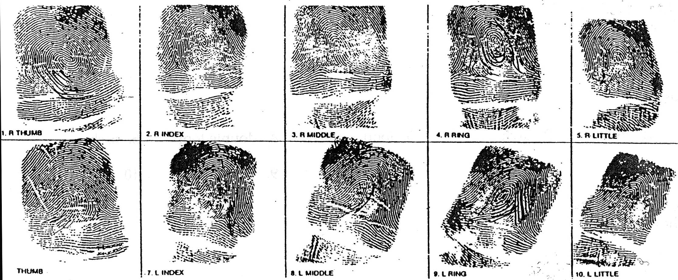

SHOW YOUR WORK ON THE ANSWER SHEET!

3. These prints were found on the window sill where a burglary occurred.

Look at the suspect and victim prints on the next two pages.

Answer the questions below ON YOUR ANSWER SHEET!:

Do these prints match either (if so which one)?

Could you testify in court that they are a match?

Why or why not?

These are the suspect’s prints:
These are the victim’s prints:

