Multiple Choice: Write your answers on the answer sheet provided. Allow thirty minutes. (2 points each for 60 points total)

1. A revolver would be considered a:
a. | handgun | c. | shotgun
b. | rifle | d. | air gun

ANS: A PTS: 1

2. A single shot or bullet in a shotgun shell is called a:
a. | shot | c. | slug
b. | gauge | d. | bore

ANS: C PTS: 1

3. Which of the following leave marks on the cartridge?
a. | extractor | d. | chamber
b. | ejector | e. | all of these leave marks
c. | magazine | f. | only c and d leave marks

ANS: E PTS: 1

4. As a bullet leaves the muzzle of a weapon, it carries along with it some of the unburned particles as well as combustion products primarily coming from:
a. | citrates | c. | the oxygen in the air
b. | nitrates | d. | any of these

ANS: B PTS: 1

5. Which of the following shows an individual characteristic of shoe prints.
a. | manufacturer | c. | damage to the sole
b. | shoe type | d. | shoe size

ANS: C PTS: 1

6. Which of the following is NOT a class characteristic of tire impressions?
a. | a tear in the tread | d. | model
b. | size | e. | all of these are class characteristics
c. | type | f. | none of these are class characteristics

ANS: A PTS: 1

7. Bitemarks were the prime evidence against which of the following serial killers.
a. | BTK | c. | The Green River Killer
b. | Ted Bundy | d. | Son of Sam

ANS: B PTS: 1

8. A color test for the presence of nitrite in gunpowder residue is called:
a. | Greiss | c. | Greer
b. | Glaister | d. | sodium rhodizonate test

ANS: A PTS: 1

9. A color test for the presence of lead in gunshot residue is called:
a. | Greiss | c. | Greer
b. | Glaister | d. | sodium rhodizonate test

ANS: D PTS: 1

Use this diagram to answer 10 - 13
B
D
C
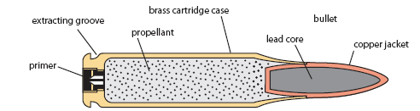
A
10. “A” in the above picture is the:
a. | cartridge casing | c. | primer
b. | propellant | d. | projectile

ANS: C PTS: 1

11. “B” in the above picture is the:
a. | cartridge casing | c. | primer
b. | projectile | d. | propellant

ANS: D PTS: 1

12. “C” in the above picture is the:
a. | cartridge casing | c. | primer
b. | propellant | d. | projectile

ANS: A PTS: 1

13. “D” in the above picture is the:
a. | cartridge casing | c. | primer
b. | projectile | d. | propellant

ANS: B PTS: 1

Use this diagram to answer 14 - 17
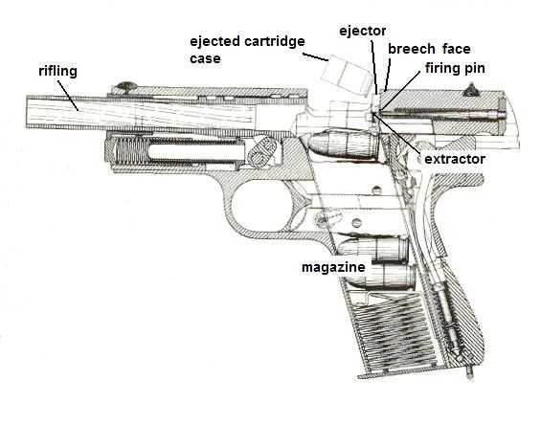

B
C
D
A

14. “A” in the above picture is the:
a. | firing pin | c. | magazine
b. | extractor | d. | rifling

ANS: D PTS: 1

15. “B” in the above picture is the:
a. | firing pin | c. | magazine
b. | extractor | d. | rifling

ANS: A PTS: 1

16. “C” in the above picture is the:
a. | firing pin | c. | magazine
b. | extractor | d. | rifling

ANS: B PTS: 1

17. “D” in the above picture is the:
a. | firing pin | c. | magazine
b. | extractor | d. | rifling

ANS: D PTS: 1
Use this diagram to answer 18 – 20
C
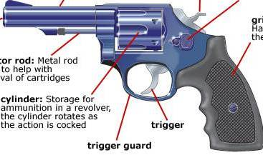

A

B

18. “A” in the above picture is the:
a. | hammer | c. | trigger
b. | cylinder | d. | ejector rod

ANS: D PTS: 1

19. “B” in the above picture is the:
a. | hammer | c. | trigger
b. | cylinder | d. | ejector rod

ANS: B PTS: 1

20. “C” in the above picture is the:
a. | hammer | c. | trigger
b. | cylinder | d. | ejector rod

ANS: A PTS: 1

21. The diameter of the bore of a firearm or the cartridge that is fired is called the (a)
a. | bore | c. | caliber
b. | rifle | d. | gauge

ANS: C PTS: 1

22. The interior diameter of a shot gun barrel as determined by the number of lead balls of a size exactly fitting the barrel that are required to make one pound.
a. | bore | c. | caliber
b. | rifle | d. | gauge

ANS: D PTS: 1

23. Parallel sets of scratches on a bullet caused by unique markings in the bore of a rifled weapon.
a. | striae | c. | breech
b. | magazine | d. | stance

ANS: A PTS: 1

24. The distance from the centerline of the right tire to the centerline of the left tire.
a. | striae | c. | breech
b. | magazine | d. | stance

ANS: D PTS: 1

25. A container that holds cartridges under spring pressure to be fed into the gun’s chamber.

a. | striae | c. | breech
b. | magazine | d. | stance

ANS: B PTS: 1

26. The standard method documenting impression evidence is

a. | casting | c. | putty
b. | biogreen | d. | photography

ANS: D PTS: 1

27. The part of the tooth DNA can usually be extracted from:

a. | pulp | c. | enamel
b. | cementum | d. | crown

ANS: A PTS: 1

28. Number of teeth in a healthy adult:

a. | 20 | c. | 28
b. | 32 | d. | 36

ANS: B PTS: 1

29. Which of the following is NOT relevant in postmortem dental examinations?

a. | presence/absence of tooth | c. | path of bullet
b. | unerupted teeth | d. | fillings or crowns

ANS: C PTS: 1

30. Which of the following would be true of a antemortem bite?

a. | diffused bruise | c. | defined bruise
b. | no bruise | d. | easy to make an impression of

ANS: A PTS: 1

Calculation: Interpol has asked for evidence from your file to compare similarities to crimes in France. You must convert your investigation measurements to metric. Write your answers on the answer sheet provided. Allow five minutes. (2 points each for 10 points total)

Helpful Hints and Formulas
(F - 32) x 5/9 = C  (C x 1.8) + 32 = F  1floz = 29.6ml | 1ft = 30.5cm  1in = 2.54cm  1oz = 28.3g

31. Your room measured 11 feet by 13 feet. How many squared meters?

11ft | 13ft | 30.5cm | 30.5cm | 1m | 1m | 13.3m²
1 | 1 | 1ft | 1ft | 100cm | 100cm

32. The knife was 5.5 inches. How long is that in cm?

5.5 in | 2.54cm | 13.97cm
1 | 1 in

33. There were 8 ounces of methamphetamine recovered. How many g?

8oz | 28.3g | 226.4 g
1 | 1oz

34. You recovered 9 fluid ounces of liquid explosive. How many ml?

9floz | 29.6ml | 266.4ml
1 | 1

35. The room was 78 degrees. What is the Celsius temperature?

(78-32) x 5/9 = 25.55

Short Answer/Essay: 30 total points. Allow for fifteen minutes. Use the answer sheet to record your response. 10 points each.

1. Describe a way in which a cartridge could be individual evidence.

Describe a way in which a cartridge could be class evidence.

ANS:
Individual if you have the impression of the firing pin

Class based on the dimension of the shell casing, whether it is rim or centerfire, the imprint on the head stamp

PTS: 4

2. Give an example of how a tool could produce individual evidence.

ANS:
As it is worn or damaged, it acquires particular markings that differentiate it from others of the same. Students may give a specific example.

PTS: 4
3. A body is discovered that appears to be a suicide using a semiautomatic handgun shot to the temple inside a house. There is no apparent exit wound.

How would you prepare the body for transport to the morgue?

How would you handle/collect the gun?

What would you look for at the crime scene (specifically related to this unit of study)?

Once at the morgue what tests would be run on the victim?

ANS:
Hands should be bagged
Gun should be cleared and handled in a way to minimized rubbing prints
Crime scene search for casing
GSR test on hands & arms, GSR around entry site to determine proximity.

PTS: 4

